PROPOSED RULE AMENDMENTS
Public Hearing
March 3, 2026 (2:00pm) Microsoft Teams

Instructions for Oral and Written Comments: The
Objection, reasons for the objection, and the clearly
Identified portion of the rule to which the objection
pertains, must be submitted in writing to:

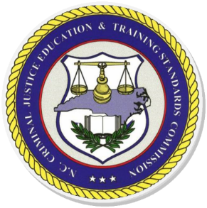

Holly Cardoza
Rulemaking Coordinator
Criminal Justice Standards Division
PO Drawer 149
Raleigh, NC 27602
Agency: Criminal Justice Education and Training Standards Commission
Contact: Holly Cardoza
Impact Summary: State Government: No
Local Government: No
Substantial Impact: No
Small Business: No

Purpose of Rule Changes: To repeal rules that are no longer in use. To update requirements for law enforcement officers who fail to complete annual firearms qualification. To update requirements for recertification of correctional and probation/parole officers with a break in service.

For Repeal:
12 NCAC 09B .0601 Purpose
12 NCAC 09B .0602 Establishment of Program Evaluation Committee
12 NCAC 09B .0603 Levels of Approval
12 NCAC 09B .0604 Self Study
12 NCAC 09B .0605 Institutional Visitation
12 NCAC 09B .0606 Application Procedures
12 NCAC 09B .0607 Procedural Considerations
12 NCAC 09B .0608 Appeal Procedures

For Readoption with Substantive Changes:
12 NCAC 09E .0107 Failure to Qualify: Annual Firearms Qualification
12 NCAC 09G .0305 Recertification Following Separation

Statutory authority for rule change: G.S. 17C-6, 17C-10

*Rule begins on the following page

