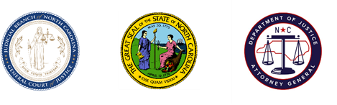
North Carolina Task Force for Racial Equity in Criminal Justice
Implementation Committee #1 –
Executive Branch Action
Meeting #4 – Training Discussion
Date: Friday, March 26, 2021
Time: 11:00 AM
Chairperson: Sergeant Billy Gartin

AGENDA

- Welcome
  - Sergeant Billy Gartin, Committee Chair

- Training Discussion
  - Sergeant Billy Gartin and Chief CJ Davis, Training Bucket

- Schedule and Next Steps
  - Leslie Cooley Dismukes, Substantive Staff Lead

