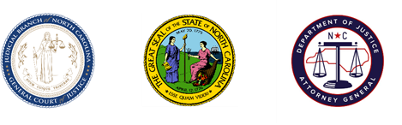
North Carolina Task Force for Racial Equity in Criminal Justice
Implementation Committee #1 –
Executive Branch Action
Meeting #4 – Commissions Discussion
Date: Tuesday, March 9, 2021
Time: 2:00PM
Chairperson: Sergeant Billy Gartin

AGENDA

- Welcome
  - Sergeant Billy Gartin, Committee Chair

- Commission Discussion
  - Leslie Cooley Dismukes, Substantive Staff Lead

- Schedule and Next Steps
  - Leslie Cooley Dismukes, Substantive Staff Lead

