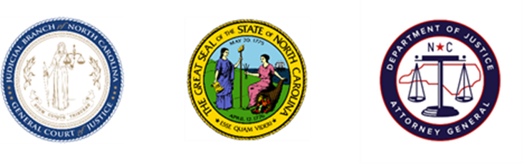
North Carolina Task Force for Racial Equity in Criminal Justice
Judicial Committee

Date: Thursday 18 November 2021
Time: 8:00am
Chairpersons: Judge Alan Thornburg & Judge Brooke Clark

AGENDA

- Welcome
  - Sam Davis, Co-Lead
- Fines and Fees Presentation
  - Emma Ferriola-Bruckenstein, Orange County Criminal Justice Resource Department
  - Emily Mistr, Fair Chance Criminal Justice Project, NC Justice Center
- Update on Prosecutor Guide
  - Ellen Spolar
- Discussion and Questions
- Adjourn

