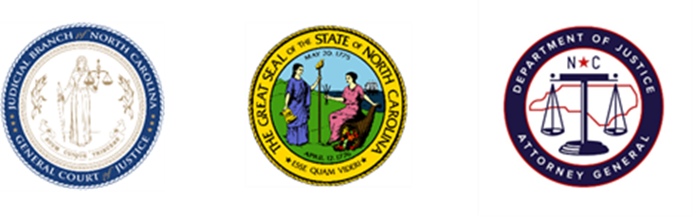
North Carolina Task Force for Racial Equity in Criminal Justice
Executive Committee

Date: Tuesday, November 30, 2021
Time: 2:00 PM
Chairperson: Sergeant Billy Gartin

AGENDA

- Welcome
  - Sergeant Billy Gartin, Committee Chair
- Commissions Update
  - Leslie Cooley Dismukes (15-20 minutes)
- Training Update
  - Jasmine McGhee (5-10 minutes)
- Discussion and Questions (15 Minutes)
- Adjourn

