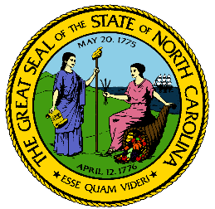
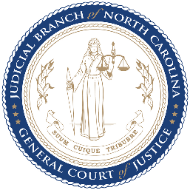
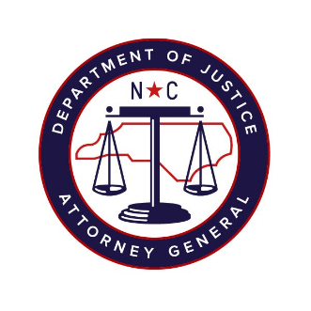

North Carolina Task Force for Racial Equity in Criminal Justice
Working Group #4
Addressing Racial Equity in Trials and Post-Conviction
Meeting #10
Date: 20 October 2020
Time: 8:00 AM EST
Chairperson: Hill, Henderson
AGENDA
- Welcome & Approval of Minutes (5 mins)
  - Workgroup Chair, Henderson Hill
- Slate of Collateral Consequences Recommendations (15 mins)
Invited Guests:
  - Irene Lawrence, Program Coordinator, Reentry, Programs, Services, Division of Adult Correction and Juvenile Justice
  - Daniel Bowes & Quisha Mallette, Fair Chance Criminal Justice Project, NC Justice Center
  - Melissa Radcliffe, Program Director, Our Children’s Place of Coastal Horizons Center, Inc.
- Discussion: Collateral Consequences (45 mins)
- General Discussion (If Needed):
  - Fines & Fees Survey
  - Prison Discipline Survey
  - Death Penalty Draft Recommendation
- Next Steps (10 mins)
  - Workgroup Chair, Henderson Hill

