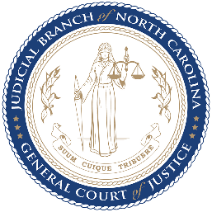
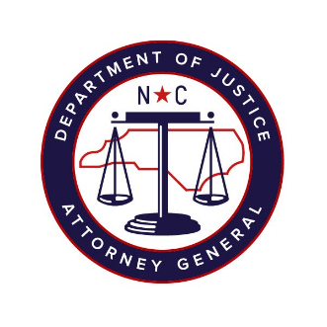
North Carolina Task Force for Racial Equity in Criminal Justice
Working Group #4
Addressing Racial Equity in Trials and Post-Conviction
Meeting #11
Date: 27 October 2020
Time: 8:00 AM EST
Chairperson: Hill, Henderson
AGENDA
- Welcome and Approval of the Minutes (5 mins)
Workgroup Chair, Henderson Hill
- Presentation & Discussion: Second Look Act Recommendation(45 mins)
Workgroup Chair, Henderson Hill
- Updates & Discussion on Task Force Straw Polls & Working Group Surveys (20 mins)
Substantive Staff Lead, Mercedes Restucha-Klem
  - Fines & Fees Recommendation (5 mins)
  - Prison Discipline Recommendations (10 mins)
  - Collateral Consequences Recommendations (5 mins)
- Next steps (5 mins)
  - Workgroup Chair, Henderson Hill

