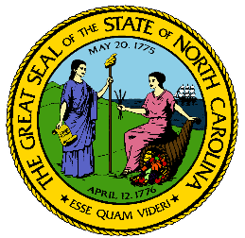
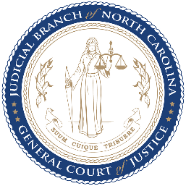

North Carolina Task Force for Racial Equity in Criminal Justice
Working Group #4
Addressing Racial Equity in Trials and Post-Conviction
Meeting #7
Date: 6 October 2020
Time: 8:00 AM EST
Chairperson: Hill, Henderson
AGENDA
- Welcome (2 mins)
  - Workgroup Chair, Henderson Hill
- Review Proposed Recommendations: Racial Equity in Juries (10 mins)
  - Substantive Staff Lead, Mercedes Restucha-Klem
- Review Proposed Recommendations: Clemency/Parole (10 mins)
  - Substantive Staff Lead, Mercedes Restucha-Klem
  - Working Group Member, Mary Pollard
- Discussion: Fines and Fees Survey Results & Draft Language (30 mins)
  - Substantive Staff Lead, Mercedes Restucha-Klem
  - Richardson Distinguished Professor of Political Science, UNC-CH, Frank Braumgartner
- Discussion: Prison Discipline Suggested Recommendations (20 mins)
  - Substantive Staff Lead, Mercedes Restucha-Klem
  - Administrative Lead/UNC Law Intern, Malia Benison
- Next steps (2 mins)
  - Workgroup Chair, Henderson Hill

