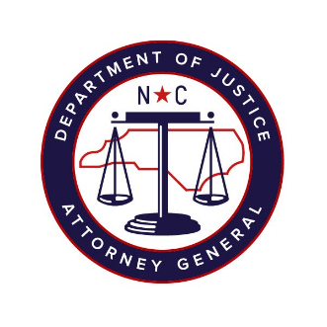

North Carolina Task Force for Racial Equity in Criminal Justice
Working Group #3
Court-Based Interventions to End Discriminatory Criminalization
Meeting #10
Date: Tuesday, November 10, 2020
Time: 4:00 pm – 5:30 pm
Chairperson: Representative Marcia Morey

AGENDA
- Marijuana Policy
  - Speaker Introductions by Steve Mange
  - Presentation by Dr. Lynn Silver, MD, MPH, FAAP, Senior Advisor, Public Health Institute (15 minutes)
  - Presentation by Beau Kilmer, Director, RAND Drug Policy Research Center; Senior Policy Researcher, RAND Corporation (15 minutes)
  - Discussion (45 minutes)

- Prosecutorial Ethics and Charging Decisions by Jim Woodall (15 minutes)

