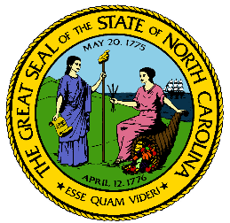
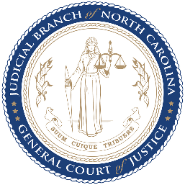
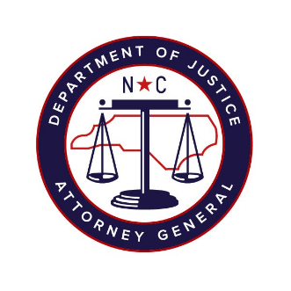

North Carolina Task Force for Racial Equity in Criminal Justice
Working Group #3
Court-Based Interventions to End Discriminatory Criminalization
Meeting #4
Date: Friday, September 11, 2020
Time: 10:30 am – 12:00 pm
Chairperson: Representative Marcia Morey

AGENDA
- Welcome and Review Meeting Goals (5 minutes)
- Workgroup Chair, Marcia Morey

- Presentation by Sonya Harper, Director of Mecklenburg County's Criminal Justice Services Department (15 minutes)

- Presentation by Caitlin Fenhagen, Director of Orange County’s Criminal Justice Resource Department (15 minutes)

- Presentation by Christie Long, Pretrial Program Supervisor, Durham County Pretrial Services (15 minutes)

- Discussion (35 minutes)

- Next Steps (5 minutes)
- Workgroup Chair, Marcia Morey

