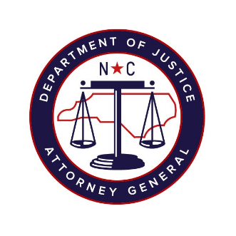

North Carolina Task Force for Racial Equity in Criminal Justice
Working Group #3
Court-Based Interventions to End Discriminatory Criminalization
Meeting #6
Date: Wednesday, September 30, 2020
Time: 4:00 pm – 5:30 pm
Chairperson: Representative Marcia Morey

AGENDA
- Welcome and Review Meeting Goals (2 minutes)
- Workgroup Chair, Marcia Morey

- Presentation by William “Billy” Lassiter, Deputy Secretary of Juvenile Justice, North Carolina Department of Public Safety (30 minutes)

- Presentation by Professor Jacquelyn “Jacqui” Greene, Assistant Professor of Public Law and Government, UNC School of Government (10 minutes)

- The Campaign for Fair Sentencing of Youth (15 minutes)
- Preston Shipp, Senior Policy Counsel
- Eric Alexander, National Advocate & Co-Director of Movement Building

- Discussion (30 minutes)

- Next Steps (5 minutes)
- Workgroup Chair, Marcia Morey

