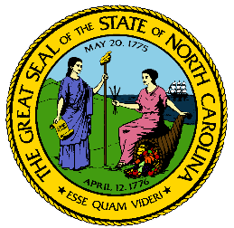
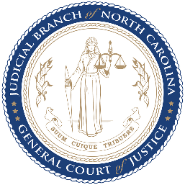
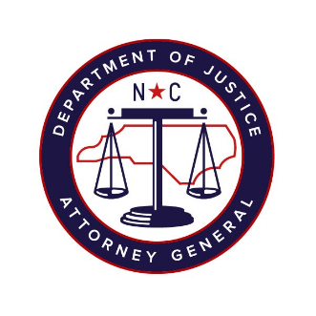

North Carolina Task Force for Racial Equity in Criminal Justice
Working Group #3
Court-Based Interventions to End Discriminatory Criminalization
Meeting #8
Date: Wednesday, October 21, 2020
Time: 4:15 pm – 6:15 pm
Chairperson: Representative Marcia Morey

AGENDA
- Presentation/Remarks by Danielle Sered, Executive Director, Common Justice (15 minutes)
Johnson
- Question & Answer/Discussion (15 minutes)

- Presentation/Remarks by Mai Fernandez, Senior Fellow, Justice Policy Institute (15 minutes)

- Question & Answer/Discussion, including Recommendation Discussion (30 minutes)

- Victim Compensation Recommendation Presentation (10 minutes)

- Discussion of Victim Compensation and Additional Victim Equity Recommendations (35 minutes)
- Angelica Wind, Executive Director, Our Voice
- Monika Johnson-Hostler, Executive Director, North Carolina Coalition Against Sexual Assault (NCCASA)

