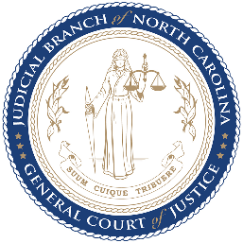
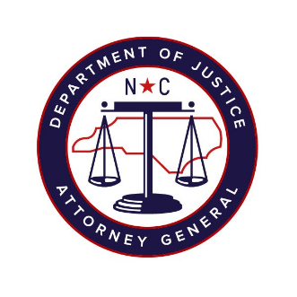

North Carolina Task Force for Racial Equity in Criminal Justice
Working Group #4
Addressing Racial Equity in Trials and Post-Conviction
Meeting #9
Date: 13 October 2020
Time: 8:00 AM EST
Chairperson: Hill, Henderson
AGENDA
- Welcome & Approval of Minutes (5 mins)
  - Workgroup Chair, Henderson Hill
- Presentation of Extreme Sentencing Recommendations: Second Look Act and Death Penalty (40 mins)
  - Invited Guests:
  - Homicide: Public Safety, Restoration and Redemption - Mecklenburg County Sheriff, Garry McFadden
  - Second Look Act - The Sentencing Project, Dr. Ashley Nellis
- Discussion: Prison Discipline Proposed Recommendations (30 mins)
Invited Guests:
  - NC Prisoners Legal Services, Dir. of Just Sentencing Project, Ben Finholt
  - NC Department of Public Safety, Commissioner of Prisons, Todd Ishee
  - NC Department of Public Safety, Assistant Commissioner of Prisons, Brandeshawn Harris
  - NC Department of Public Safety, Dir. of Prisons Healthcare & Wellness, Dr. Gary Junker
- Updated Work Schedule & Next Steps (5 mins)
  - Substantive Staff Lead, Mercedes Restucha-Klem
  - Workgroup Chair, Henderson Hill

