MODEL BAIL POLICY
Jessica Smith, UNC School of Government Criminal Justice Innovation Lab
Christopher Tyner, UNC School of Government Legal Research Associate
October 2021

This model is designed to serve as a template for judicial officials when revising local bail policies. It benefited from feedback provided by District and Superior Court Judges, Elected District Attorneys, Public Defenders and others. Additional feedback was provided by North Carolina Administrative Office of the Courts (NC AOC) legal counsel on logistical and legal issues; NC AOC did not weigh in on local policy options or best practices. Notwithstanding these contributions, any errors in this document should be attributed solely to the author.

Although this document is lengthy, many pages are devoted to appendices offering variations of tools, colloquies and other materials that can be used or discarded as appropriate depending on local policy choices. Explanatory notes and optional and alternative language add to the length of the document.

Using this document:
- Standard language appears in black font.
- Language that should be tailored to the local jurisdiction and optional language appears in italicized, blue font.
- In some instances, alternative language is provided. When provided, alternative language is set out in back-to-back brackets, e.g., [within 24 hours][within 48 hours].
- Explanatory notes to officials are highlighted in gray and are preceded by the designation: Note.
- The Table of Contents is dynamic; if you click on a page number in the Table of Contents + the Ctrl key, you will be brought to the relevant page in the model.
- Before finalizing your policy
  - Delete brackets, unused optional language, Notes, and this introductory language.
  - Update the Table of Contents. To do so, put your cursor in front of the word “Contents” below and click. A gray box will appear (see below). Click on “Update Table” and then “Update entire table” (see below)

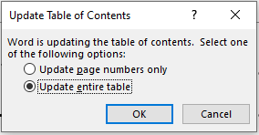

NC AOC has authorized me to indicate that it is available to answer questions about local bail policies or otherwise assist judicial officials who are using the model to revise local policies. Additionally, NC AOC legal counsel is a resource for two related topics that are not addressed in this model: taking bonds (e.g., procedures for approval of sureties and of property offered as security for a bond) and forfeiture proceedings.

Contents
I. Introductory Matters. 4
A. Name. 4
B. Authority. 4
C. Definitions. 4
D. Purpose of this Policy. 5
E. Scope. 6
II. General Principles & Guidelines. 6
A. General Principles. 6
B. Who Can Set Conditions of Release. 7
C. Remote Proceedings. 8
D. Types of Release. 9
E. Multiple Types of Release. 10
F. Timing of Pretrial Release Decisions. 11
G. Defense Counsel. 11
H. Rules of Evidence. 11
I. Recordkeeping. 11
J. Modifying Conditions of Release. 12
K. Revoking a Pretrial Release Order. 14
L. Habitual Felon, Violent Habitual Felon & Armed Habitual Felon. 15
M. Offense Committed While on Pretrial Release. 15
N. Warrantless Arrest for Violation of Conditions of Release. 15
O. Issues Regarding Identity. 16
P. Noncitizens. 17
III. General Procedure for Making Pretrial Release Decisions. 17
A. Notice before Initial Appearance 20
B. Statutory Preference for Conditions of Release Other Than Secured Bond. 20
C. Policy Preference for Non-Monetary Conditions of Release. 20
D. Secured Bond for [Certain Class 3 Misdemeanors][Low Level Misdemeanors]. 20
E. Presumption Against Secured Bond for Placement on Probation for Deferred Prosecution/Conditional Discharge. 21
F. Probation Violations. 21
G. Written Findings & Other Explanations. 22
H. Consideration of Other Factors. 24
I. Ability to Pay. 24
J. Maximum Bond Table. 27
K. Additional Restrictions & Conditions of Release. 28
L. Special Cases. 31
IV. Exceptions—Release Not Authorized. 32
A. Capital Cases. 32
B. Parole or Post-Release Supervision Violators. 32
C. Certain Fugitives. 32
D. Probationers—Interstate Compact Supervision. 32
E. Offenses Committed During Involuntary Commitment. 32
F. Military Deserters. 33
G. Impaired Driving Hold. 33
H. Hold for Violators of Health Control Measures. 33
I. Communicable Disease Testing Hold. 34
J. Hold for Conditions of Release in Certain Domestic Violence & Threat Cases. 34
K. Limited Hold–Probationer Charged With Felony. 35
L. No Bail & Limited Hold–Probation Violator with Pending Felony or Conviction Requiring Sex Offender Registration. 35
V. Exceptions—Statutory Presumptions Against Release. 36
A. Recidivist Drug Trafficking. 36
B. Recidivist Gang Offense. 37
C. Recidivist Firearm-Involved Offense. 37
D. Manufacture of Methamphetamine. 38
VI. Exceptions—Statute Requires Consideration of Certain Information. 38
A. Domestic Violence Cases. 38
B. Threat of Mass Violence Cases. 38
C. Probationer Charged With Felony. 39
D. Probation Violator with Pending Felony or Conviction Requiring Sex Offender Registration. 39
E. Manufacture of Methamphetamine Cases. 39
VII. Exceptions—Statute Requires or Prohibits Certain Conditions of Release. 40
A. Arrest after Failure to Appear (FTA). 40
B. Extradition—Fugitive Arrests. 41
C. Probationer Charged With Felony. 41
D. Infractions. 41
VIII. Judicial Review of Bail Conditions of Release. 42
A. First Appearances & Bail Review Hearings. 43
B. Detention Bond Hearings. 47
IX. Promoting Court Appearances and Responding to Non-Appearances. 49
A. Promoting Court Appearances. 50
B. Responding to Non-Appearances 50
X. Surrender. 52
A. Arrest for Surrender. 52
B. Who Can Accept Surrender. 52
C. Surrender Before a Breach. 52
D. Surrender After a Breach. 52
XI. Release after Conviction in Superior Court. 52
XII. Speedy Trial & Opportunities for Case Resolution/Diversion. 53
XIII. Review of Jail Roster. 53
XIV. Summons in Lieu of Arrest. 54
XV. Citation in Lieu of Arrest. 55
XVI. Data Collection & Reporting. 56
XVII. Training for Local Officials. 56
XVIII. Information for Judges from Other Districts. 56
XIX. Review of this Policy. 56
Appendix A: Sample Forms for Documenting Pretrial Decision Making 57
1. Alamance County Form 57
2. Forsyth County Magistrate & Judge Forms 59
3. Judicial District 2 Magistrate Form 63
4. Orange County Form 65
5. Mecklenburg County Reason Codes—For Use on AOC-CR-200 67
Appendix B: Sample Matrices—For Use with Empirical Risk Assessment Tools 68
1. Mecklenburg County Decision-Making Matrix 68
2. Buncombe County Decision-Making Matrix 69
3. Orange County Decision-Making Matrix 70
Appendix C: Sample Structured Decision-Making Tools—For Determining Conditions of Release 72
1. Judicial District 30B Tool 72
2. Judicial District 21 Tool 76
3. Judicial District 2 Tool 80
4. Alamance County Tool 84
5. Orange County Tool 88
Appendix D: Sample Oral Notice–At Initial Appearance 92
Appendix E: Sample Notice–After Initial Appearance 93
1. For Defendants with Cases Pending in the District/County 93
2. For Defendants with Cases Pending in Other Districts/Counties 95
Appendix F: Sample First Appearance and Bail Review Advisement Summary 97
Appendix G: Sample Decision Making Tool–Responding to Non-Appearances 98

BAIL POLICY FOR DISTRICT [Superior Court District ___][District Court District ___][_________ County]
EFFECTIVE [EFFECTIVE DATE]

Introductory Matters.

Name.
This policy shall be known as the “Bail Policy for [Superior Court District ___][District Court District ___][_________ County].”

Authority.
This policy is adopted pursuant to G.S. 15A-535(a), providing, in relevant part, that "the senior resident superior court judge . . . in consultation with the chief district court judge or judges . . . must devise and issue recommended policies . . . [for] determining whether, and upon what conditions, a defendant may be released before trial."

Definitions.
In addition to the terms defined in this section, the terms and definitions in G.S. 15A-531 are adopted and incorporated by reference into this policy.
- Capital Offense.
The term “capital offense” means an offense for which the death penalty is an authorized punishment. An offense is a capital offense regardless of whether the District Attorney is seeking the death penalty in the case; if the death penalty is authorized by law for the offense, it is a capital one. A pending charge of "murder" that does not specify first- or second-degree shall be deemed a "capital offense" for purposes of this policy.

- Cash.
The term “cash” means United States currency or its equivalent (cashier's check, certified check, or money order).

- Clerk.
The term “Clerk” is as defined in G.S. 15A-101(2). When this policy intends to refer only to the elected Clerk of Superior Court the following language will be used: “the Clerk of Superior Court.”

- Conditions of Release.
The term “conditions of release” refers to the conditions of release specified in G.S. 15A-534(a) (written promise to appear; unsecured bond; custody release to a person or organization agreeing to supervise the defendant; secured bond; and secured bond with house arrest and electronic monitoring (EHA)) and any other conditions (e.g., drug testing as requirement of release to pretrial services) or obligations (e.g., stay away from the victim) imposed on the defendant as part of pretrial release.

- Judicial Official.
The term “judicial official” is as defined in G.S. 15A-101(5). The use of a specific judicial official’s title in this policy, e.g., “magistrate,” is intended to refer to that official only.

- Release Order.
The term “release order” means an order entered pursuant to G.S. 15A-511(e) and G.S. 15A-521(b), which may contain conditions for a defendant's release, or any separate order that addresses a defendant’s conditions of release.

- Surety.
The term “surety” means an entity other than the defendant who executes a monetary bail bond, either personally or through an authorized agent, and who is jointly and severally liable with the defendant and all other sureties on the same bond in the event of forfeiture of bail.

- Type of Release.
The term “type of release” refers to the five conditions of release specified in G.S. 15A-534(a): written promise to appear; unsecured bond; custody release to a person or organization agreeing to supervise the defendant; secured bond; and secured bond with house arrest and electronic monitoring (EHA).

- Victim.
The term “victim” is as defined in G.S. 15A-830(a)(7).

Purpose of this Policy.
The purpose of this policy is to provide uniform guidance for the implementation of North Carolina General Statutes Chapter 15A, Article 26, and related statutes governing pretrial release of individuals charged with criminal offenses and infractions.

Scope.
This policy is applicable to all pretrial release determinations in criminal and infraction cases for which trial venue originates in or is transferred to [Superior Court District ____][District Court District ____][______County] and to probation violation and extradition proceedings heard in the [Superior Court District ____][District Court District ____][______County].

When a judicial official determines eligibility or conditions of pretrial release for a defendant charged with a crime or infraction for which trial venue lies in another [District][county], the judicial official shall make every reasonable effort to obtain information about and adhere to that [District’s][county’s] local bail policy. If the other [District’s][county’s] bail policy cannot be obtained within the time frame in which a pretrial release determination must be made, see section II.F below, the judicial official shall proceed according to this policy.

General Principles & Guidelines.

General Principles.
  - Applicability of State & Federal Law.
The provisions of this policy shall be applied in a manner consistent with state statutes and the State and federal Constitutions. In case of direct conflict, state statutes and constitutional law override provisions in this policy.

  - Liberty Is The Norm.
In United States v. Salerno, 481 U.S. 739 (1987), the United States Supreme Court instructed that “[i]n our society liberty is the norm, and detention prior to trial or without trial is the carefully limited exception.” Id. at 755. This principle is reflected in this policy.

  - Bail Cannot Be Used to Punish.
Bail cannot be used to punish. See Salerno, 481 U.S. at 746 (federal bail act passed constitutional muster in part because its purpose was held to be regulatory not punitive); see also Stack v. Boyle, 342 U.S. 1, 4 (1951) (“This traditional right to freedom before conviction permits the unhampered preparation of a defense, and serves to prevent the infliction of punishment prior to conviction. Unless this right to bail before trial is preserved, the presumption of innocence, secured only after centuries of struggle, would lose its meaning.” (internal citation omitted)).

  - Purpose of Pretrial Release.
In light of these principles, the purpose of pretrial release is to impose the least restrictive conditions of release that will reasonably assure a defendant’s appearance in court; protect against injury to any person; and prevent destruction of evidence, subornation of perjury, or intimidation of potential witnesses. See G.S. 15A-534(b).

  - Presumption of Innocence & Right to Fair Trial.
The right to pretrial release recognizes the presumption of innocence and promotes a defendant’s right to a fair trial by facilitating access to counsel, freedom of movement to secure witnesses, and the general ability to prepare a defense. See Stack v. Boyle, 342 U.S. at 4 (pretrial release permits unhampered preparation of a defense and makes the presumption of innocence meaningful).

  - Pretrial Risk.
Pretrial release may create some risk that the defendant will flee, commit another crime, or interfere with the criminal proceeding. The only way to completely eliminate these risks would be to incarcerate all persons pretrial, which is unconstitutional. These risks are codified in the legislature’s statutory presumption in favor of release on conditions of release other than secured bond. See G.S. 15A-534(b) (judicial official “must” impose a written promise, custody release or unsecured bond unless the judicial official “determines that such release will not reasonably assure the appearance of the defendant as required; will pose a danger of injury to any person; or is likely to result in destruction of evidence, subornation of perjury, or intimidation of potential witnesses.”).

  - Unaffordable Money Bail & De Facto Detentions.
While monetary bail that is higher than what a defendant currently can meet is not per se excessive, bail higher than an amount reasonably calculated to address pretrial risks is excessive and unconstitutional. Salerno, 481 U.S. at 752-54 (addressing the defendants’ Eighth Amendment Excessive Bail Clause claim).
Making pretrial release contingent upon the payment of money bail that a person cannot afford results in a de facto detention order. To be constitutional, such an order must afford the individual necessary protections, see Salerno, 481 U.S. 739 (finding the procedural protections in a federal pretrial detention statute constitutionally sufficient), as set out in this policy.

Who Can Set Conditions of Release.
- Generally.
Subject to the exceptions discussed immediately below, any judicial official is authorized to determine a defendant's eligibility for and conditions of release when presiding over a proceeding where determination or review of pretrial release is required or authorized, and at which the defendant’s conditions of release are within the subject matter jurisdiction of that judicial official. These settings generally will include, but are not limited to:
  - Initial appearances. Presided over by any judicial official (typically magistrates).
  - First appearances. Presided over by district or superior court judges (and clerks or magistrates pursuant to G.S. 15A-601(e), as modified by S.L. 2021-138).
  - Bail hearings. Presided over by judges of the trial division.

- Exceptions.
  - Capital Cases. As noted in section IV.A below only a judge can set conditions of release in a capital case.
  - 48-Hour Rule for Domestic Violence Cases. Whenever a defendant is charged with

      - an assault on, stalking, communicating a threat to, or committing a felony as provided in G.S. Chapter 14, Articles 7B (Rape & Other Sex Offenses), 8 (Assaults), 10 (Kidnapping & Abduction), or 15 (Arson & Other Burnings), upon a current or former spouse, a person with whom the defendant lives or has lived as if married, or a person with whom the defendant is or has been in a dating relationship as defined in G.S. 50B-1(b)(6);
      - domestic criminal trespass; or
      - a violation of a 50B order,

only a judge can set conditions of release within 48-hours of arrest. G.S. 15A-534.1(a). When a defendant is brought before a magistrate or clerk for an offense covered by this provision, the magistrate or clerk shall hold an initial appearance and order the defendant produced at the first available session of district or superior court to have conditions of release determined by a judge. Alternatively, if a session of court is then in progress, the magistrate or clerk shall order that the defendant immediately be brought to that session. If a judge does not act within 48 hours, the magistrate must set conditions of release. G.S. 15A-534.1(b).

A chart listing common offenses covered by the 48-hour rule is posted on the UNC School of Government’s web page for magistrates. From that site, click on the link entitled “Domestic Violence: 48-Hour Rule Offense Paper.”
  - 48-Hour Rule for Threats of Mass Violence Cases. Whenever a defendant is charged with

      - communicating a threat of mass violence on educational property, G.S. 14-277.6; or
      - communicating a threat of mass violence at a place of religious worship, G.S. 14-277.7

only a judge can set conditions of release within the first 48 hours of arrest. G.S. 15A-534.7(a). When a defendant is brought before a magistrate or clerk for a covered offense, the magistrate or clerk shall hold an initial appearance and order the defendant produced at the first available session of district or superior court to have conditions of release determined by a judge. Alternatively, if a session of court is then in progress, the magistrate or clerk shall order that the defendant immediately be brought to that session. If a judge does not act within 48 hours, the magistrate must set conditions of release. G.S. 15A-534.7(b).

  - Rebuttable Presumption Cases. As discussed in section V below, in certain drug trafficking, gang, and firearm cases a presumption that no conditions of release can address defined pretrial risks applies; when the presumption applies, only a judge can set conditions of release after certain findings.

Remote Proceedings.
Note: The statutes allow for the initial appearance and other proceedings to determine, modify, or revoke conditions of release to be conducted by an audio and video transmission in which the parties, the presiding official, and any other participants can see and hear each other. The judicial official must safeguard the constitutional rights of those persons involved in the proceedings and preserve the integrity of the judicial process. The videoconferencing application used to conduct remote proceedings must be approved by the Administrative Office of the Courts. G.S. 7A-49.6.. If your jurisdiction has such capabilities, add appropriate authorizing language that includes the relevant statutory requirements.

Types of Release.
G.S. 15A-534(a) specifies five types of release:
- written promise to appear;
- unsecured bond;
- custody release to a person or organization agreeing to supervise the defendant;
- secured bond; and
- secured bond and house arrest with electronic monitoring (EHA).
If a custody release is imposed, a defendant may elect to have a secured bond imposed instead. G.S. 15A-534(a).
Note: In counties that have pretrial release programs, the senior resident superior court judge may order that defendants who both consent to be released to the program and are accepted into the program be released to it. G.S. 15A-535(b). If your jurisdiction has such a program, specify here which judicial officials may release to pretrial services (e.g., magistrates, judges, etc.) and modify (3) above to state:
(3) custody release to a person or organization agreeing to supervise the defendant, including [name of pretrial services entity];
Note: Insert appropriate language depending on the availability of EHA equipment in your jurisdiction and your policy decision about whether EHA should be allowed as a condition of release and if so, under what circumstances. In a report available here, the UNC School of Government Criminal Justice Innovation Lab offers a summary of the research on the effectiveness of electronic monitoring, and other pretrial supervision tools. As discussed in that report, research uncovered only four studies evaluating the effectiveness of pretrial electronic monitoring, and two of the studies are quite old. Although the two newer studies suggest that the use of electronic monitoring can positively impact pretrial outcomes, only one metric in one study found the benefits of electronic monitoring to exceed 5%. Also, none of the studies accounted for the significant costs of implementing an electronic monitoring program. If you wish to address electronic monitoring in your policy, sample language that can be adapted to your needs is provided immediately below.
Note: Sample language to prohibit the use of electronic monitoring:
Secured bond with EHA shall not be imposed as a condition of release in [District ___][_______ County].
Note: Sample language when electronic monitoring is allowed:
Secured bond with EHA shall not be imposed as a condition of release unless the judicial official determines that EHA equipment is immediately available and that lack of such equipment will not result in pretrial detention. Secured bond with EHA may be imposed only in extraordinary circumstances. [Consider delineating here what would constitute extraordinary circumstances.] Only a judge may impose secured bond with EHA, and written findings are required. Notwithstanding G.S. 7A-313.1, the cost of EHA may not be passed on to the defendant.
Note: Under G.S. 7A-313.1, a county that provides EHA may collect a fee from the offender that is the lesser of the authorized jail fee or the actual cost of providing the monitoring, except that a county may not collect a fee from a defendant who is determined to be indigent and entitled to court-appointed counsel. Some have objected to the practice of imposing fees for monitoring, asserting that it leads to the same unfair and inequitable results as financial bail. See, e.g., Nat’l Ass’n of Pretrial Servc. Agencies, Standards on Pretrial Release 12 (2020), https://drive.google.com/file/d/1edS2bltwfNROieGeu1A6qKIuTfzqop92/view. To provide an option for addressing this concern, optional language is included in the paragraph above providing that the cost of EHA may not be passed on to the defendant.
Note: G.S. 15A-534(a)(4) provides that in determining conditions of release, a judicial official may “[r]equire the execution of an appearance bond in a specified amount secured by a cash deposit of the full amount of the bond, by a mortgage pursuant to G.S. 58-74-5, or by at least one solvent surety.” Additionally, G.S. 15A-531(4) provides that “[a] bail bond signed by any surety . . . is considered the same as a cash deposit for all purposes in this Article.” In light of 15A-531(4), it is not clear whether or not a judicial official who designates a secured bond as the condition of release also can designate a cash deposit as the only means to secure the bond. You may wish to address this issue expressly in your policy. Sample language prohibiting the use of cash bonds is:
When imposing a secured bond, the judicial official may not also specify the means of satisfying the bond. Thus, “cash only” or “U.S. currency only” bonds are not permissible in this [district][county] except that as required by G.S. 15A-531(4), cash bonds set in child support contempt proceedings may be satisfied only with the deposit of cash.
A condition to abstain from alcohol consumption, as verified by a continuous alcohol monitoring system (CAM), is not EHA. For imposition of CAM as a condition of release, see section III.K below.
As discussed in section IV.G below, G.S. 15A-534.2 requires, in certain circumstances, that the judicial official conducting the initial appearance impose an impaired driving hold on a defendant. An impaired driving hold is not a pretrial condition of release and a release under that hold to a sober responsible adult is not a custody release within the meaning of the pretrial release statutes.

Multiple Types of Release.
Although G.S. 15A-534(a) may be read to allow for imposition of more than one type of release (e.g., a custody release and unsecured bond), judicial officials in this [district][county][may impose only one type of release][may impose more than one type of release only if extraordinary circumstances are present and documented. [Consider delineating here what would constitute extraordinary circumstances.]]
Note: As discussed in a November 19, 2009 NC AOC memorandum addressing this issue:
[S]ome combinations of conditions will be of little effect. For example, imposing a written promise in concert with any other condition of release is superfluous, because the defendant always agrees in writing to appear as required in order to obtain release, regardless of the other conditions imposed. Other combinations may complicate pretrial release for the parties involved; combining a custody release and a secured bond may confuse the respective authority of the persons involved when the person agreeing to supervise the defendant is not the same person as the surety on the bond. Finally, at least one combination may be prohibited . . . . [Specifically, the statute provides that] when a custody release is imposed, the defendant may choose the imposition of a secured bond in lieu of the custody release; in that scenario, custody release should not be imposed in conjunction with the secured bond over the defendant’s objection.

Timing of Pretrial Release Decisions.
- Initial Appearance.
Conditions of release typically first are set at an initial appearance.
  - General Rule. The initial appearance must be held without unnecessary delay. G.S. 15A-511(a)(1), subject to the exception immediately below.
  - Exception–Unruly or Intoxicated Defendants. If a defendant is so unruly and disruptive as to impede the initial appearance, or is grossly intoxicated, unconscious, or otherwise unable to understand the procedural rights afforded by the initial appearance, the judicial official may delay the initial appearance temporarily and order the defendant temporarily confined. G.S. 15A-511(a)(3). Delay for this reason delays the entire initial appearance, not just the setting of conditions of release. When imposing a temporary confinement for this reason, the judicial official shall include in the order a clear directive to the custodian to return the defendant for completion of the initial appearance either within a reasonable time or upon a specified contingency (e.g., “when the defendant wakes up”).

Defense Counsel.
At any proceeding where conditions of release are considered for a defendant who is represented by counsel (including initial appearance, first appearance, or any subsequent bail hearing), the defendant shall be allowed to communicate fully and confidentially with counsel before and during the proceeding and defense counsel (or the defendant if unrepresented) shall be afforded the opportunity to be heard.

Note: See section VIII.A below for recommendations regarding the role of defense counsel at judicial proceedings to review bail conditions.

Rules of Evidence.
When deciding questions of pretrial release, the formal rules of evidence do not apply. G.S. 15A-534(g); G.S. 8C-1101(b). The judicial official must take into account all available evidence that the judicial official considers reliable. G.S. 15A-534(g). In proceedings where evidence is offered, the judicial official shall hear from both the prosecution and defense.

Recordkeeping.
- Form AOC-CR-200.
All orders setting or modifying conditions of release shall be entered on form AOC-CR-200 (Conditions of Release and Release Order) promulgated by the North Carolina Administrative Office of the Courts (AOC), except in emergency and disaster situations where the judicial official cannot access the form in paper or electronic format. Other forms shall be used as required by statute [and this policy].

- AOC Electronic Systems.
Except in emergency or disaster situations when the judicial official does not have access to the AOC electronic system for completing form AOC-CR-200, that form should be completed in the AOC electronic system (currently NC AWARE). When conditions of release are set or modified by a judicial official without access to the AOC electronic system, the clerk shall enter those conditions of release into the AOC electronic system as soon as reasonably possible after the order is filed. Orders or modifications entered in this manner shall be entered so as to identify both the official who entered the order and the clerk who performed the entries on that official's behalf.

- Findings—Secured Bond & Ability to Pay.
See sections III.G and III.I below for additional documentation that must be made when imposing secured bonds and assessing ability to pay.

- Grouping Charges.
  - Charges Part of a Continuous Transaction.
[Charges resulting from the same continuous transaction [including multiple probation violations] shall be grouped together with one AOC-CR-200 form used to set conditions of release for all charges [and probation violations] that are part of the same continuous transaction, even if the charges [and probation violations] are under separate file numbers.]
[A judicial official has discretion regarding whether charges resulting from the same continuous transaction [including multiple probation violations] should be grouped together with one AOC-CR-200 form used to set conditions of release for all charges [and probation violations] or whether separate forms will be used for each charge [and probation violation].]

Note: Grouping of related charges with separate file numbers currently can be executed in existing NC AOC electronic recordkeeping systems. As of the writing of this model, it was not clear whether or not the new NC AOC electronic recordkeeping system will maintain this capability. If you wish to allow grouping of charges with separate file numbers, please check with NC AOC for updates on this issue.
  - Charges Not Part of a Continuous Transaction. Charges that are not part of the same continuous transaction shall not be grouped together for purposes of determining conditions of release and a separate form AOC-CR-200 shall be used for each charge.

Modifying Conditions of Release.
- Sua Sponte by the Judicial Official.
  - Magistrates and Clerks. A magistrate or a clerk may modify their own pretrial release order at any time before the first appearance before the district court judge. G.S. 15A-534(e). [A magistrate or clerk may not modify a release order set by another magistrate or clerk][A magistrate or clerk may modify a release order set by another magistrate or clerk [specify circumstances when modification is allowed]].

Once the case is in district court, the magistrate may not set or modify conditions of release unless (1) authorized to do so by a judge; or (2) the defendant is re-arrested and brought before the magistrate for an initial appearance after the re-arrest.
  - District Court Judges. At or after a first appearance, except when the conditions of release have been reviewed by the superior court pursuant to G.S. 15A-539, a district court judge may modify a pretrial release order of a magistrate or clerk or any pretrial release order entered by the judge at any time before:

      - in a misdemeanor case tried in district court, the noting of an appeal; and
      - in a case in the original trial jurisdiction of the superior court, the binding over of the defendant to superior court after the holding or waiver of a probable cause hearing. G.S. 15A-535(e).
Note: The statute suggests that a district court judge cannot modify conditions of release after the defendant appeals for a trial de novo, and the recommended language above reflects that suggestion. However, other statutes create some confusion on this issue, suggesting that a district court judge retains authority to modify conditions of release after notice of appeal. Specifically, (1) G.S. 7A-290 provides that “[t]he original bail shall stand pending appeal, unless the judge orders bail denied, increased, or reduced”; (2) G.S. 15A-1431(e) provides that “[a]ny order of pretrial release remains in effect pending appeal by the defendant unless the judge modifies the order”; and (3) G.S. 15A-1431(f1) provides that “the judge may order any appropriate condition of pretrial release, including confinement in a local confinement facility, pending the trial de novo in superior court.” For more on this issue, see the blog post here.
  - Superior Court Judges. After a case is before the superior court, a superior court judge may modify the pretrial release order of a magistrate, clerk, or district court judge, or any such order entered by the superior court judge, at any time before the defendant’s guilt is established in superior court. G.S. 15A-534(e). See section XI below for provisions on release after conviction in superior court.

- On Motion of a Party.
  - Defendant’s Motion. G.S. 15A-538(a) provides that a defendant who is detained or objects to conditions of release imposed or allowed to stand by order of a district court judge may apply in writing to a superior court judge to modify the order.

Note: If there are issues regarding the timely calendaring of defense requests for bond modification hearings, it may be helpful to seek stakeholder input on this issue and address it in the local policy. One option is to require the hearing be calendared as promptly as possible, taking into account statutory timing constraints including but not limited to those of G.S. Chapter 15A, Article 46, the North Carolina Crime Victim’s Rights Act.
  - State’s Motion. The State may at any time apply to an appropriate district or superior court judge for modification or revocation of a release order. G.S. 15A-539(a).

- At Request of Pretrial Services.
Note: If your jurisdiction is served by a pretrial services unit, address here circumstances when and procedures for the pretrial services unit to bring issues regarding modifications of conditions of release to the attention of the District Attorney’s or other office (e.g., specific form, information required, etc.).

- For Substitution of Surety.
The power to modify an order of release includes the power to substitute sureties upon any bond. G.S. 15A-538(b). Substitution or addition of acceptable sureties may be made at the request of any obligor on a bond or, in the interests of justice, at the request of a prosecutor under G.S. 15A-539. G.S. 15A-538(b).

- Source of Money or Property to Be Posted.
On the State’s motion or sua sponte, a judge may, for good cause shown, conduct a hearing into the source of money or property to be posted for any defendant who is about to be released on a secured bond. G.S. 15A-539(b). The court may refuse to accept offered money or property as security for the bond that, because of its source, will not reasonably assure the appearance of the person as required. Id. The State shall have the burden of proving, by a preponderance of the evidence, the facts supporting the court's decision to refuse to accept the offered money or property as security for the bond. Id.

Revoking a Pretrial Release Order.
For good cause shown a judge may, at any time, revoke an order of pretrial release. G.S. 15A-534(f). [Consider including here guidance regarding what may and may not constitute good cause.] Upon application of any defendant whose order of pretrial release has been revoked, the judge shall set new conditions of release, id., in accordance with this policy including its requirements regarding written findings.
Note: If your jurisdiction is served by a pretrial services unit, address here circumstances when and procedures for the pretrial services unit to bring issues regarding revocation to the attention of the relevant official (e.g., specific form, information required, etc.).
If the defendant already has been released from custody when the judge revokes an order of pretrial release and the defendant is not before the court at the time of entry of the revocation, the judge may issue an order for the defendant's arrest. G.S. 15A-305(b)(5).
If a secured or unsecured bond has been posted for the defendant’s release and has not been ordered forfeited due to a failure to appear, the judge shall order termination of that bond pursuant to G.S. 15A-534(h)(1) to release the obligors from their obligation.

Habitual Felon, Violent Habitual Felon & Armed Habitual Felon.
Habitual felon, violent habitual felon and armed habitual felon are statuses not substantive criminal offenses. Thus, conditions of release, including a secured bond, shall not be set or recommended in an Order for Arrest issued upon return of an indictment alleging one of these statuses as its sole count. Conditions of release may be set only on the “habitualized” underlying offense. When an indictment is returned solely for one of these statuses, the State may seek to have the bond modified in the underlying principal felony upon which the status is based.

At an initial appearance after an arrest pursuant to an Order for Arrest issued upon return of an indictment alleging one of these statuses as its sole count, the judicial official conducting the initial appearance [shall release the defendant without setting new conditions as the conditions of release set in the “habitualized” underlying offense are in effect.][shall release the defendant without setting new conditions as the conditions of release set in the “habitualized” underlying offense apply, except that if a judge has ordered conditions of release in the Order for Arrest, the judicial official shall follow that directive.]

M. Offense Committed While on Pretrial Release.
G.S. 15A-534(d3) provides that when a judicial official determines conditions of release for a defendant charged with an offense while on pretrial release for another offense, the judicial official may (but is not required to) impose a secured bond double the amount of any monetary bond for the previous offense, and if there was no prior monetary bond, a secured bond of at least $1,000. This discretionary authority should be exercised only in extraordinary circumstances and the judicial official shall ensure that the new condition appropriately contemplates the circumstances and conduct associated with the new offense.
Example: A defendant on pretrial release for burglary with a $20,000 secured bond is arrested for the new offense of misdemeanor littering. Applying the statutory provision would result in a $40,000 secured bond for misdemeanor littering. Given the conduct associated with the new offense, the discretionary authority under the statute should not be applied.
If the new arrest or charge is for an offense alleged to have been committed before the offense for which the defendant already is on pretrial release, the provisions of G.S. 15A-534(d3) shall not be applied.

Warrantless Arrest for Violation of Conditions of Release.
Under G.S. 15A-401(b)(2)f, a law enforcement officer may arrest a defendant without a warrant for violation of conditions of release. When a defendant appears before a judicial official after such an arrest, the judicial official shall first determine whether or not a valid condition of release was violated. If there is no probable cause to believe that a valid condition of release was violated, the judicial official shall order the defendant released on the existing release order. If there is probable cause to believe that a valid condition of release was violated, the judicial official shall determine the defendant’s eligibility for and conditions of release as set out in this policy and, if new conditions of release are warranted, shall enter a new release order.
When setting new conditions of release after a warrantless arrest for a violation of conditions of release, the judicial official shall not issue new criminal process (such as a Magistrate’s Order) unless the conduct also constitutes an independent, new substantive criminal offense (such as communicating threats or trespass). Judicial officials should not charge “violation of a court order” under G.S. 14-226.1 for violations of release orders. By its terms that statute is limited to violations of orders issued “for the purpose of maintaining or restoring public safety and public order, or to afford protection for lives or property during times of a public crisis, disaster, riot, catastrophe, or when such condition is imminent, or for the purpose of preventing and abating disorderly conduct as defined in G.S. 14-288.4.” The North Carolina Administrative Office of the Courts advises that this provision applies only to orders issued in the context of civil disturbances. If the judicial official decides to pursue contempt for violation of the prior release order, the judicial official should initiate separate proceedings for contempt via show cause order, AOC-CR-219, and should not issue criminal process charging “violation of court order.”

Issues Regarding Identity.
- Defendants Who Refuse to Identify Themselves.
Without knowing a defendant’s identity, a judicial official cannot determine, among other things, whether the defendant has a record or has previously failed to appear. When a defendant refuses to self-identify, the following procedures shall apply:
- A judicial official [may] [shall] delay the initial appearance so that a law enforcement officer can investigate the defendant’s identity.

Note: If a person (1) is charged with an offense involving impaired driving, as defined in G.S. 20-4.01(24a), or driving while license revoked when the revocation is for an impaired driving revocation, as defined in G.S. 20-28.2, and (2) cannot be identified by a valid form of identification, then the arresting officer must have the person fingerprinted and photographed. G.S. 15A-502(a6). This requirement may result in identification of the person without further investigation.
- If a defendant can be adequately identified by the investigation, the judicial official shall set conditions of release as provided in this policy, taking into account the defendant’s failure to self-identify.
- If the investigation is unsuccessful or cannot be done within [specify time period e.g., “8 hours”], the judicial official shall proceed with the initial appearance. A judicial official shall not allow an indefinite delay of the initial appearance for an investigation into the defendant’s identity.
- If the investigation is not feasible or is unsuccessful, [specify conditions of release to be set for defendants who refuse to identify themselves][the judicial official must consider the defendant’s refusal to self-identify to be evidence of flight risk]. Additionally, the judicial official shall include as a condition of pretrial release that either the defendant adequately self-identify or that there is an adequate identification of the defendant. Any reasonable form of identification may meet this condition, even if it is not a written form of identification—for example, a responsible member of the community may vouch for the defendant’s identity. Because individuals may lawfully be in the country without a United States government-issued form of identification, a judicial official may not require a defendant to produce such identification as a condition of release.

Note: G.S. 15A-534(a) provides that if a defendant is required to provide fingerprints or a DNA sample and the fingerprints or DNA sample have not yet been taken or the defendant has refused to provide those items, the judicial official shall make the collection of the fingerprints or DNA sample a condition of pretrial release. The fingerprint requirement may facilitate identification.
- If a defendant fails to self-identify or provided a false or fictitious name to a law enforcement officer or judicial official in connection with the current proceeding, [this conduct constitutes a valid reason for setting a financial condition of release in excess of the amounts listed in the Maximum Bond Table in section III.J.] [the condition imposed shall be a secured bond and this conduct constitutes a valid reason for setting a financial condition of release in excess of the amounts listed in the Maximum Bond Table in section III.J.]

Noncitizens.
Detainer requests from the United States Immigrations and Customs Enforcement (ICE) are not a basis for delaying the initial appearance or denying conditions of release. If a judicial official is aware of an ICE detainer for a defendant, the judicial official shall determine conditions of release pursuant to this policy. The judicial official may note the existence of the detainer on the release order but shall not impose a condition that the defendant be held subject to the detainer.

General Procedure for Making Pretrial Release Decisions.
Note: This core section of the bail policy should set out the general rules for making pretrial release decisions, subject to the statutory exceptions discussed in sections IV through VII below. These rules will apply whenever conditions of release are being set or modified by a judicial official (magistrate, clerk, judge).
Note: Historically, local bail policies have set out general statutory guidance and included a bond table. This practice may have contributed to an overreliance on secured bonds, notwithstanding the statutory requirement in G.S. 15A-534(b) that the judicial official must impose a type of release other than a secured bond unless the official determines that those types of release will not reasonably assure the appearance of the defendant as required; will pose a danger of injury to any person; or are likely to result in destruction of evidence, subornation of perjury, or intimidation of potential witnesses. Additionally, other concerns have been raised about the use of a bond table as the core tool for setting conditions of release. First, bond tables typically recommend money bond amounts for local ordinance violations and other Class 3 misdemeanors. As such, they allow for the imposition of money bonds and create the potential for wealth-based detentions for individuals who could not receive any active time even if convicted. Second, no evidence exists supporting the effectiveness of bond tables in assessing or managing pretrial risk. Third, the bond table only looks at one factor—the punishment level of the charged offense—when setting conditions of release. Setting bail in this manner is inconsistent with state law, which requires the judicial official to take into account a broad range of factors when setting conditions of release including the nature and circumstances of the offense charged; the weight of the evidence; the defendant’s family ties, employment, financial resources, character, and mental condition; whether the defendant is intoxicated such that he or she would be endangered by being released without supervision; the length of the defendant’s residence in the community; the defendant’s record of conviction; the defendant’s history of flight to avoid prosecution or failure to appear at court proceedings; and any other evidence relevant to the issue of pretrial release. G.S. 15A-534(c). Fourth, bond tables do not account for a person’s ability to pay and thus can result in detention bonds when that result was not intended by the judicial official. And fifth, national best practices recommend against the use of bond tables. Amer. Bar Ass’n, ABA Standards for Criminal Justice: Pretrial Release, Standard 10-5.3(e) (3d ed. 2007) ("Financial conditions should be the result of an individualized decision taking into account the special circumstances of each defendant, the defendant's ability to meet the financial conditions and the defendant's flight risk, and should never be set by reference to a predetermined schedule of amounts fixed according to the nature of the charge.").
Note: For those wishing to provide alternatives to general statements and/or bond tables, two options that have been employed in North Carolina are: (1) empirical pretrial risk assessment tools and (2) non-empirical structured decision-making tools. (Note that even when such tools are used for the “garden variety” case, the specific statutory exceptions set out in sections IV through VII still apply and must override operation of those tools.)
Note: For those wishing to explore use of empirical pretrial risk assessment tools, the following publication provides a useful primer: Sarah L. Desmarais & Evan M. Lowder, Pretrial Risk Assessment Tools: A Primer For Judges, Prosecutors, And Defense Attorneys (2019). As of the writing of this model policy, Mecklenburg, Buncombe, and Orange counties were using empirical pretrial risk assessment tools. Mecklenburg and Buncombe counties use the Public Safety Assessment (sometimes called the PSA). Orange County uses a modified version of the Virginia Risk Assessment Instrument Revised (VPRAI-R). Generally, these tools use a set of inputs that have been tested for predictability to calculate one or more risk levels for a defendant. Those risk levels then are used with a locally-created matrix to recommend conditions of release, with intensity of supervision increasing as a defendant’s risk levels increase. If you are interested in such a tool, you may find it helpful to reach out to officials in those jurisdictions to learn more about their tools and experience with them. Sample matrices are included in Appendix B. Note that use of an empirical tool requires, among other things, resources in terms of staff to research the “inputs” for the risk assessment and execute and document the assessment itself. In Mecklenburg, Buncombe and Orange counties, this work is executed by county-funded pretrial service units. Note also that in at least one North Carolina jurisdiction that uses an empirical risk assessment tool, stakeholders have asserted that it does not sufficiently address intimate partner violence lethality. More generally, it is important to note there is a national debate regarding whether the use of empirical pretrial risk assessment tools is appropriate. Compare The Use of Pretrial “Risk Assessment” Instruments: A Shared Statement of Civil Rights Concerns (opposing the use of empirical risk assessment instruments), with Open Letter to the Pretrial Justice Institute (arguing that opposition to risk assessment instruments fails to account for the state of the scientific evidence). Additionally, the Civil Rights Corps, which is leading much of the national bail litigation, challenges the appropriateness and legitimacy of empirical pretrial risk assessment tools, creating some litigation risk associated with their use.
Note: In 2019 and 2020, several North Carolina jurisdictions adopted locally developed, non-empirical structured decision-making tools to guide pretrial decision-making and better align it with state law, either at the magistrate level, judge level or both. In January 2019, Judicial District 30B was the first jurisdiction to do so. In January 2020, Judicial District 21 (Forsyth) and Judicial District 2 (Washington, Beaufort, Martin, Tyrrell, Hyde) adopted their own version of that tool. In July 2020, Alamance County adopted a similar tool, as a result of a federal class action lawsuit challenging the constitutionality of the local money-based bail system. And in October 2020, Orange County adopted a similar tool. All of these tools are included as samples in Appendix C. Unlike empirical tools, these tools require no new funding resources to develop and implement. The Criminal Justice Innovation Lab worked with these jurisdictions, and has or is executing empirical evaluations of their effectiveness. The Lab’s reports, which to date show that the tools are achieving their objectives, are available on the Lab’s website here.
Note: A jurisdiction may opt to include both tools. For example, in Orange County a non-empirical structured decision-making tool is used at the magistrate level and an empirical tool is used at the judge level.
Note: If you opt to use an empirical pretrial risk assessment tool with a matrix or a non-empirical structured decision-making tool to inform pretrial decisions, include relevant language here requiring the use of those tools.
Note: For example, to require use of a non-empirical decision-making tool:
Unless an exception listed in sections IV through VII applies, in making pretrial release decisions, [magistrates][judicial officials] shall follow the [District ___][_____ County] structured decision-making tool included in this Policy as Appendix [appendix number] and shall document their decisions on [name form].
Note: To require use of an empirical pretrial risk assessment tool, add language addressing:
- the requirement that pretrial services complete the risk assessment using the specified tool (including specifying which defendants are subject to this requirement and how other defendants are to be handled);
- the form and timing for transmission of that assessment to the judge, district attorney and public defender or defense counsel before the first appearance, bail review hearing, or bond hearing;
- all content that should be included in the report from pretrial services (e.g., criminal history; risk assessment; release recommendation; etc.);
- use of the locally developed decision-making matrix by judicial officials when determining conditions of release (this matrix should be included in the policy as an Appendix; sample matrices are included in this model as Appendix B);
- discretion to deviate from recommendations; and
- supremacy of any specific statutory rules (see sections IV through VII below).
Note: If you decide against adopting some type of empirical or non-empirical tool and prefer to offer only broad narrative guidance in your local policy, consider addressing the following issues, though some, like the statutory preference for conditions of release other than secured bond should be included in all policies. Even if you opt for an empirical or non-empirical pretrial tool, you may wish to consider including some or all of this content.

Notice before Initial Appearance
Note: The following provision comes from the Alamance Policy adopted in connection with the Consent Order in the federal court bail litigation. The notice required in that county is included in Appendix D to this model.
Prior to conducting an initial appearance, the judicial official shall give the defendant oral notice of the general nature of the initial appearance as provided in G.S. 15A-511. [Specify appendix] provides an oral notice that [shall][may] be used to do this.

Statutory Preference for Conditions of Release Other Than Secured Bond.
Under state law, a judicial official must impose a written promise, unsecured bond or custody release unless the judicial official determines that such release will not reasonably assure the appearance of the defendant as required; will pose a danger of injury to any person; or is likely to result in destruction of evidence, subornation of perjury, or intimidation of potential witnesses. G.S. 15A-534(b). This mandate applies to all offenses. If release on a written promise, unsecured bond or custody release will not reasonably assure appearance, will pose a danger of injury to any person, or is likely to result in destruction of evidence, subornation of perjury or intimidation of potential witnesses, the judicial official shall impose a secured bond. Id.

Policy Preference for Non-Monetary Conditions of Release.
When setting conditions of release, this policy requires a preference for non-financial conditions of release (written promise and custody release) over financial conditions (unsecured and secured bond).

Secured Bond for [Certain Class 3 Misdemeanors][Low Level Misdemeanors].
Note: This section provides optional language to limit the use of secured bonds in certain misdemeanor cases. The optional language regarding Class 3 misdemeanors is modeled on the Alamance County policy, with the addition of alternatives that can be tailored to your policy objectives.
If the highest charged offense is a [Class 3 misdemeanor and, based on the defendant’s prior record level, the defendant cannot be sentenced to active imprisonment upon conviction][specify relevant misdemeanor classes e.g., Class 2 or 3 misdemeanor; Class 1, 2 or 3 misdemeanor], a secured bond [is strongly discouraged] [[is strongly discouraged][shall not be imposed] absent clear and convincing evidence that the defendant presents a danger of physical injury to any person or intimidation of a witness].

Presumption Against Secured Bond for Placement on Probation for Deferred Prosecution/Conditional Discharge.
A court order placing a defendant on probation pursuant to a deferred prosecution, G.S. 15A-1341, or a conditional discharge, see, e.g., G.S. 15A-1341(a4); G.S. 90-96, terminates the obligation of any bond previously posted, secured or unsecured. G.S. 15A-534(h)(5). Upon entry of such an order, the court shall enter a new release order specifying the conditions of release governing any required appearances during the deferral probation. The court shall not impose a secured bond unless the evidence conclusively shows that a defendant is unlikely to appear before the court as required during the deferral, is likely to cause injury to persons, or is likely to interfere with the criminal proceeding.

Probation Violations.
Note: Unless a specific statute requires otherwise, see sections IV through VII below, a person arrested for a probation violation is entitled to have conditions of release set pursuant to G.S. 15A-534. G.S. 15A-1345(b). Thus, the procedure for setting conditions of release in “garden-variety” probation violation matters follows the District’s/County’s general bail policy. However, you may want to address here whether the pretrial release decision should be made with respect to the underlying offense, with respect to the nature of the probation violation, or with respect to both these and other matters. Some sample language is provided below for both scenarios, that you can use or adapt as appropriate.
Note: In the current wave of bail litigation, at least one federal case has held that it is unconstitutional to set secured bonds in orders for arrests for probation violations without making certain findings or giving the arrestee an opportunity to be heard or present evidence regarding ability to pay or alternative conditions of release. McNeil v. Cmty. Prob. Servs., LLC, No. 1:18-CV-00033, 2019 WL 633012, at *15 (M.D. Tenn. Feb. 14, 2019), aff'd, 945 F.3d 991 (6th Cir. 2019) (“the system of setting secured bail . . . is constitutionally deficient in failing to provide notice and an opportunity for the arrestee to be heard, and for failing to provide oral or written findings regarding the arrestee's ability to pay, alternative conditions of release, and the need for pre-revocation detention). Although this case is not binding in North Carolina, you may wish to consider this case in developing provisions regarding bail for probationers and provide guidance to judicial officials when issuing Orders for Arrest for probation violations. If so, add appropriate language here.
Note: Sample language for when you intend for conditions of release to be primarily determined based on the nature of the violation:
Unless a specific statute exists requiring other conditions of release or procedures, see sections IV through VII below, conditions of release for probation violations shall be based primarily on the nature of the probation violation, not the offense class of the underlying offense, and the following shall apply: The condition of release for a technical violation shall be a written promise to appear, except that allegations of multiple technical violations may be sufficient grounds to deviate from this directive. As used here the term “technical violation” refers to a violation other than absconding or conduct that constitutes a new criminal offense. For violations that constitute criminal offenses, conditions shall be set as provided in this policy, using the class level assigned to the conduct that constitutes the violation as the relevant reference, as needed. When the allegation is absconding, as defined by G.S. 15A-1343(b)(3a) and interpreting cases, conditions shall be set as provided in this policy, except the allegation of absconding shall be prima facie evidence that types of release other than secured bond will not reasonably assure the defendant’s appearance. When determining conditions of release in probation violation cases, the judicial official shall consider the number of alleged violations, prior violations, and the nature of the offense of conviction, and these factors, along with an allegation of absconding, may be deemed exceptional circumstances warranting deviation from the amounts listed in the Maximum Bond Table below.
Note: Language for when you intend for conditions of release to be primarily determined based on the underlying charge:
Unless a specific statute exists requiring other conditions of release or procedures, see sections IV through VII below, the following shall apply: Conditions of release in probation violation cases shall be based primarily on the lead offense of conviction on the judgment in which probation was imposed. An allegation of absconding, as defined by G.S. 15A-1343(b)(3a) and interpreting cases, shall be prima facie evidence that types of release other than secured bond will not reasonably assure the defendant’s appearance. The judicial official shall consider the number of alleged violations, prior violations, and whether the alleged violation(s) include(s) absconding or commission of a new criminal offense, and these factors may be deemed exceptional circumstances warranting deviation from the amounts listed in the Maximum Bond Table below.

Written Findings & Other Explanations.
        - For Secured Bond.
Note: G.S. 15A-534(b) provides that when a secured bond (with or without EHA) is imposed, the judicial official “must record the reasons for so doing in writing to the extent provided in the policies or requirements issued by the senior resident superior court judge.” G.S. 15A-535(a) in turn provides that the senior resident may include in the local bail policy, or separate order, a requirement that a judicial official who imposes a secured bond must record the reasons for doing so in writing. Requiring that reasons be given for imposing a secured bond may help to ensure fidelity to the relevant constitutional and statutory rules and the local bail policy. Additionally, principles emerging from bail litigation suggest that certain written findings should be made in connection with pretrial decisions. The language below may be used to require written findings when a secured bond is imposed. This language is adapted from the Alamance County local bail policy that was enacted in connection with the Consent Order in the federal class action bail litigation. To require a written explanation for the imposition of any bond, modify the language below to include unsecured bonds.
When a secured bond is imposed, the judicial official shall make written findings. A form for recording these findings is provided in Appendix [designate relevant Appendix]. The findings shall include:
a. A determination that a secured bond is required by
(i) A specific statute; or
(ii) An order of a superior tribunal in the case in question; or
b. (i) Individualized findings, based on clear and convincing evidence, supporting the judicial official's determination that a secured bond is warranted under G.S. 15A-534(b); and
(ii) A finding, based on clear and convincing evidence, that either
(1) The defendant is able to pay the bond imposed; or
(2) The defendant appears to be unable to pay the bond imposed or there is insufficient information to determine ability to pay but that pretrial detention is necessary because no less restrictive type of release will reasonably assure the appearance of the defendant as required; address the danger of injury to any person; or prevent destruction of evidence, subornation of perjury, or intimidation of potential witnesses within the meaning of G.S. 15A-534(b).
Note: For the form being used in Alamance County to record reasons for imposing a secured bond and the ability to pay determination, see Appendix A, item 1. For forms being used in other North Carolina jurisdictions to record reasons for imposing secured bonds, see Appendix A, items 2-4. An alternative approach for recording reasons for imposing a secured bond is to use the “Additional Information” box on form AOC-CR-200, possibly with a coded list of reasons. This approach is used in Mecklenburg County; that jurisdiction’s list of explanation codes is included in Appendix A, item 5. Ability to pay determinations are discussed in section III.I below.

Note: When a defendant is unable to pay a secured bond, the bond acts as a detention bond, triggering the defendant’s rights to the procedural protections addressed in section VIII.B (Detention Bond Hearings) below. To clarify this issue in your policy, add the following language:

When a secured bond operates to detain, the defendant must be afforded the additional procedural protections set forth in section VIII.B below.

        - When Release Is Not Authorized.
Note: As discussed in section IV below, release is not authorized in certain cases. To require written findings in these scenarios, the following language may be used:

Whenever bail is denied, the judicial official shall document in writing why release is unauthorized. [That finding must cite to the relevant section of this policy e.g., “Military deserter per section IV.F of Local Bail Policy.”] [That finding must cite to the specific statute authorizing or requiring denial of bail.]

        - Oral Explanations in Other Cases.
Note: To require an oral explanation of reasons in other cases, add the following language:

When written findings are not required, the judicial official shall inform the parties orally of the judicial official’s pretrial decision and the reasons for it.

Consideration of Other Factors.
Note: G.S. 15A-534(c) requires consideration of listed factors when setting conditions of release. If your jurisdiction is using an empirical risk assessment tool or a non-empirical structured decision-making tool, modify the language presented here to indicate that these factors should be considered in deciding whether to adhere to or deviate from the conditions of release recommended by those tools and/or pretrial services.
In determining which conditions of release to impose, the judicial official must, on the basis of available information, take into account the nature and circumstances of the offense charged; the weight of the evidence against the defendant; the defendant’s family ties, employment, financial resources, character, and mental condition; whether the defendant is intoxicated to such a degree that the defendant would be endangered by being released without supervision; the length of the defendant’s residence in the community; the defendant’s record of convictions; the defendant’s history of flight to avoid prosecution or failure to appear at court proceedings; and any other evidence relevant to the issue of pretrial release. G.S. 15A-534(c). [The mere fact that the defendant is homeless and not a resident of the local community is not, by itself, a reason to impose a secured bond.] Additionally, whenever a secured or unsecured bond is set, ability to pay must be considered.
Section VI below discusses situations where specific additional information must be considered.

Ability to Pay.
Note: When a secured appearance bond is set, it may unintentionally result in detention if the defendant’s ability to pay is not considered. For example, while a business executive might easily be able to pay a $2,000 secured bond; the same may not be true for someone who works part-time at a local fast-food restaurant. Additionally, a policy’s failure to account for ability to pay may open it to a constitutional challenge. In fact, emerging principles from bail litigation suggest that ability to pay must be considered when setting conditions of release. The content presented here is adapted from the Alamance County federal court Consent Order. It is not the only approach that can be used to address this issue. A jurisdiction may wish to, for example, require a structured, detailed inquiry into an individual’s, income, expenses, assets, and liabilities on a locally created form or computer application. This model focuses on the Alamance approach for two reasons. First, because the core provisions of the Alamance model are included in the federal court Consent Order, it is a model that the parties and the court agreed addressed the constitutional claims raised. Second, although the NC Affidavit of Indigency requires detailed information about income, expenses, assets and liabilities, judicial officials have reported that the Affidavit of Indigency is not optimal for assessing indigency, in part because it is difficult and time consuming to obtain the required information. The Alamance model by contrast applies a series of presumptions, avoiding the type of detailed inquiry included on the Affidavit of Indigency. Judicial officials are, of course, free to adopt some other local tool that may be better suited to local concerns and interests. Although the content that follows is drawn from the Alamance County ability to pay rules, all of the listed presumptions regarding inability to pay any bond (except for the one regarding juveniles), also are included in the federal court Consent Order resolving the Harris County, Texas bail litigation. See ODonnell v. Harris County, Consent Decree, 22 (No. 16-cv-01414) (Nov. 21, 2019).
- Generally.
When determining the type of condition to impose and the amount of any secured or unsecured bond, the judicial official shall make an individualized assessment of the defendant’s ability to pay. Ability to pay must be determined as to the total amount of the bond, not a percentage that might be due to a commercial surety.
When assessing ability to pay, a judicial official may consider only a defendant’s income or assets; income or assets of the defendant’s family and friends may not be considered, except that monthly income of family members (but not friends or roommates) may be considered with respect to federal poverty guidelines, discussed below.
To assess ability to pay, the judicial official may ask the defendant to complete and be sworn or affirmed to an Affidavit of Indigency (AOC-CR-226). If this procedure is followed, the judicial official shall explain that the purpose of requested information is to determine conditions of release, shall mark the Affidavit “submitted for bail decision, only,” and shall not consider information in the Affidavit for any other purposes.
- Rebuttable Presumptions.
- That Defendant is Unable to Pay Any Amount of Secured Bond. The following circumstances create a rebuttable presumption that the defendant cannot afford any amount of secured bond:

  - The defendant is eligible for appointment of counsel.
  - The defendant is or has been homeless in the last 6 months.
  - The defendant’s household income is at or below 200% of federal poverty guidelines (see Table 1 below).
  - The defendant is a juvenile under the age of 18.
  - The defendant is a full-time student.
  - The defendant was incarcerated on an active sentence within the last six months.
  - The defendant resides in mental health/other treatment program, or has resided there in last 6 months.
  - The defendant is or has dependents eligible for any federal or state public assistance based on financial hardship (e.g. Social Security disability income, food stamps, etc.).
Note: The Alamance County Consent Order includes all of these presumptions, except for the one pertaining to juveniles.
Table 1: [2020] [replace with 2021 when available] Federal Poverty Guidelines
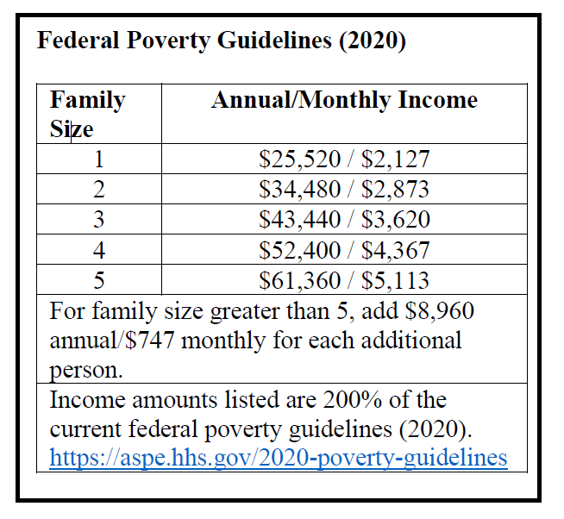
- Regarding Amount of Secured Bond. There is a rebuttable presumption that a person cannot pay any secured bond amount that exceeds [insert a percentage of the defendant’s monthly income; in the Alamance Consent Order, this provision states: “2% of his/her monthly income”].

- Rebutting the Presumptions.
Note: The Alamance County policy, adopted in accordance with the Consent Order in the federal class action bail litigation, provides that only four types of evidence, listed below, can be considered to rebut the presumptions just stated. The content that follows comes from that Order and the county’s revised local policy.

The presumptions listed above may be rebutted only with evidence that:
  - Income. The defendant’s monthly income is greater than 200% of poverty level. If so, defendant is presumed able to pay a total secured bond in the amount of 2% percent of monthly income.
  - Assets. The defendant has liquid assets of at least $3,000. If so, the judicial official shall determine how much the defendant can pay without unreasonable impairment of the defendant’s ability to satisfy other financial obligations e.g., housing, food, medical, care of dependents, etc. Liquid assets refer to assets that are readily convertible into cash, such as money in bank accounts, marketable securities, notes, or accounts receivable; personal property such as vehicles or jewelry are not liquid assets for purposes of the ability to pay determination.
  - Equity. The defendant has sufficient equity in real property [Insert a formula here; the formula used in Alamance County is as follows:

The defendant has ownership of real property with available equity in the amount of (A) $__________, of which the defendant’s ownership share is (B) ____%, for a value of (C) $_________ (A*B). Eighty percent (80%) of the defendant’s share $__________ (C* 0.80), is deemed available for the purpose of securing bond.

  - Unsolicited Statement. The defendant has made an unsolicited statement to a district or superior court judge that the defendant can satisfy a specific secured bond amount without unreasonable impairment of ability to satisfy other financial obligations.

- Determining Ability to Pay When Multiple Bonds Are Imposed.
As discussed in section II.I.4 above, in certain circumstances more than one bond may be imposed on a single defendant at one proceeding. In these circumstances, ability to pay must be assessed as to the total financial obligations imposed at one time.

- Setting Bond Above Ability to Pay/When Ability to Pay Cannot Be Determined.
A judicial official may set a secured bond in excess of a defendant’s assessed ability to pay and when the information is insufficient to determine ability to pay only if:

- the bond is statutorily required (see section VII below) or required by order of a superior tribunal in the case in question; or
- the State establishes, by clear and convincing evidence, that no less-restrictive type of release will reasonably assure the appearance of the defendant as required; address the danger of injury to any person; or prevent destruction of evidence, subornation of perjury, or intimidation of potential witnesses within the meaning of G.S. 15A-534(b).
As noted in section III.G, written findings must be made when setting a secured bond.
- Infractions.
See section VII.D for the ability to pay rule that applies to out-of-state residents charged with infractions.

- Documentation.
A [magistrate’s][judicial official’s] ability to pay determination shall be documented in writing on [name form].

Note: See Appendix A, item 1 for a sample form.

Maximum Bond Table.
Note: As discussed in the Note under section III above, use of a bond table as the primary device for assessing conditions of release is not advised. However, if your policy allows for imposition of financial conditions of release, you may wish to include a maximum bond table in the policy to provide some “guardrails” on decision-making. Should you wish to do so, you also may wish to allow for deviations above the listed maximum bond amounts in extraordinary circumstances and when those reasons are documented. Should you opt to include a maximum bond table in your policy, consider including some or all of the clarifying language included immediately below. When considering whether to include a maximum bond table, please note that advocates who oppose money bail and are involved in the North Carolina litigation also oppose use of maximum bond tables, asserting, in part, that they serve as an anchor encouraging higher bonds.
The Maximum Bond Table includes maximum bond amounts that may be imposed for various classes of offenses. This table should not be construed as guidance that a secured bond should be imposed or that the listed amounts should be imposed. Judicial officials may exercise discretion to impose a bond in excess of the listed maximum bond amounts, but reasons for doing so must be documented in writing on [name form].
    - Habitual Felon Charges.
For purposes of applying the Maximum Bond Table to defendants charged with any type of habitual felon status, the charge level of the offense is the “habitualized” charge level of the underlying felony charge.

    - Probation Violations.
[When using the Maximum Bond Table to set a bond in a probation violation case, the relevant maximum bond amount is the one associated with the lead offense of conviction on the judgment in which probation was imposed.][When using the Maximum Bond Table to set a bond in a probation violation case, the relevant maximum bond amount is the one associated with the new charge that constitutes the probation violation. For instructions on setting conditions of release when the probation violation is not a new criminal offense, see section III.F.]
Note: Insert your maximum bond table here or include it as an appendix to your policy with a cross reference here. Many jurisdictions include separate tables for drug trafficking, other felonies, and misdemeanors. Sample maximum bond tables are included in the materials in Appendix C.

Additional Restrictions & Conditions of Release.
      - DNA & Fingerprints. If the defendant is required to provide fingerprints pursuant to G.S. 15A-502(a1), (a2), (a4), or (a6), or a DNA sample pursuant to G.S. 15A-266.3A or G.S. 15A-266.4, and the fingerprints or DNA sample have not yet been taken or the defendant has refused to provide the fingerprints or DNA sample, the judicial official shall make the collection of the fingerprints or DNA sample a condition of pretrial release. G.S. 15A-534(a).

      - Restrictions on Place of Abode, Contact with Victim, Use of CAM, Etc.
        - Permissible in All Cases. In all cases, in addition to types of release specified in 15A-534(a) (written promise to appear; unsecured bond; custody release to a person or organization agreeing to supervise the defendant; secured bond; and secured bond and house arrest with EHA), the judicial official may place restrictions on the travel, associations, conduct, or place of abode of the defendant as conditions of release. G.S. 15A-534(a). The judicial official also may include as a condition of pretrial release that the defendant abstain from alcohol consumption, as verified by the use of a continuous alcohol monitoring system, of a type approved by the Division of Adult Correction and Juvenile Justice of the Department of Public Safety, and that any violation of this condition be reported by the monitoring provider to the district attorney. G.S. 15A-534(a). When imposing CAM in non-domestic violence cases, the judicial official shall use form AOC-CR-242; domestic violence cases are discussed immediately below.

Any restrictions imposed shall be reasonable and related to the purpose of pretrial release. Restrictions shall not be used as punishment.
b. Domestic Violence Cases. In domestic violence cases subject to the 48-hour rule, see section IV.J below, the following additional conditions of release may be imposed:
- That the defendant stay away from the home, school, business or place of employment of the alleged victim.
- That the defendant refrain from assaulting, beating, molesting, or wounding the alleged victim.
- That the defendant refrain from removing, damaging or injuring specifically identified property.
- That the defendant may visit the defendant’s child or children at times and places provided by the terms of any existing order entered by a judge.
- That the defendant abstain from alcohol consumption, as verified by the use of a continuous alcohol monitoring system, of a type approved by the Division of Adult Correction and Juvenile Justice of the Department of Public Safety, and that any violation of this condition be reported by the monitoring provider to the district attorney.
G.S. 15A-534.1(a)(2). Form AOC-CR-630 shall be used when imposing these additional conditions of release.
c. Cases Involving Certain Child Victims. In all cases where the defendant is charged with
(1) felonious or misdemeanor child abuse;
(2) taking indecent liberties with a minor in violation of G.S. 14-202.1;
(3) rape or any other sex offense in violation of G.S. Article 7B, Chapter 14, against a minor victim, incest with a minor in violation of G.S. 14-178, kidnapping, abduction, or felonious restraint involving a minor victim;
(4) a violation of G.S. 14-320.1 (transporting child outside the State with intent to violate custody order);
(5) assault or any other crime of violence against a minor victim, or with communicating a threat against a minor victim,

the judicial official shall impose the following additional conditions of release:
  - That the defendant stay away from the home, temporary residence, school, business, or place of employment of the alleged victim.
  - That the defendant refrain from communicating or attempting to communicate, directly or indirectly, with the victim, except under circumstances specified in an order entered by a judge with knowledge of the pending charges.
  - That the defendant refrain from assaulting, beating, intimidating, stalking, threatening, or harming the alleged victim.
G.S. 15A-534.4(a). Upon request of the defendant, the judicial official may waive one or more of these conditions of release if the judicial official makes written findings of fact that it is not in the best interest of the alleged victim that the condition be imposed. G.S. 15A-534.4(b). Form AOC-CR-631 shall be used to impose the additional conditions of release and to record the findings required for waiver, when appropriate.
d. Cases Involving Certain Threats of Mass Violence. When the defendant is charged with:
(1) communicating a threat of mass violence on educational property in violation of G.S. 14-277.6; or
(2) communicating a threat of mass violence at a place of religious worship in violation of G.S. 14-277.7,
the following conditions of release may be imposed:
  - That the defendant stay away from the educational property or place of religious worship against which the threat was communicated.
  - That the defendant stay away from any other educational property or place of religious worship unless permission to be present is granted by the person in control of the property.
G.S. 15A-534.7.
e. Arrest after Failure to Appear (FTA). G.S. 15A-534(d1) provides that when setting conditions of release after arrest on an OFA for a FTA, the judicial official shall impose such restrictions on the travel, associations, conduct, or place of abode of the defendant as will assure that the defendant will not again fail to appear. Id. [Include any guidance you wish to provide about what types of restrictions may and may not be used for this purpose; you may wish to include a provision requiring that judicial officials offer to initiate sign up for the AOC court date reminder system for each defendant who appears before them. See section IX.A below.]
f. Fees Associated with Restrictions and Conditions of Release. No person may be incarcerated pretrial solely because of inability to pay a fee associated with a restriction or condition of release (e.g., fees for drug testing).

L. Special Cases.
Sections IV through VII below detail the exceptions to the general rules set out in this section, and are organized by type of exception: when release is not authorized; when statutory presumptions against release apply; when the statute requires consideration of certain information; and when the statute requires or prohibits certain conditions. To streamline application of this policy, this section provides an at a glance summary of the rules that apply in three recurring situations that involve several types of exceptions.
Probation Violator with Pending Felony/Conviction Requiring Sex Offender Registration
- Judicial official must determine if poses a "danger to the public" before setting conditions of release.
  - If yes, deny conditions of release pending the probation violation hearing.
  - If no, follow general rules.
  - If insufficient information, detain until determination can be made.
- If detention lasts seven days, must immediately be brought to any judicial official who must set conditions of release per this policy.
Sections IV.L, VI.D.
48-Hour Domestic Violence Cases
- Only a judge may set conditions within first 48 hours of arrest. Section II.B.2.b
- Additional conditions may be imposed. Section III.K.2.b
- Special hold for conditions when immediate release poses a danger of injury or is likely to result in intimidation of victim. Section IV.J.1
- Must consider criminal history when setting conditions. Section VI.A
Probationer Charged with Felony
- Judicial official must determine if poses a "danger to the public" before setting conditions of release.
- If yes, must impose secured bond.
- If no, follow general rules.
- If insufficient information, detain until determination can be made, making required written findings & setting case for first appearance.
- At first appearance, judge determines conditions per this policy.
Sections IV.K, VI.C, VII.C.

Exceptions—Release Not Authorized.
In the circumstances listed in this section, state law provides that the defendant may not be released pretrial or may be detained temporarily. In these circumstances, and unless another form is specified below, the judicial official shall complete form AOC-CR-200, checking the option for “Your release is not authorized” and documenting on that form a brief description of the basis for denying release, such as “Capital Case” or “Governor’s Warrant.”

Capital Cases.
It is within the discretion of a judge (and only a judge) to decide whether a defendant charged with a capital offense will be released before trial. G.S. 15A-533(c). A magistrate or clerk must deny release when determining conditions of release for a defendant charged with a capital offense. A judge shall determine eligibility for release and conditions of release for a defendant charged with a capital offense as provided in this policy.

Parole or Post-Release Supervision Violators.
A defendant arrested on an order of “temporary or conditional revocation” of post-release supervision or parole is not entitled to conditions of release. G.S. 15A-1368.6; G.S. 15A-1376. Upon committing the defendant to custody, if a probation/parole officer was not the arresting officer, the presiding judicial official should notify the local chief probation or parole officer of the arrest as soon as feasible or ensure that such notification is made.

Certain Fugitives.
A fugitive defendant charged in another state with an offense punishable by death or life imprisonment has no right to pretrial release. G.S. 15A-736. Also, a fugitive arrested on a governor’s warrant has no right to pretrial release. Robert L. Farb, State of North Carolina Extradition Manual 57 (3d ed. 2013). These defendants shall be committed to jail without conditions of release being set. Id. at 43.
As discussed in section VII.B below, a defendant arrested on a fugitive process for an offense that is not punishable by death or life in prison is entitled to conditions of release and that condition must be a secured bond. G.S. 15A-736.

Probationers—Interstate Compact Supervision.
A defendant supervised on probation in North Carolina on behalf of another state pursuant to the Interstate Compact on Adult Supervision (Interstate Compact) may be arrested for a "retaking" hearing to determine whether or not the defendant should be returned to the other state for a probation violation proceeding. A probationer arrested for such a proceeding is not entitled to conditions of release. G.S. 148-65.8(a). Upon committing the defendant to custody, if a probation/parole officer was not the arresting officer, the presiding judicial official should notify the local chief probation or parole officer of the arrest as soon as feasible or ensure that such notification is made, so that the local probation office can notify North Carolina's Interstate Compact office of the arrest.

Offenses Committed During Involuntary Commitment.
There is no right to pretrial release for a defendant who is alleged to have committed a crime while involuntarily committed or while an escapee from commitment. G.S. 15A-533(a). In addition to imposing the condition that "Your release is not authorized," the judicial official's release order shall direct the custodian to return the defendant to the treatment facility for continuation of treatment, pending additional proceedings on the criminal offense. G.S. 15A-533(a).

Military Deserters.
Military deserters arrested and presented to civilian authorities for confinement are not entitled to conditions of release. 10 U.S.C. § 808, et. seq. In addition to committing the deserter to custody, the judicial official's release order should direct the custodian to contact the relevant military authority to take custody of the deserter.

Impaired Driving Hold.
An impaired driving hold must be imposed when a magistrate finds both probable cause to charge the defendant with an offense involving impaired driving, as defined in G.S. 20-4.01(24a), and clear and convincing evidence that if the defendant is released, his or her physical or mental impairment presents a danger of physical injury to self or others or of damage to property. G.S. 15A-534.2(b). Specifically, the judicial official must order that the defendant be held in custody until one of the following requirements is met:

- the defendant's physical and mental faculties are no longer impaired to the extent that the defendant presents a danger of physical injury to self or others or of damage to property if released; or
- a sober, responsible adult is willing and able to assume responsibility for the defendant until the defendant’s physical and mental faculties are no longer impaired.

G.S. 15A-534.2(a)-(c). Form AOC-CR-270 shall be used to document an impaired driving hold and the judicial official also shall determine the appropriate conditions of pretrial release in accordance with G.S. 15A-534 and this policy. G.S. 15A-534.2. Note that a release to a sober responsible adult is not a custody release for purposes of pretrial release. When a person is released from an impaired driving hold to a sober responsible adult, that person agrees to supervise the defendant only until the defendant is no longer impaired; under a custody release, the custodian agrees to supervise the defendant during the entire pretrial period.

An impaired driving hold may last no longer than 24 hours. G.S. 15A-534.2(c). If the defendant has not been released within 24 hours, a judicial official shall rescind the impaired driving hold.

For detailed information about conducting initial appearances in impaired driving cases and impaired driving holds, see Jessica Smith, Criminal Proceedings Before North Carolina Magistrates 23 (UNC School of Government 2014).

Hold for Violators of Health Control Measures.
If a judicial official conducting an initial appearance finds by clear and convincing evidence that a person arrested for violating an order limiting freedom of movement or access issued pursuant to G.S. 130A-475 (incident involving nuclear, biological, or chemical agents) or G.S. 130A-145 (quarantine and isolation authority) poses a threat to the health and safety of others, the judicial official must deny pretrial release. G.S. 15A-534.5. The judicial official must order that the person be confined in a designated area or facility. This pretrial confinement ends when a judicial official determines that the confined person does not pose a threat to the health and safety of others. Id. These determinations shall be made only after the state health director or local health director has made recommendations to the judicial official. Id. Upon recommendation of the State or local health director that the defendant may be released, if any criminal charge related to the alleged violation is pending, a judicial official shall determine conditions of release as otherwise provided in this policy.

Communicable Disease Testing Hold.
If a judicial official conducting an initial or first appearance finds probable cause that an individual had a nonsexual exposure to the defendant in a manner that poses a significant risk of transmission of the AIDS virus or Hepatitis B by the defendant, the judicial official shall order the defendant to be detained for a reasonable period of time, not to exceed 24 hours, for investigation by public health officials and for testing for AIDS virus infection and Hepatitis B infection if required by public health officials pursuant to G.S. 130A-144 and G.S. 130A-148. G.S. 15A-534.3. This provision does not authorize a delay in setting conditions of release; the judicial official shall set conditions of release as appropriate but, when required by the statute, also shall impose the temporary detention for testing. Form AOC-CR-270 shall be used for this purpose. Immediately after detention for testing is ordered, the judicial official or custodian shall contact the local public health department to notify appropriate officials of the detention. Contact information for local health officials is as follows [Insert contact information for local health department(s)].

Hold for Conditions of Release in Certain Domestic Violence & Threat Cases.
- Domestic Violence Cases.
As discussed in section II.B.2.b above, only a judge can set conditions of release for cases that fall within the scope of the 48-hour domestic violence rule. G.S. 15A-534.1(a)(1) allows for a separate hold that may be ordered when conditions actually are set in these cases. Specifically, it provides that upon a determination that

      - the defendant’s immediate release will pose a danger of injury to the alleged victim or any other person or is likely to result in intimidation of the alleged victim; and
      - execution of an appearance bond will not reasonably assure that such injury or intimidation will not occur,
the judicial official may order the defendant detained for a reasonable period of time while determining the conditions of release. G.S. 15A-534.1(a)(1).
- Threat of Mass Violence Cases.
As discussed in section II.B.2.c above, only a judge can set conditions of release for cases that fall within the scope of the 48-hour threat of mass violence rule. G.S. 15A-534.7 allows for a separate hold that may be ordered when conditions actually are set in these cases. Specifically, it provides that upon a determination that

      - immediate release of the defendant will pose a danger of injury to persons; and
      - that execution of an appearance bond will not reasonably assure that such injury will not occur,
the official may order the defendant detained for a reasonable period of time while determining the conditions of release. G.S. 15A-534.7(a)(1).

Limited Hold–Probationer Charged With Felony.
When determining conditions of release for a defendant who is
(1) charged with a felony; and
(2) currently on probation for a prior offense,
the judicial official shall determine whether the defendant poses a "danger to the public" prior to setting conditions of release. G.S. 15A-534(d2).
If the defendant poses such a danger, a secured bond must be imposed. G.S. 15A-534(d2)(1). If the defendant does not pose such a danger, conditions of release are determined under the general rules set out in this policy. G.S. 15A-534(d2)(2). If, however, the judicial official has insufficient information to determine whether the defendant poses a danger to the public, the judicial official must order the defendant detained in custody until a determination can be made. G.S. 15A-534(d2)(3). If such a detention is ordered, the judicial official must record, in writing
- that the defendant is being held pursuant to G.S. 15A-534(d2);
- the basis for the decision that additional information is needed to determine whether the defendant poses a danger to the public and the nature of the necessary information; and
- a date, within 96 hours of arrest, when the defendant will be brought to a judge for a first appearance.
G.S. 15A-534(d2)(3). Form AOC-CR-272 (Side One) shall be used for these purposes. If the necessary information is provided at any time before to the first appearance, the first available judicial official shall set the conditions of release. Id. The judge who reviews the defendant's eligibility for release at the first appearance shall determine the conditions of release as provided in this policy.
Note: G.S. 15A-534(d2)(3) requires a first appearance within 96 hours of arrest. S.L. 2021-138 amended the statute pertaining to first appearances by reducing the time within which a defendant must be brought before a judge from 96 hours to 72 hours. No corresponding change was made to G.S. 15A-534(d2)(3). To provide for first appearances within a narrower window of time (e.g., “within 48 hours of arrest”), modify the text above accordingly.

L. No Bail & Limited Hold–Probation Violator with Pending Felony or Conviction Requiring Sex Offender Registration.
When a judicial official is determining conditions of release for a defendant arrested for a probation violation and the defendant has either
(1) a pending felony charge; or
(2) a prior conviction for an offense that requires registration as a sex offender under G.S. Chapter 14, Article 27A, or that would have required registration but for the effective date of the legislative acts establishing the sex offender registration program under that Article and the offenses subject to it,
the judicial official shall determine whether the defendant poses a "danger to the public" prior to setting conditions of release. G.S. 15A-1345(b1).
If the judicial official determines that the defendant presents a danger to the public, then the official shall deny conditions of release pending the probation violation hearing. G.S. 15A-1345(b1)(1). If the judicial official determines that the defendant does not present a danger to the public, then the official shall set conditions of release as normal and as otherwise provided in this policy. G.S. 15A-1345(b1)(2). If the judicial official has insufficient information to determine whether the defendant poses a danger to the public, then the judicial official shall order the defendant detained without bail so that sufficient information can be obtained to make the required determination. G.S. 15A-1345(b1)(3). Form AOC-CR-272 (Side Two) shall be used for this purpose. If the defendant has been detained without bail for seven days from the date of arrest for this reason, the defendant must be brought immediately to any judicial official, who shall record that fact in writing and set conditions of release as otherwise provided in this policy. G.S. 15A-1345(b1)(4).

Exceptions—Statutory Presumptions Against Release.

Recidivist Drug Trafficking.
Under G.S. 15A-533(d) there is a rebuttable presumption that no condition of release will reasonably assure the appearance of the person as required and the safety of the community if a judicial official finds:
- reasonable cause to believe that the person committed an offense involving trafficking in a controlled substance;
- the offense was committed while the person was on pretrial release for another offense; and
- the person has been previously convicted of a Class A through E felony or an offense involving trafficking in a controlled substance and not more than five years has elapsed since the date of conviction or the person's release from prison for the offense, whichever is later.
If the presumption applies, then the magistrate or clerk conducting the initial appearance shall deny release and set the case for the first available appearance before a judge. The clerk or magistrate shall complete form AOC-CR-200 by checking the option for “Your release is not authorized” and documenting on that form a brief description of the basis for denying release, such as “G.S. 15A-533(d).” The person only may be released by a district or superior court judge after a finding that there is a reasonable assurance that the person will appear and release does not pose an unreasonable risk of harm to the community. G.S. 15A-533(g).

Recidivist Gang Offense.
Under G.S. 15A-533(e) there is a rebuttable presumption that no condition of release will reasonably assure the appearance of the person as required and the safety of the community, if a judicial official finds:

- reasonable cause to believe that the person committed an offense for the benefit of, at the direction of, or in association with, any criminal gang, as defined in G.S. 14-50.16A(1);
- the offense was committed while the person was on pretrial release for another offense; and
- the person has been previously convicted of an offense described in G.S. 14-50.16 through G.S. 14-50.20; or has been convicted of a criminal offense and received an enhanced sentence for that offense pursuant to G.S. 15A-1340.16E, and not more than five years has elapsed since the date of conviction or the person's release for the offense, whichever is later.
If the presumption applies, then the magistrate or clerk conducting the initial appearance shall deny release and set the case for the first available appearance before a judge. The clerk or magistrate shall complete form AOC-CR-200 by checking the option for “Your release is not authorized” and documenting on that form a brief description of the basis for denying release, such as “G.S. 15A-533(e).” The person only may be released by a district or superior court judge after a finding that there is a reasonable assurance that the person will appear and release does not pose an unreasonable risk of harm to the community. G.S. 15A-533(g).

Recidivist Firearm-Involved Offense.
Under G.S. 15A-533(f) there is a rebuttable presumption that no condition of release will reasonably assure the appearance of the person as required and the safety of the community, if a judicial official finds:

- reasonable cause to believe that the person committed a felony or Class A1 misdemeanor offense involving the illegal use, possession, or discharge of a firearm; and either
- the offense was committed while the person was on pretrial release for another felony or Class A1 misdemeanor offense involving the illegal use, possession, or discharge of a firearm; or
- the person has previously been convicted of a felony or Class A1 misdemeanor offense involving the illegal use, possession, or discharge of a firearm and not more than five years have elapsed since the date of conviction or the person's release for the offense, whichever is later.
If the presumption applies, then the magistrate or clerk conducting the initial appearance shall deny release and set the case for the first available appearance before a judge. The clerk or magistrate shall complete form AOC-CR-200 by checking the option for “Your release is not authorized” and documenting on that form a brief description of the basis for denying release, such as “G.S. 15A-533(f).” The person only may be released by a district or superior court judge after a finding that there is a reasonable assurance that the person will appear and release does not pose an unreasonable risk of harm to the community. G.S. 15A-533(g).

Manufacture of Methamphetamine.
Under G.S. 15A-534.6, there is a rebuttable presumption that no conditions of release on bond will assure the safety of the community if the State shows by clear and convincing evidence that:

- the person was arrested for a violation of G.S. 90-95(b)(1a) (manufacture of methamphetamine) or G.S. 90-95(d1)(2)b (possession of an immediate precursor chemical knowing/having reasonable cause to know that the chemical will be used to manufacture methamphetamine); and
- the person is in any manner dependent upon methamphetamine or has a pattern of regular illegal use of methamphetamine, and the current charge was committed or attempted in order to maintain or facilitate the dependence or pattern of illegal use in any manner.
If the presumption applies and is not rebutted, then the judicial official shall complete form AOC-CR-200 by checking the option for “Your release is not authorized” and documenting on that form a brief description of the basis for denying release, such as “G.S. 15A-534.6.” If the judicial official denying release is a magistrate or clerk, the judicial official shall set the case for the first available appearance before a judge.
Even if the rebuttable presumption does not apply, the statute requires that in all cases where the defendant is charged with a covered offense, in determining bond and other conditions of release, the judicial official must consider any evidence that the person is in any manner dependent upon methamphetamine or has a pattern of regular illegal use of methamphetamine. G.S. 15A-534.6.

Exceptions—Statute Requires Consideration of Certain Information.

Domestic Violence Cases.
G.S. 15A-534.1(a) provides that when setting conditions of release in 48-eight-hour rule domestic violence cases, see section IV.J above, the judicial official must direct a law enforcement officer or district attorney to provide the defendant’s criminal history report and must consider that history when setting conditions of release. After setting conditions of release, the judge must return the report to the providing agency or department and it shall not be included with the paperwork delivered to the clerk for filing. The judge may not unreasonably delay the determination of conditions of release to review the criminal history report. G.S. 15A-534.1(a).

B. Threat of Mass Violence Cases.
G.S. 15A-534.7 provides that when setting conditions of release in 48-hour rule threat of mass violence cases, see section IV.J above, the judicial official must direct a law enforcement officer or district attorney to provide a criminal history report for the defendant for consideration when setting conditions of release. If the report is not provided promptly, the judicial official shall proceed without it and so note in the applicable section of form AOC-CR-660. If provided, the report shall be returned to the providing agency after conditions of release have been set and shall not be included with the paperwork delivered to the clerk for filing.

C. Probationer Charged With Felony.
G.S. 15A-534(d2) provides that when determining conditions of release for a defendant who is
(1) charged with a felony; and
(2) currently on probation for a prior offense,
the judicial official shall determine whether the defendant poses a "danger to the public." If the judicial official finds that the defendant poses a danger to the public, then the judicial shall impose a secured bond. G.S. 15A-534(d2)(1). If the judicial official finds that the defendant does not pose a danger to the public, then the official shall set conditions of release as normal and as otherwise provided in this policy. G.S. 15A-534(d2)(2). If the judicial official has insufficient information to make the required determination, then the judicial official shall proceed as instructed in section IV.K above.

D. Probation Violator with Pending Felony or Conviction Requiring Sex Offender Registration.
When a judicial official determines conditions of release for a defendant arrested for a probation violation, if the defendant has either
(1) a pending felony charge; or
(2) a prior conviction for an offense that requires registration as a sex offender under G.S. Chapter 14, Article 27A, or that would have required registration but for the effective date of the legislative acts establishing the sex offender registration program under that Article and the offenses subject to it,
the judicial official shall determine whether the defendant poses a "danger to the public." G.S. 15A-1345(b1). If the judicial official determines that the defendant presents a danger to the public, then the official shall deny conditions of release pending the probation violation hearing. G.S. 15A-1345(b1)(1). If the judicial official determines that the defendant does not present a danger to the public, then the official shall set conditions of release as normal and as otherwise provided in this policy. G.S. 15A-1345(b1)(2). If the judicial official has insufficient information to make the required determination, then the judicial official shall proceed as instructed in section IV.L above.

Manufacture of Methamphetamine Cases.
Whenever a defendant is arrested for certain methamphetamine offenses, in determining bond and other conditions of release, the judicial official must consider any evidence that the person is in any manner dependent upon methamphetamine or has a pattern of regular illegal use of methamphetamine. G.S. 15A-534.6. Whenever there is evidence of such a dependence or pattern of use, the presumption discussed in section V.D above may apply.

Exceptions—Statute Requires or Prohibits Certain Conditions of Release.

Arrest after Failure to Appear (FTA).
When conditions of release are being imposed on a defendant who has failed to appear for the charges to which the conditions of release apply, the judicial official must, at a minimum, impose the conditions of release recommended by the Order for Arrest (OFA). G.S. 15A-534(d1). If no conditions of release are recommended in the OFA, the judicial official shall require a secured appearance bond of at least double the most recent secured or unsecured bond for the charges or, if no bond has yet been required for the charges, in the amount of at least $1,000. Id. The judicial official shall also impose such restrictions on the travel, associations, conduct, or place of abode of the defendant as will assure that the defendant will not again fail to appear. Id. The judicial official shall indicate on the release order that the defendant was arrested or surrendered after failing to appear as required under a prior release order. Id. If the information available to the judicial official indicates that the defendant has failed on two or more prior occasions to appear to answer the charges, the judicial official shall indicate that fact on the release order. Id.
If the defendant has been arrested on an OFA after a failure to appear (FTA), the judicial official conducting the initial appearance shall check for a prior surrender by the surety for the same FTA. If the defendant already has been surrendered and a new release order was entered and a new bond was set and posted, the judicial official shall re-release the defendant on the bond already posted. If the defendant has not already been surrendered by a surety for the same FTA, set conditions of release as described immediately above.
G.S. 15A-534(d1) frequently is referred to as “the bond doubling statute.” That provision applies to judicial officials setting conditions of release after an OFA has been issued; it does not restrict the judge’s decision-making when issuing the OFA. If a judge wishes to avoid mandatory application of the bond doubling statute before the clerk or magistrate, the judge may, in appropriate cases, recommend conditions of release in the OFA, e.g., unsecured bond. When a judge has done so, the judicial official shall set conditions of release as recommended by the judge.
Note: The optional language included immediately above, is designed to offer a procedure for jurisdictions wishing to avoid the impact of the bond doubling statute in appropriate cases. Note however that groups bringing legal challenges to bail systems, such as the Civil Rights Corps, take issue with the practice of using OFAs to preset secured bonds that result in detention. In support of that position, they offer recent case law from the probation violation context. Specifically, in McNeil v. Cmty. Prob. Servs., LLC, No. 1:18-CV-00033, 2019 WL 633012, at *15 (M.D. Tenn. Feb. 14, 2019), aff'd, 945 F.3d 991 (6th Cir. 2019), the court held that it is unconstitutional to set secured bonds in warrants for arrests for probation violations without making certain findings or giving the arrestee an opportunity to be heard or present evidence regarding ability to pay or alternative conditions of release. These concerns about setting money bonds in OFAs for FTAs may be alleviated by affording defense counsel an opportunity to be heard when the OFA is issued and providing defendants prompt first appearances after arrest and detention, see section VIII.A below.

Extradition—Fugitive Arrests.
As discussed in section IV.C above, a defendant arrested on a fugitive process under G.S. Chapter 15A, Article 37 is not entitled to conditions of release if the offense is punishable by death or life in prison. However, a defendant arrested on a fugitive process for an offense that does not carry punishment of death or life in prison is entitled to conditions of release, and that condition must be a secured bond. G.S. 15A-736. When setting a secured bond in these cases, judicial officials must consider ability to pay, see section III.I above, and should consult the Maximum Bond Table in section III.J above. A requesting state's preference regarding bail (e.g., a "no bail" note in an automated record of the outstanding process) is not binding on the judicial official's determination of conditions of release; conditions of release shall be imposed as provided here.

Probationer Charged With Felony.
When determining conditions of release for a defendant who is
(1) charged with a felony; and
(2) currently on probation for a prior offense,
the judicial official shall determine whether the defendant poses a "danger to the public." G.S. 15A-534(d2). If the judicial official finds that the defendant poses a danger to the public, then the judicial shall impose a secured bond. G.S. 15A-534(d2)(1). If the judicial official finds that the defendant does not pose a danger to the public, then the official shall set conditions of release as normal and as otherwise provided in this policy. G.S. 15A-534(d2)(2). If the judicial official has insufficient information to make the required determination, then the judicial official shall proceed as instructed in section IV.K above.

D. Infractions.
1. North Carolina Residents.
A North Carolina resident charged only with an infraction, may not be required to post an appearance bond. G.S. 15A-1113(c)(2), and may not be committed to custody with conditions of release.
2. Motor Vehicle Infractions—Non-NC Residents.
A non-North Carolina resident charged with a motor vehicle infraction may not be required to post an appearance bond if:
- the person is licensed to drive by a state that subscribes to the nonresident violator compact as defined in G.S. Chapter 20 Article 1B;
- the infraction charged is subject to the provisions of the compact; and
- the person executes a personal recognizance as defined by the compact.
G.S. 15A-1113(c)(1). The compact carves out from its scope infractions that would result in the suspension or revocation of a license. G.S. 20-4.19(b). As a result, an appearance bond may be set for an infraction that would result in revocation. Id.; G.S. 15A-1113(c). However, only one motor vehicle infraction requires revocation: Failure to yield resulting in serious bodily injury in violation of G.S. 20-160.1. Because it is not clear that the two other infractions allowing for discretionary revocations fall within the scope of the compact carve out, see G.S. 20-154(a2); G.S. 20-141 and -16(a)(10), appearance bonds should not be set in those cases.
If a secured bond is imposed on a non-North Carolina resident for a motor vehicle infraction and the person is unable to post the bond, the judicial official must allow release on an unsecured bond. G.S. 15A-1113(c).
For a list of compact member states, see this website.
3. Wildlife Infractions—Non-NC Residents.
A non-North Carolina resident charged only with a North Carolina wildlife infraction may not be required to post a secured bond if:
- the person is a resident of a state that is a member of the Interstate Wildlife Violator Compact; and
- provides adequate proof of his or her identity.
G.S. 113-300.6, Art. III. State law provides that people who do not meet these requirements may be required to post an appearance bond for a wildlife infraction. However, bond may be imposed for wildlife infractions only if extraordinary circumstances are present and documented. If a secured bond is imposed and the person is unable to post the secured bond, the judicial official must allow the person to be released on an unsecured bond. G.S. 15A-1113(c).
Almost all states are members of the compact; for a map showing interstate wildlife violator compact member states, see this website.
4. Other Infractions—Non-NC Residents.
For other infractions, state law provides that non-North Carolina residents may be required to post an appearance bond. G.S. 15A-1113(c). However, bond may be imposed for other infractions only if extraordinary circumstances are present and documented. If a secured bond is imposed and the person is unable to post the secured bond, the judicial official must allow the person to be released on an unsecured bond. Id.

Judicial Review of Bail Conditions of Release.
Note: As noted in section I.B above, G.S. 15A-535(a) provides that "the senior resident superior court judge . . . in consultation with the chief district court judge or judges . . . must devise and issue recommended policies . . . [for] determining whether, and upon what conditions, a defendant may be released before trial." The provisions in this section may go beyond “recommended policies . . . [for] determining whether, and upon what conditions, a defendant may be released before trial,” to address matters of case management and calendaring and thus may raise a question about whether the senior resident has authority to promulgate them after only “consultation” with the chief district court judge. In light of that, if this section is included in the local bail policy, the policy should be jointly adopted by both the senior resident judge and chief district court judge and section I.B above should be modified to state: “This policy is adopted pursuant to the General Statutes, including G.S. 15A-535(a), and the inherent authority of the Senior Resident Superior Court Judge and Chief District Court Judge in the administration of criminal procedure for this [District][County].” Alternatively, this content can be dealt with in a separate administrative order issued jointly by those judges.

First Appearances & Bail Review Hearings.
- Required in [All Cases] [All Cases Where the Defendant is Held Pretrial]
Note: North Carolina statutes require a first appearance for defendants held in custody and certain other felony defendants. See G.S. 15A-601(a) as modified by S.L. 2021-138 (effective December 1, 2021). If a defendant is in custody on a felony or misdemeanor charge, a first appearance must be held within 72 hours after the defendant is taken into custody or at the next session of district court, whichever occurs first. Additionally, certain other felony defendants are entitled to a first appearance. Specifically, where the criminal process is a magistrate’s order, warrant for arrest, or order for arrest, felony defendants who are released on bail within 72 hours of being taken into custody are entitled to a first appearance at the next session of district court. G.S. 15A-601(a) & (c). Because the statute limits the requirement of a first appearance for felony defendants who are not in custody to those where the process is a magistrate’s order, warrant for arrest, or order for arrest, a first appearance is not statutorily required for felony defendants whose cases are initiated by indictment and not arrested with an order for arrest. See G.S. 15A-601(a) (provisions applicable only when defendant is charged by magistrate’s order or criminal process under G.S. Ch. 15A, Art. 17).

Although the statute requires a first appearance for in-custody defendants within 72 hours, the Consent Order entered in the Alamance County federal class action bail litigation requires a first appearance within 48 hours of arrest or at the next available session of court if court is not in session within 48 hours of the defendant’s arrest. Additionally, some have asserted that such proceedings should be held within 24 hours. See, e.g., Pamela R. Metzger et al., Ending Injustice: Solving the Initial Appearance Crisis (Deason Center, SMU Dedman School of Law 2021). Finally, research suggests that pretrial detention of low-level defendants has negative public safety consequences and negative case outcomes for defendants. See, e.g., Paul Heaton et al., The Downstream Consequences of Misdemeanor Pretrial Detention, 69 Stan L. Rev. 711 (2017). A prompt first appearance creates an opportunity to avoid unnecessary detentions and their negative downstream consequences. These and other reasons may warrant conducting first appearances more quickly than required by statute, as numerous North Carolina jurisdictions already do. Use the following language to integrate the first appearances into your bail policy:
In order to afford all individuals a timely judicial review of pretrial conditions of release that result in pretrial detention, individuals who remain in custody pretrial after the initial appearance shall be brought before a judge within [24] [48] [other period not to exceed 72] hours or at the next scheduled session of the appropriate trial division, if court is not in session within [24] [48] [other period] hours of the defendant’s arrest.
[If a judge is not available within 72 hours to conduct a first appearance for an individual who is in pretrial custody, a clerk may conduct the first appearance.] [If a clerk is not available, a magistrate may conduct the proceeding.]
Individuals charged with felony offenses and released on bail within 72 hours after being taken into custody shall be brought before a judge for a first appearance at the next scheduled session of district court.
For individuals charged with a criminal offense or arrested for a probation violation for which venue lies in this [District][county] or as otherwise required by the General Statutes, the proceeding shall be a first appearance. For individuals whose cases are pending in other districts the proceeding shall be limited to review of conditions of release (“bail review hearings”).
Note: Some jurisdictions hold these proceedings for all defendants, not just those entitled to a hearing by statute. This allows for early appointment of counsel and provides an opportunity for early resolution of cases. If you wish to do so, modify the above language accordingly.
Note: In districts that do not have frequent sessions of superior court, procedures should be added to ensure prompt first appearances for cases initiated in superior court and for which the first appearance is held in that division.
- Scheduling.
Note: So that defense counsel will have time to meet with the defendant and review the defendant’s criminal history information, it is recommended that first appearances and bail review hearings be held in the afternoon.

First appearances and bail review hearings are to be held [daily] [insert other schedule] at [2 pm] [specify other time for the proceeding].

Note: In jurisdictions that do not hold first appearances for defendants who have been released from custody and are not statutorily entitled to a first appearance, include instructions here regarding what court date the judicial official conducting the initial appearance should list on the release order. The notice in Appendix E contemplates that the judicial official will set the defendant’s next “normal” court date, not the first appearance date. Specifically, it informs the defendant that if they are unable to secure release, they will be brought before a judge for a first appearance or bail review hearing that is earlier than the date listed on that form.

- First Appearance & Bail Review Hearing Docket.
Each weekday when court is in session [specify, e.g., the detention center liaison and staff of the clerk’s office] shall identify defendants entitled to a first appearance or bail review hearing before a judge. Clerk’s office staff will create a docket listing each defendant scheduled for a first appearance or bail review hearing. For cases pending in other counties, the Clerk shall note the charging county on the docket. The Clerk shall provide [specify delivery method e.g., email] the first appearance docket to the District Attorney, [first appearance/bail review hearing contract counsel] [Public Defender], and detention center liaison by [10 am] [specify other deadline that affords counsel sufficient time to prepare for the hearing].

- Counsel.
Note: The United State Supreme Court has held that under the Sixth Amendment an individual is entitled to representation by counsel at “critical stages” of the criminal proceeding. Although G.S. 15A-601(a) provides that a first appearance is not a critical stage of the criminal proceeding, cases in the current wave of bail litigation have held that bail determinations are critical stages. See, e.g., Booth v. Galveston Cty., 352 F. Supp. 3d 718, 738 (S.D. Tex. 2019) (“There can really be no question that an initial bail hearing should be considered a critical stage of trial.”). Additionally, early involvement of counsel at pretrial proceedings will better inform pretrial decisions and protect defendants’ rights in light of the significant consequences associated with pretrial detention. See, e.g., Heaton et al. Early involvement of counsel also is recommended by national standards. Amer. Bar Ass’n, ABA Standards for Criminal Justice: Prosecution and Defense Function, Defense Function Standard 4-2.3 (4th ed. 2017) ("A defense counsel should be made available in person to a criminally-accused person for consultation at or before any appearance before a judicial officer, including the first appearance."). And it has been specifically recommended for North Carolina. North Carolina Commission on the Administration of Law & Justice, Final Report March 2017: Recommendations for Strengthening the Unified Court System of North Carolina, Appendix D: Improving Indigent Defense Services, at 30 (2017). Finally, providing counsel to defendants at first appearance is required in Alamance County as part of the Consent Order entered in the federal court bail litigation.
Note: Implementation of early involvement of counsel is relatively easier in jurisdictions that are served by a Public Defender’s office than those that have no Public Defender. And in fact a number of Public Defender offices currently provide this representation. But even in Public Defender jurisdictions, workload and logistical issues should be considered and you should coordinate with the Chief Public Defender on this. Jurisdictions that are not served by a Public Defender will need to consider funding issues. North Carolina Indigent Defense Services currently is not funded to provide counsel for first appearance or bail review hearings. Some jurisdictions however have secured support to engage contract private assigned counsel for these proceedings through grants or county funding. If you will be using contract counsel at these proceedings, the following language was used in an Administrative Order on First Appearances entered in Alamance County in connection with the Consent Order in the federal class action bail litigation:
Contract counsel is hereby appointed to represent all defendants covered by this policy for the limited purpose of representation at the first appearance or bail review hearing only and shall be deemed to have entered a limited appearance for that purpose, without the necessity of a separate notice of limited appearance filed in each defendant’s case.
Contract counsel shall not be deemed appointed for any defendant for whom other counsel appears and enters an appearance, whether limited or general, or for which the defendant declines the assistance of appointed counsel.
Contract counsel shall make all reasonable efforts to meet with each qualifying defendant listed on the first appearance/bail review hearing docket between 10 AM and 2 PM on contract counsel’s assigned day(s).
Note: For this representation to be meaningful, counsel must have an opportunity to meet with defendants prior to the proceeding, to learn facts and circumstances relevant to the issues that will be addressed at it, including conditions of release. In some jurisdictions this has been executed by affording counsel a time to meet with the defendant at the jail; in others these meetings take place at the courthouse before the proceeding. However you choose to address this issue, it is recommended that procedures are documented in your policy here.
Note: In order for counsel to effectively represent the defendant at first appearance and bail review hearings, defense counsel must have access to the defendant’s criminal history records, and your policy can include procedures to do this. If you wish to do so, it is recommended that you consult with the District Attorney’s Office and obtain the District Attorney’s agreement about this aspect of your policy. A sample procedure in place in some North Carolina jurisdictions is as follows:
The District Attorney’s Office shall make available to the [Public Defender ] [first appearance contract counsel] by [12 noon] [specify other deadline], criminal history records for all individuals listed on the first appearance and bail review hearing docket by [specify production method e.g., the box in the District Attorney’s Office].
Note: Some jurisdictions (notably Harris County, Texas as a result of landmark federal bail litigation there) require that defendants be provided access to all evidence and information that will be considered at the first appearance, not just criminal history records. If you wish to do so, it is recommended that you consult with the District Attorney’s Office and obtain the District Attorney’s agreement about this aspect of your policy. Sample language for this purpose:
Additionally, the District Attorney’s Office shall provide defense counsel with access to all other evidence and information that will be presented at the first appearance or bail review hearing.
Note: In order for representation to be meaningful, the defendant must have adequate time to consult with counsel. To that end the following sample language, borrowed from the Alamance County policy adopted in connection with the Consent Order in the federal class action bail litigation, may be used:
The court shall ensure that the defendant has had an opportunity to consult privately with counsel with sufficient time before the proceeding to prepare to address the matters to be decided at the first appearance or bail review hearing, including but not limited to financial considerations and other factors related to the defendant's conditions of release, unless the defendant expressly waives the assistance of counsel at the first appearance or bail review hearing.

- Procedure–Generally.
First appearances shall be conducted as provided in Chapter 15A, Article 29, and as otherwise provided in this policy. Provisions of Article 29 clearly inapplicable to misdemeanors within the original jurisdiction of the District Court shall not apply.

When the proceeding is being held for charges originating in a county outside of this [Judicial District][County], the presiding official shall limit the scope of the hearing to the defendant’s conditions of release.

When reviewing the defendant's conditions of release pursuant to G.S. 15A-605(3) or at the bail review hearing, the judge may consider factual findings made and conditions of release imposed at the initial appearance but shall make an independent determination of the defendant's eligibility for and conditions of release in compliance with this policy.

- Notice.
Note: The following notice provisions are borrowed, with modifications, from Alamance County policies enacted in connection with Consent Order entered in the federal court class action bail litigation.
        - After Initial Appearance. For any defendant committed to custody after the initial appearance, the judicial official shall inform the defendant orally of the general nature and scheduled date of the first appearance or bail review hearing and that, if still in custody at the time of that appearance, the defendant will be given an opportunity to meet with counsel prior to and be represented at that proceeding. In addition, for cases pending in [District ___][______ County] the judicial official shall provide the defendant with a copy of the written notice in [specify Appendix; the notice used for this purpose in Alamance is included as Appendix E.1 to this model policy]. For cases pending in other counties, the official shall provide the defendant with a copy of the written notice in [specify Appendix; the notice used for this purpose in Alamance is included as Appendix E.2 to this model policy].
        - At First Appearance or Bail Review Hearing. Before conducting a first appearance or bail review hearing, the court shall advise the defendant generally about the nature of the proceeding and the issues to be considered and decided. This advisement may be given to defendants collectively or individually. For the purposes of this advisement, consult [specify Appendix; the notice used for this purpose in Alamance is included as Appendix F to this model policy]

Detention Bond Hearings.
Note: As discussed above, state law expressly allows for pretrial detention without conditions of release for only a limited set of defendants. Although it is unclear whether North Carolina law allows for the use of money bonds to preventatively detain pretrial other classes of defendants, if a money bond—or any order—detains a defendant pretrial, the defendant is entitled to appropriate procedural due process. And although the United States Supreme Court has not yet clarified the minimum constitutional protections that must be afforded, that Court has upheld as constitutional the federal bail act, which affords defendants a detention bond hearing including, among other things, the right to testify, present evidence and cross-examine witnesses, and counsel. That law also requires that detention orders be supported by written findings of fact and a statement of reasons. For a detailed discussion of this issue see Jessica Smith, Preventative Pretrial Detention in North Carolina (2019). Depending on the scheduling of the first appearance, it may be possible to incorporate detention bond procedures into that proceeding. However, if the first appearance occurs quickly after arrest, defense counsel may not have adequate time to prepare for a full detention bond hearing and it may be necessary for that hearing to be scheduled promptly but at a later date. That issue, however, should be addressed here. Also, you may wish to include in your policy intervals at which a defendant who remains in custody for some extended period of time can request a subsequent detention bond hearing. Among other benefits, addressing this issue proactively avoids emergency situations created when a defendant held in custody on a bond that the defendant cannot afford seeks relief through habeas corpus.
  - Timing.
Any individual who remains detained pretrial without a bond or on a secured bond shall, in addition to a first appearance, have a detention hearing within [5 days][other period] after arrest. On motion of the defendant or defense counsel, the hearing may be continued for up to [3 days][other period]. Such hearings shall comply with all applicable statutory rules, including but not limited to those of G.S. Chapter 15A, Article 46, the North Carolina Crime Victim’s Rights Act.
  - Defendant’s Rights.
At the hearing, the defendant has a right to counsel. If the defendant is indigent, counsel shall be provided at the state’s expense unless the defendant, after the opportunity to consult with counsel, waives either the right to state provided counsel (and thus appears with retained counsel) or the right to counsel (and thus appears pro se). The defendant has the right to review, before the hearing, evidence to be introduced by the state. At the hearing, the defendant has the right to present evidence and witnesses; to testify; and to cross-examine witnesses.
  - Court’s Determination & Order.
The court may order that the defendant’s detention be continued or the continuation of a secured bond that results in detention only if it finds probable cause to believe that the defendant committed the charged offense(s) and finds, by clear and convincing evidence, that:

          - The detention or secured bond is required by a specifically applicable statute or order of a superior tribunal in the case in question; or
          - [The defendant is charged with a covered offense and that] no other conditions or combination of conditions will reasonably assure the appearance of the defendant as required; prevent danger of injury to any person; or prevent the destruction of evidence, subornation of perjury, or intimidation of potential witnesses.

In making the determination under (2) above, the court shall consider whether additional restrictions and conditions of release, see section III.K above, and supportive services (e.g., court date reminders) can sufficiently mitigate the risk of non-appearance; of danger of injury to any person; or of destruction of evidence, subornation of perjury, or intimidation of potential witnesses.

[As used in (2) above, a “covered offense” includes [any Class A-E felony; any other felony that includes as an element an act of violence on another person, a credible threat to commit violence on another person, or sexual contact with another person; any Class A1 misdemeanor that involves domestic violence or the use of a firearm][other specified offenses]].

If the court finds probable cause to believe that the defendant committed the charged offense(s), finds, by clear and convincing evidence, that (1) or (2) above applies, and orders that the detention be continued or the continuation of the secured bond, it shall do so by written order including findings of fact and a statement of reasons.

If the court does not so find, it shall issue a written order that the defendant be released on a secured bond in an amount that the defendant has the ability to pay, see section III.I above, or on a written promise, custody release, [release to pretrial services,] or unsecured bond, along with any other restrictions or conditions of release, see section III.K above, that the court deems appropriate. If the defendant was detained on a secured bond at the time of the hearing, this shall be prima facie evidence that the defendant cannot afford the bond that was imposed.

If after the hearing the defendant remains detained with or without bond, the defendant shall be entitled to a new hearing within [specify days e.g., 30 days] after the hearing at which detention was continued. On motion of the defendant or defense counsel, the hearing may be continued for up to [5 days][other period].

Promoting Court Appearances and Responding to Non-Appearances.
Note: As noted in section I.B above, G.S. 15A-535(a) provides that "the senior resident superior court judge . . . in consultation with the chief district court judge or judges . . . must devise and issue recommended policies . . . [for] determining whether, and upon what conditions, a defendant may be released before trial." The provisions in this section may go beyond “recommended policies . . . [for] determining whether, and upon what conditions, a defendant may be released before trial,” to address matters of case management and calendaring and thus may raise a question about whether the senior resident has authority to promulgate them after only “consultation” with the chief district court judge. In light of that, if this section is included in the local bail policy, the policy should be jointly adopted by both the senior resident judge and chief district court judge and section I.B above should be modified to state: “This policy is adopted pursuant to the General Statutes, including G.S. 15A-535(a), and the inherent authority of the Senior Resident Superior Court Judge and Chief District Court Judge in the administration of criminal procedure for this [District][County].” Alternatively, this content can be dealt with in a separate administrative order issued jointly by those judges.

Promoting Court Appearances.
Note: In 2018, the NC AOC launched a new court date notification system. See North Carolina Administrative Office of the Courts, Press Release, Court Date Notifications and Reminders for Criminal Cases Now Available via Text and Email (Oct. 19, 2018). The service allows individuals to subscribe and receive criminal court date notifications and reminders via email or SMS/text messages. Additionally, any judicial branch employee can initiate the sign-up process for a defendant at the defendant’s request. Operating like reminders from dentists, hair salons, and doctors, court date reminder systems have been shown to reduce FTAs. Notwithstanding the availability of this service, many judicial branch employees are not aware of it and relatively few defendants have signed up for it. Thus, it may be helpful to establish multiple entry points to offer defendants the option to receive court date reminders including at the initial appearance at the magistrate’s office; whenever individuals call the Clerk’s office to find out about court dates; by public defenders during regular contacts with clients; and by courtroom personnel when defendants are present in court. Additionally, jurisdictions may wish to supplement the AOC court date reminder system with locally developed reminder systems that provide more detailed information such as, transportation and parking, courthouse map, reminders to get off from work or to arrange childcare, opportunities to reschedule court dates, notification that a lawyer will be appointed if the person is indigent, opportunities to resolve the case prior to the court date, and the consequences of a failure to appear. Supplemental systems could include, for example, a supplemental written notice form that is provided at the initial appearance or a locally-developed court date reminder text and/or phone call system. Should you wish to address these issues, include relevant directives here.

Responding to Non-Appearances
Note: There are many reasons, other than flight, why a defendant may miss a court date. For example, the defendant may be held in custody in another jurisdiction or unable to get time off from work notwithstanding his or her best efforts. Some jurisdictions see value in implementing a variety of procedures to align judicial responses to non-appearances—particularly first missed court appearances—with the jurisdiction’s overall pretrial goals. For an example of how one North Carolina county did this with a decision-making tool for District Court Judges, see Appendix G. Examples of procedures that can be considered include:
- Holding all called and failed cases until the end of the day (district court) or week (superior court) before an Order for Arrest (OFA) is issued.
- Providing that no OFA shall be issued for a non-appearance unless at least [specify time, e.g., 60 minutes] have passed from the defendant’s scheduled court appearance.
- Requiring the attorney, or clerk if the defendant is not represented, to contact the defendant by phone, to give the defendant an opportunity to appear before the end of the day (district court) or week (superior court) when an OFA is issued.
- Encouraging judges to recommend conditions of release in OFAs for FTAs less stringent than the bond-doubling or minimum $1,000 secured bond that otherwise would be imposed by default under G.S. 15A-534(d1), to avoid those harsh outcomes in cases for which they may be disproportionate or otherwise inappropriate.
- Adopting various presumptions regarding issuance of an OFA, such as:
  - Applying a presumption that no OFA will issue for [a first] [a first or second] non-appearance associated with [specify charges e.g., a Class 3 misdemeanor if the defendant cannot receive an active sentence upon conviction; Class 1-3 misdemeanors; misdemeanors; misdemeanors and H-I felonies; misdemeanors and non-violent felonies]. [Specify proceedings to which this rule applies e.g., non-trial settings.] Requiring that the matter be continued, with notice of a new court date sent to the defendant.
  - Applying a presumption that no OFA will issue for any non-appearance where there is good cause for the non-appearance (e.g., defendant is in the hospital or in custody elsewhere). Requiring that the matter be continued, with notice of a new court date sent to the defendant.
  - Applying a presumption that no OFA will issue for any non-appearance where the defendant did not receive proper notice of the proceeding. Requiring that the matter be continued, with notice of a new court date sent to the defendant.
  - Applying a presumption that no OFA will issue for a non-appearance for a trial setting where the case cannot proceed because [the complaining witness] [a State’s witness] was subpoenaed but did not appear. Requiring that the matter be continued, with notice of a new court date sent to the defendant.
- Adopting procedures allowing defense counsel to seek a waiver of the defendant’s appearance [before] [or during] a proceeding that is not [list e.g., trial setting, bond hearing, suppression hearing, plea proceeding] and when such a waiver is consistent with state law.
- Adopting procedures for certain defendants [e.g., those charged with misdemeanors] to reschedule a proceeding that is not [list e.g., trial setting, bond hearing, suppression hearing, plea proceeding] [specify how many times rescheduling will be allowed, e.g., once, twice] [specify conditions, e.g., for any reason; or, list reasons] provided the request is made [specify method] [specify days] business days before the proceeding.
- Establishing procedures whereby individuals have an opportunity to appear before the [clerk] [court], within [specify time period e.g., 2 weeks] at [specify time and place], to have a court date rescheduled after a [specify number of instances, e.g., first; first or second] missed court date for [specify covered proceedings], and if they do so, to allow for a striking of the prior non-appearance. Providing that if the person does not so appear an OFA will be issued.
- Establishing procedures to strike FTAs and associated fees.
- Allowing the defendant to appear remotely when consistent with otherwise applicable law.
Should you wish to incorporate these types of procedures, do so here.

Surrender.

Arrest for Surrender.
A surety may arrest a defendant for the purpose of surrender. G.S. 15A-540; G.S. 58-71-30.
Note: You may wish to address here whether a magistrate may issue an OFA for a defendant when a surety makes a request to do so. Although G.S. 58-71-30 permits this, that statute may conflict with G.S. 15A-305, which only authorizes an OFA in specified circumstances. Note that under G.S. 58-71-195, if there is a conflict between the provisions of G.S. Chapter 58 and G.S. Chapter 15A, the provisions of G.S. Chapter 15A govern.

Who Can Accept Surrender.
Judicial officials may not accept surrenders directly. Surrender only may be made to the Sheriff. G.S. 15A-540. Any surety offering a defendant to a judicial official for surrender shall be directed to the Sheriff. Judicial officials shall not advise the Sheriff about the validity or legitimacy of a potential surrender.

Surrender Before a Breach.
When a surety surrenders a defendant before a breach (failure to appear (FTA)) and the defendant is brought before a judicial official, the judicial official shall not enter a new release order. The judicial official shall notify the custodian that the existing release order in effect at the time of the surrender remains in place.

Surrender After a Breach.
When a surety surrenders a defendant after a breach (FTA) and the defendant is brought before a judicial official, the judicial official shall determine conditions of release as provided in this policy. Additionally, the judicial official shall determine whether or not an OFA for the FTA remains unserved. If so, the judicial official shall immediately recall the OFA. If the defendant already was arrested on the OFA for the FTA and new conditions of release were set at that time, conditions of release shall not be determined at the time of surrender; a new release order already was entered after the breach and the judicial official shall direct the custodian to hold or release the defendant pursuant to the release order that was entered after arrest on the OFA.

Release after Conviction in Superior Court.
Entry of final judgment in Superior Court terminates any bond posted to secure the defendant’s release. G.S. 15A-534(h). Entry of judgment occurs when sentence is pronounced. G.S. 15A-101(4a). Release of a defendant pending appeal who otherwise would be confined (for example for an active sentence) is within the discretion of the superior court judge and shall be determined in accordance with G.S. 15A-536. When imposing conditions of release after conviction in Superior Court, the court shall enter a new commitment order with conditions of release rather than modifying an existing pretrial release order. Conditions of release shall be determined as otherwise provided in this policy. Any bond posted to satisfy a monetary condition of post-conviction release imposed by the court shall be entered on form AOC-CR-238.

Speedy Trial & Opportunities for Case Resolution/Diversion.
Note: As noted in section I.B above, G.S. 15A-535(a) provides that "the senior resident superior court judge . . . in consultation with the chief district court judge or judges . . . must devise and issue recommended policies . . . [for] determining whether, and upon what conditions, a defendant may be released before trial." The provisions in this section may go beyond “recommended policies . . . [for] determining whether, and upon what conditions, a defendant may be released before trial,” to address matters of case management and calendaring and thus may raise a question about whether the senior resident has authority to promulgate them after only “consultation” with the chief district court judge. In light of that, if this section is included in the local bail policy, the policy should be jointly adopted by both the senior resident judge and chief district court judge and section I.B above should be modified to state: “This policy is adopted pursuant to the General Statutes, including G.S. 15A-535(a), and the inherent authority of the Senior Resident Superior Court Judge and Chief District Court Judge in the administration of criminal procedure for this [District][County].” Alternatively, this content can be dealt with in a separate administrative order issued jointly by those judges.
Note: You may want to consider working with your District Attorney and others to develop a plan expediting trial dates and/or creating opportunities for early case resolution/diversion for all defendants held pretrial, or for certain types of defendants, e.g., when charges relate to homelessness or substance use or other behavioral health issues. When referral is made to appropriate services, diversion may be able to address root causes of behavior. In some jurisdictions these issues may be better dealt with outside of the bail policy.

Review of Jail Roster.
Note: As noted in section I.B above, G.S. 15A-535(a) provides that "the senior resident superior court judge . . . in consultation with the chief district court judge or judges . . . must devise and issue recommended policies . . . [for] determining whether, and upon what conditions, a defendant may be released before trial." The provisions in this section may go beyond “recommended policies . . . [for] determining whether, and upon what conditions, a defendant may be released before trial,” to address matters of case management and calendaring and thus may raise a question about whether the senior resident has authority to promulgate them after only “consultation” with the chief district court judge. In light of that, if this section is included in the local bail policy, the policy should be jointly adopted by both the senior resident judge and chief district court judge and section I.B above should be modified to state: “This policy is adopted pursuant to the General Statutes, including G.S. 15A-535(a), and the inherent authority of the Senior Resident Superior Court Judge and Chief District Court Judge in the administration of criminal procedure for this [District][County].” Alternatively, this content can be dealt with in a separate administrative order issued jointly by those judges.
Note: In jurisdictions that are served by a Public Defender’s office, that office already may be regularly monitoring the jail population to ensure that all defendants receive timely appointment of counsel and judicial review of conditions of release. If that is not occurring, encouraging that practice is advised. In jurisdictions that are not served by a Public Defender’s office, it may be helpful to assign this type of review to an appropriate official. In some jurisdictions, a judge regularly receives and reviews the jail roll. In others this is done by a “jail navigator,” who brings cases requiring review to the attention of the local judge or other official. Formalizing this process, including specifying the regularity of the review and the procedure to be followed to ensure that individuals are timely added to court calendars, may be helpful. Note that G.S. 7A-453 requires certain reporting by local jails. Specifically, in counties designated by the Office of Indigent Defense Services (IDS), the authority having custody of a person who is without counsel for more than 48 hours after being taken into custody must inform IDS’s designee of that person’s status; in counties that have not been so designated by IDS, the authority having custody of a person who is without counsel for more than 48 hours after being taken into custody must so inform the clerk of superior court. G.S. 7A-453(a), (b). This required reporting procedure may be helpful in identifying individuals who should be calendared for a court appearance.

Summons in Lieu of Arrest.
Note: As noted in section I.B above, G.S. 15A-535(a) provides that "the senior resident superior court judge . . . in consultation with the chief district court judge or judges . . . must devise and issue recommended policies . . . [for] determining whether, and upon what conditions, a defendant may be released before trial." The provisions in this section may go beyond “recommended policies . . . [for] determining whether, and upon what conditions, a defendant may be released before trial,” to address matters of case management and calendaring and thus may raise a question about whether the senior resident has authority to promulgate them after only “consultation” with the chief district court judge. In light of that, if this section is included in the local bail policy, the policy should be jointly adopted by both the senior resident judge and chief district court judge and section I.B above should be modified to state: “This policy is adopted pursuant to the General Statutes, including G.S. 15A-535(a), and the inherent authority of the Senior Resident Superior Court Judge and Chief District Court Judge in the administration of criminal procedure for this [District][County].” Alternatively, this content can be dealt with in a separate administrative order issued jointly by those judges.
Note: Although a summons lawfully may be used to charge a misdemeanor in North Carolina, G.S. 15A-303, in practice the summons is used only infrequently. Analysis by the UNC Criminal Justice Innovation Lab shows that in highest charge misdemeanor cases, judicial officials opt for a summons (over a warrant for arrest) in only 32.9% of cases statewide. Jessica Smith & Ross Hatton, Use of Summons v. Arrest in North Carolina Misdemeanor Cases: A County-Level Analysis 1 (2019). Although there is considerable variability across all 100 counties, only eight counties opt for a summons in lieu of a warrant in the majority of misdemeanor cases. Id. at 2. If you are interested to see how your county comes out on this issue, the report cited above links to a spreadsheet providing this data for all counties. Because the majority of misdemeanor defendants arrested in North Carolina receive a secured bond, Jessica Smith, County-Level Bail Conditions in North Carolina (2019), a summons in lieu of arrest policy is one strategy that can be used to avoid unnecessary wealth-based detentions of individuals charged with low-level offenses. Specifically, jurisdictions may wish to consider policies to promote the increased use of summons in lieu of arrest for cases where a defendant would be released on written promise, custody release, or unsecured bond and does not require pretrial restrictions (e.g., no contact with the victim). Additionally, such policies are recommended by national standards, Amer. Bar Ass’n, ABA Standards for Criminal Justice: Pretrial Release, Standard 10-1.3 (3d ed. 2007), and give effect to the statutory direction that a warrant for arrest should issue when a person needs to be taken into custody, G.S. 15A-304(b)(1), and statutory rules regarding citizen’s warrants. G.S. 15A-304(b)(3). Should you wish to include such a policy, do so here. If you opted for a non-empirical structured decision-making tool in section III above, that tool can be adapted for these purposes.

Citation in Lieu of Arrest.
Note: As noted in section I.B above, G.S. 15A-535(a) provides that "the senior resident superior court judge . . . in consultation with the chief district court judge or judges . . . must devise and issue recommended policies . . . [for] determining whether, and upon what conditions, a defendant may be released before trial." The provisions in this section may go beyond “recommended policies . . . [for] determining whether, and upon what conditions, a defendant may be released before trial,” to address matters of case management and calendaring and thus may raise a question about whether the senior resident has authority to promulgate them after only “consultation” with the chief district court judge. In light of that, if this section is included in the local bail policy, the policy should be jointly adopted by both the senior resident judge and chief district court judge and section I.B above should be modified to state: “This policy is adopted pursuant to the General Statutes, including G.S. 15A-535(a), and the inherent authority of the Senior Resident Superior Court Judge and Chief District Court Judge in the administration of criminal procedure for this [District][County].” Alternatively, this content can be dealt with in a separate administrative order issued jointly by those judges.
Note: Promoting the increased use of citation in lieu of arrest is recommended by law enforcement and other groups. See, e.g., Final Report of the President’s Task Force on 21st Century Policing 43 (2015); Amer. Bar Ass’n, ABA Standards for Criminal Justice: Pretrial Release, Standard 10-1.3 (3d ed. 2007). Use of citations is widely embraced as a law enforcement tool nationally. International Association of Chiefs of Police, Citation in Lieu of Arrest: Examining Law Enforcement’s Use of Citation Across the United States (2016). Promoting the greater use of citations is an important policy issue for the NC Association of Chiefs of Police, which is partnering with the UNC Criminal Justice Innovation Lab on a project that has developed a model citation in lieu of arrest policy and implemented that policy in four pilot NC police departments. Greater use of citations offers potential benefits, including increased efficiency for law enforcement. One report found that citations require 24.2 minutes to process versus arrests, which require 85.8 minutes; citations thus offer a time savings of just over an hour per incident. International Association of Chiefs of Police, at 3. Promoting the increased use of citations in lieu of arrests also can help reduce unnecessary pretrial detentions of low-risk defendants and associated costs, unfairness, and negative public safety outcomes. An arrest triggers an initial appearance and imposition of conditions of release. As noted above, secured bonds are the most common condition imposed in most North Carolina jurisdictions. As a result, the decision to make an arrest versus issue a citation often results in imposition of a secured bond and associated wealth-based detentions. Thus, better decisions regarding whether to issue a citation versus making an arrest may promote officer efficiency, public safety, and efficient use of taxpayer funds. National Conference of State Legislatures, Citation in Lieu of Arrest (Mar. 18, 2019) (“States can use citations to reduce jail populations and provide local cost savings. Citations divert lower risk people from detention, reserving limited space and resources for more dangerous people. By providing an alternative to pretrial detention and release processes for certain defendants, citation in lieu of arrest can be considered a component of state pretrial policies”). Of course, judicial officials do not have the authority to create policy for law enforcement units operating within their districts. Revisions to the bail policy, however, may present opportunities for discussion of this issue and the local policy can encourage the use of citation in lieu of arrest in appropriate cases.

Data Collection & Reporting.
Note: Many judicial system leaders lack core information about the functioning of their criminal justice systems. The UNC Criminal Justice Innovation Lab posts certain county-level pretrial metrics on its web site. However, there may be other metrics—such as non-appearance rates, use of secured bond in lower-level cases, and length of pretrial detention—that are important to your criminal justice stakeholders. Identifying those metrics and putting in place procedures to capture and report on relevant data to judicial system stakeholders, local leaders, and the public can be part of your local bail policy. You may be able to draw on city and/or county staff and resources to assist with this work. Include relevant requirements here

Training for Local Officials.
Note: Whenever new procedures are adopted in the local bail policy, it may be helpful to require training and to implement procedures for quality control and coaching, as needed, for both existing employees and employees who are hired later. If you wish to require such training, do so here.

Information for Judges from Other Districts.
Note: Include here procedures for informing judges assigned to your district of your bail policy.

Review of this Policy.
Note: Some local bail policies are decades old and do not reflect current law. For these and other reasons, the local policy should include a regular schedule for its review, such as annually.
Note: State law requires that the senior resident adopt the policy in consultation with the chief district court judge. G.S. 15A-535(a). The senior resident, however, may find it helpful to consult with a broader range of stakeholders about the policy. Whatever is decided, it may be helpful to include the details of that consultation and review procedure in the policy itself.

Appendix A: Sample Forms for Documenting Pretrial Decision Making

Alamance County Form
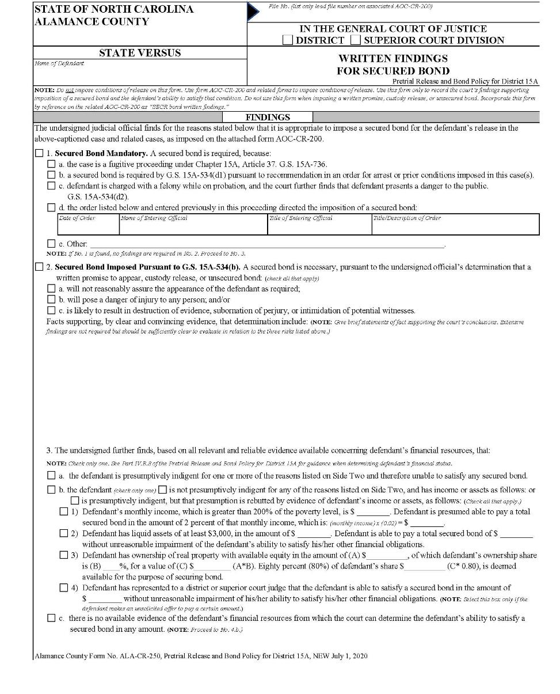
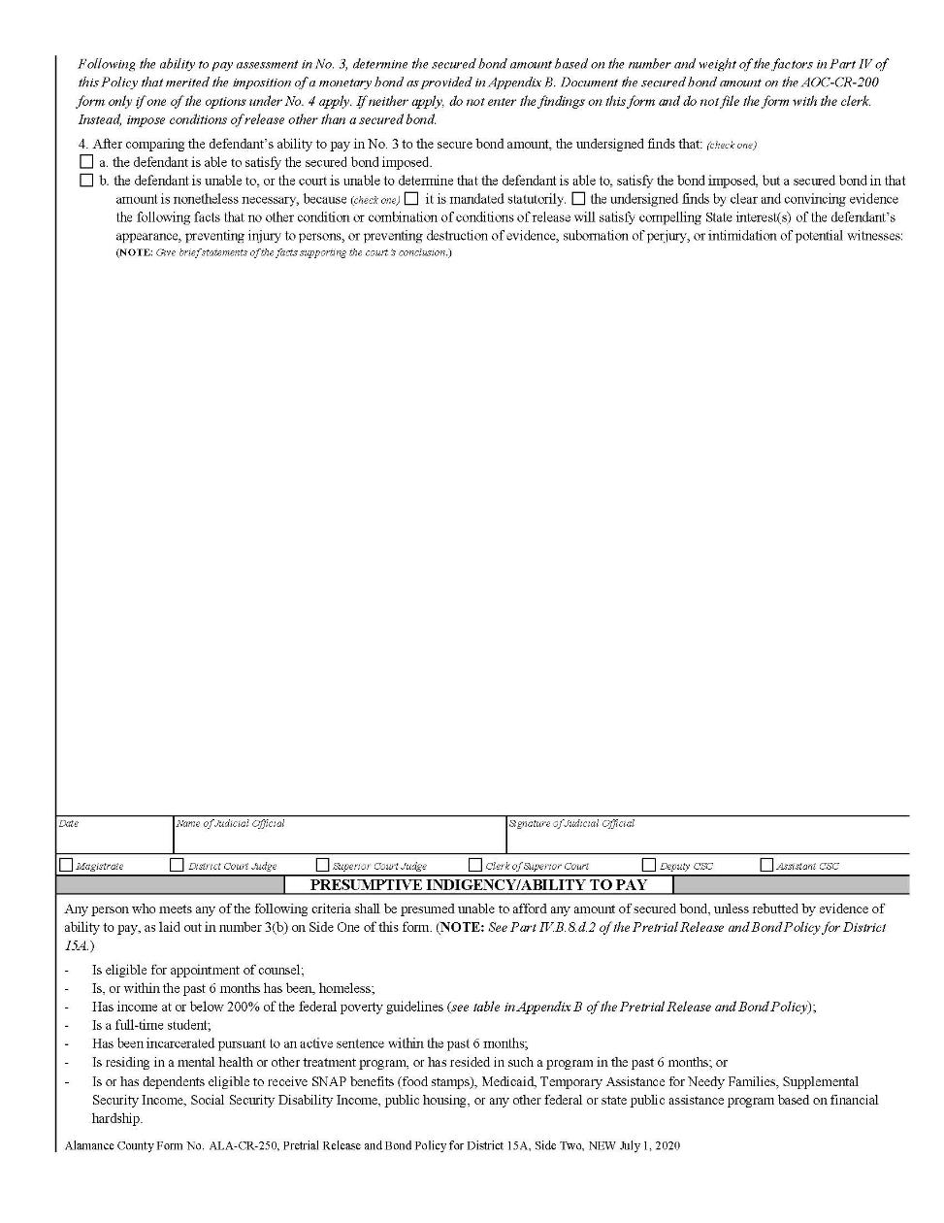

Forsyth County Magistrate & Judge Forms
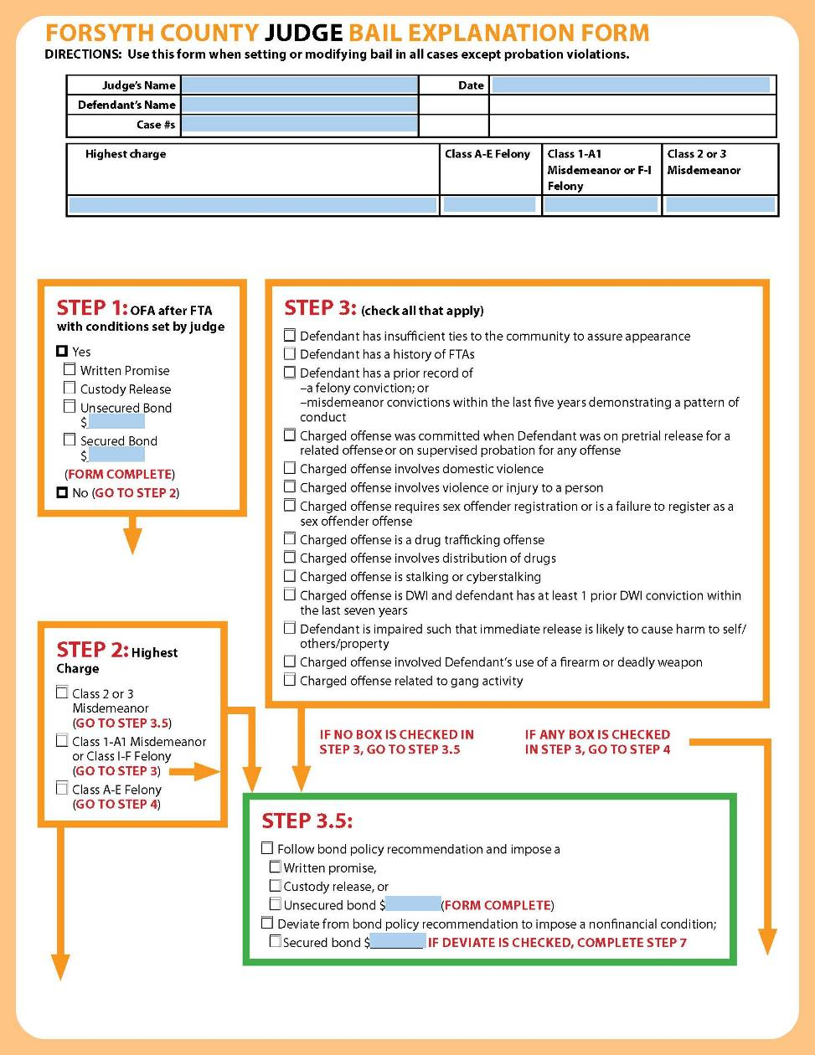
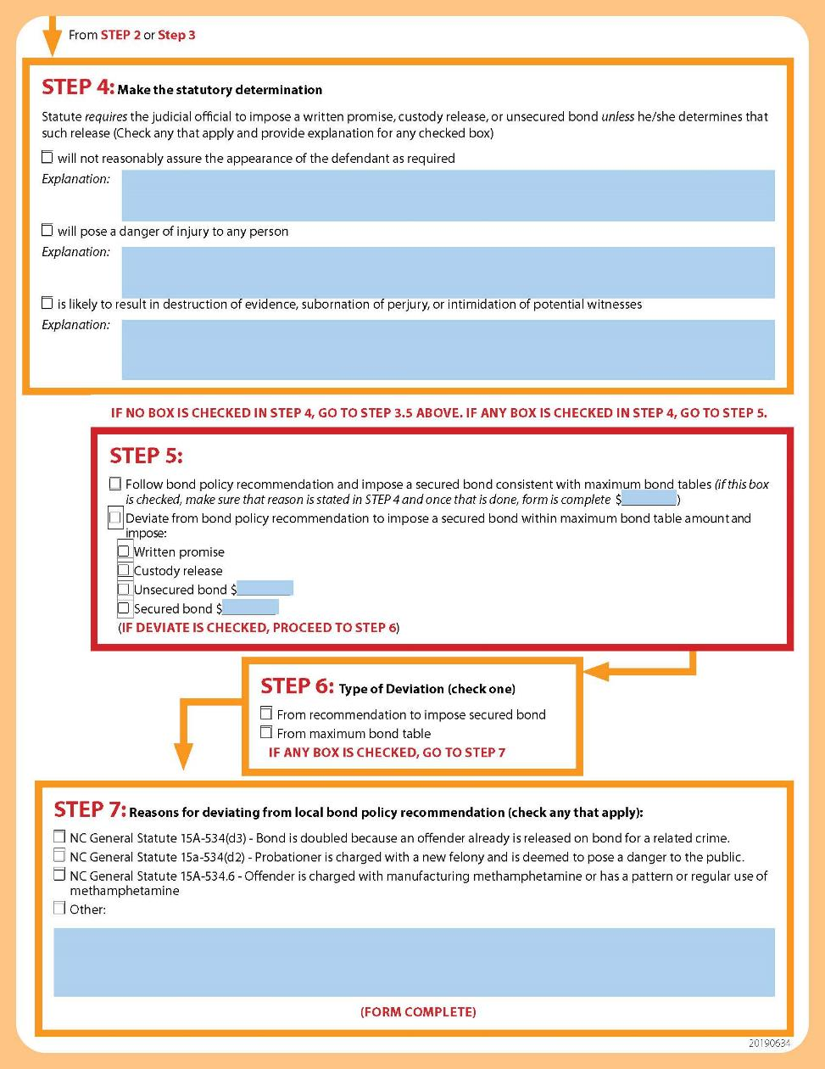
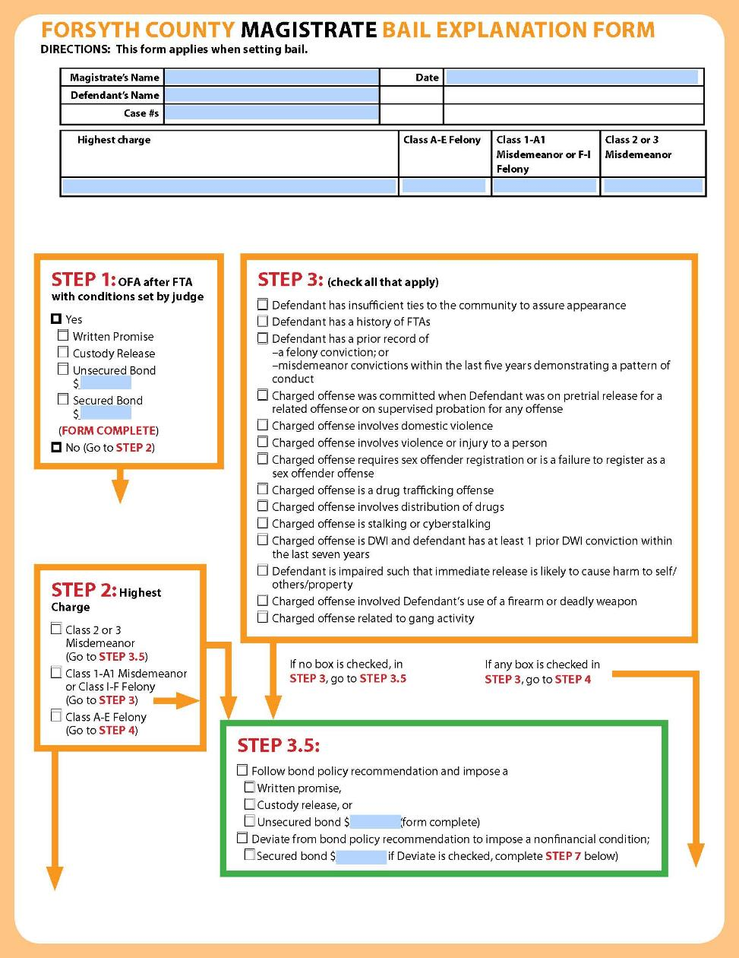
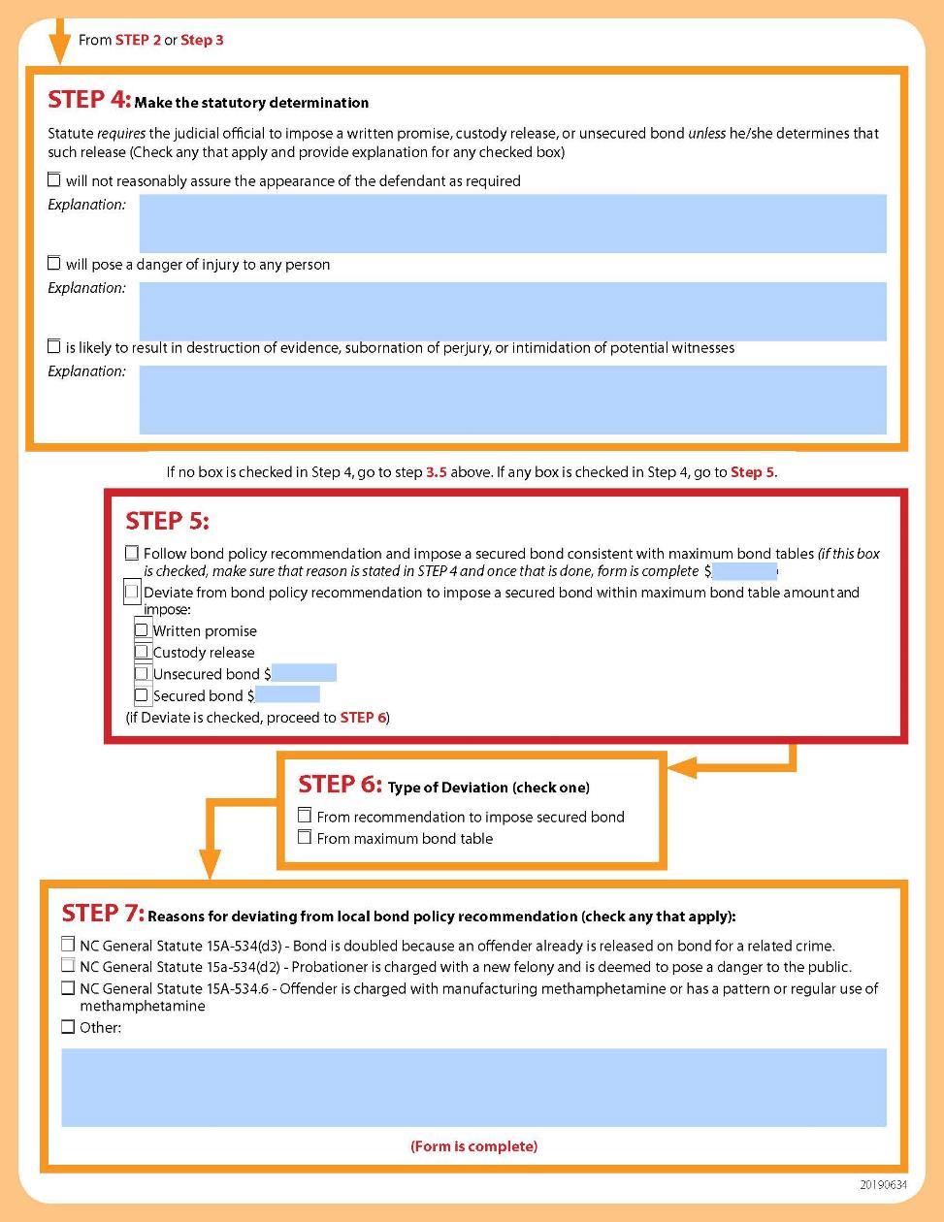

Judicial District 2 Magistrate Form
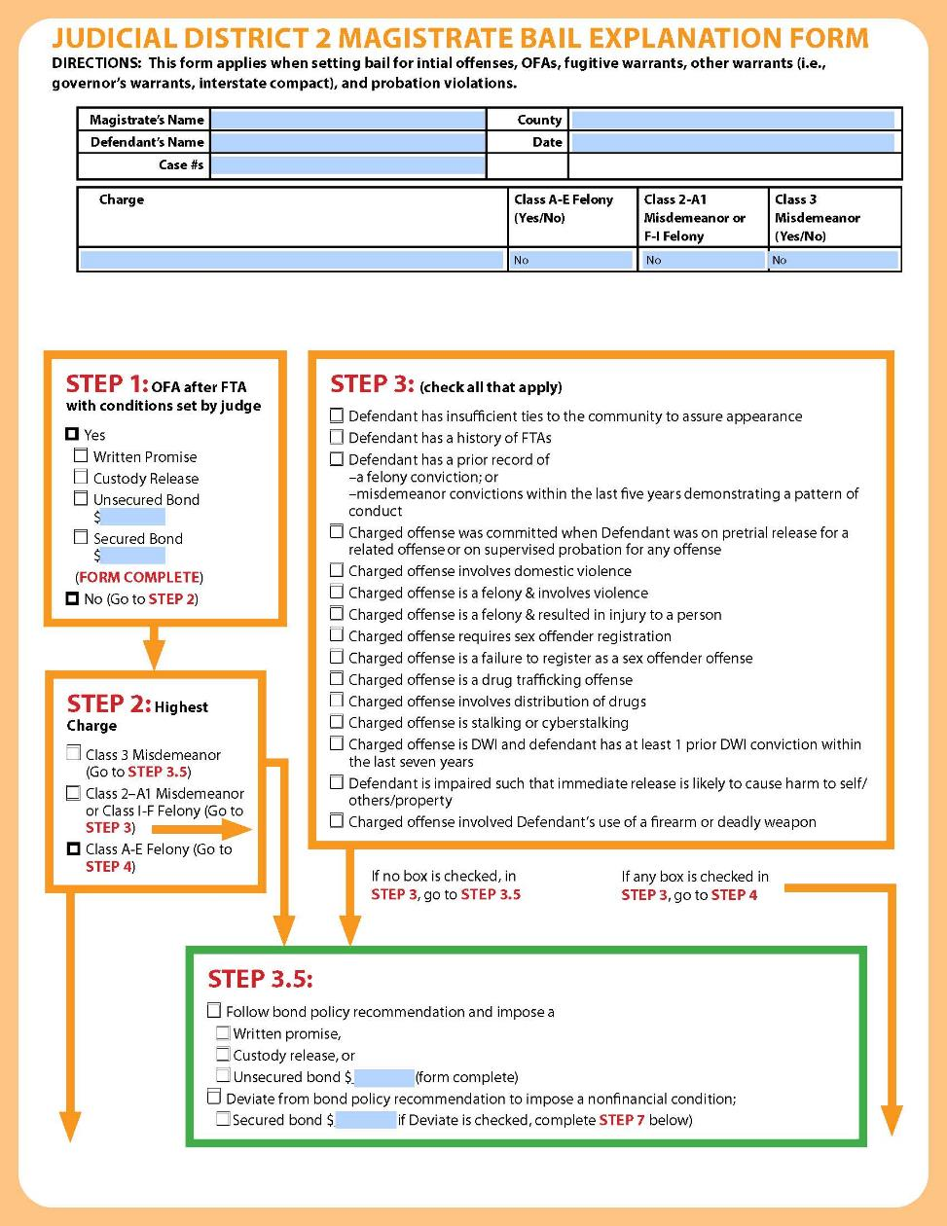

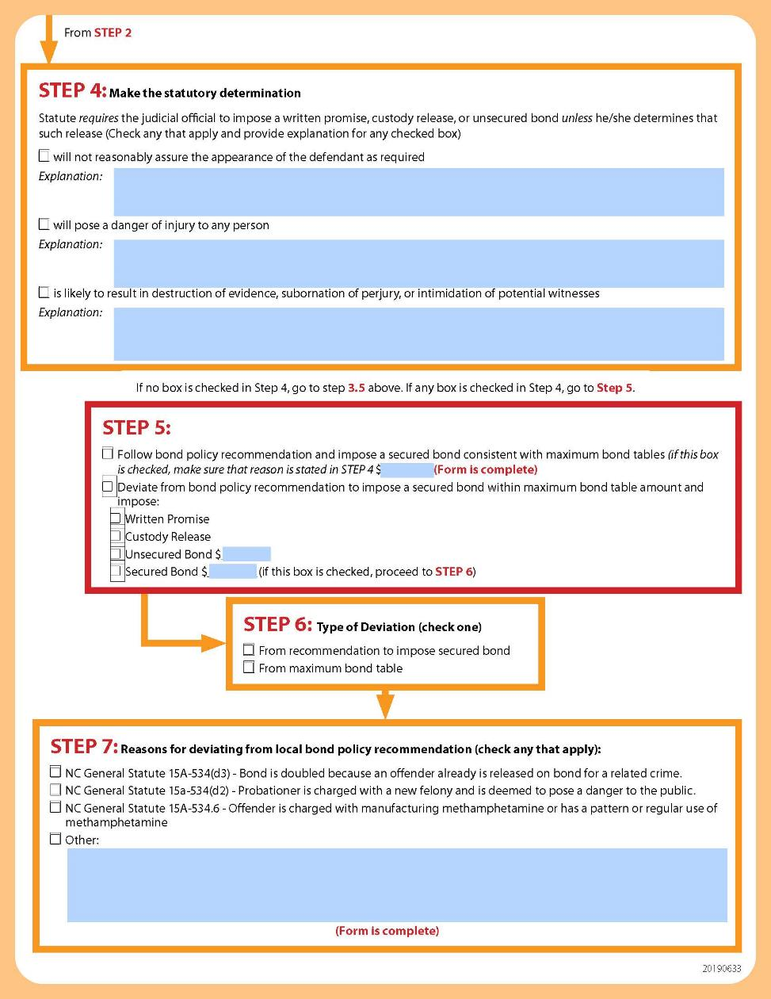

Orange County Form
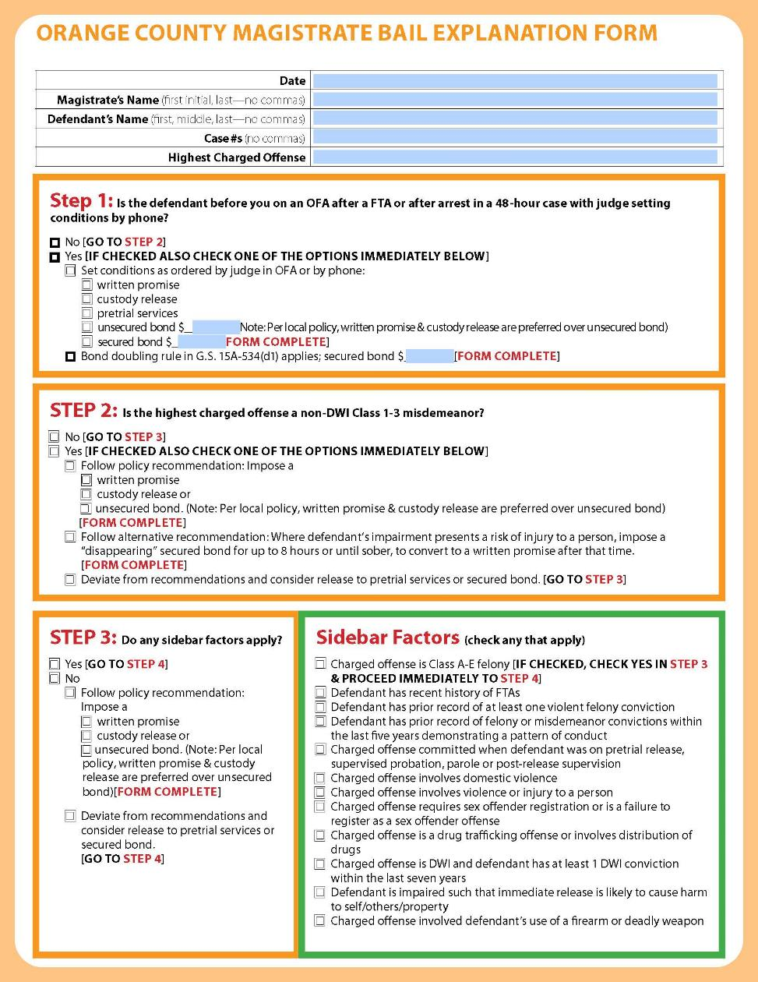

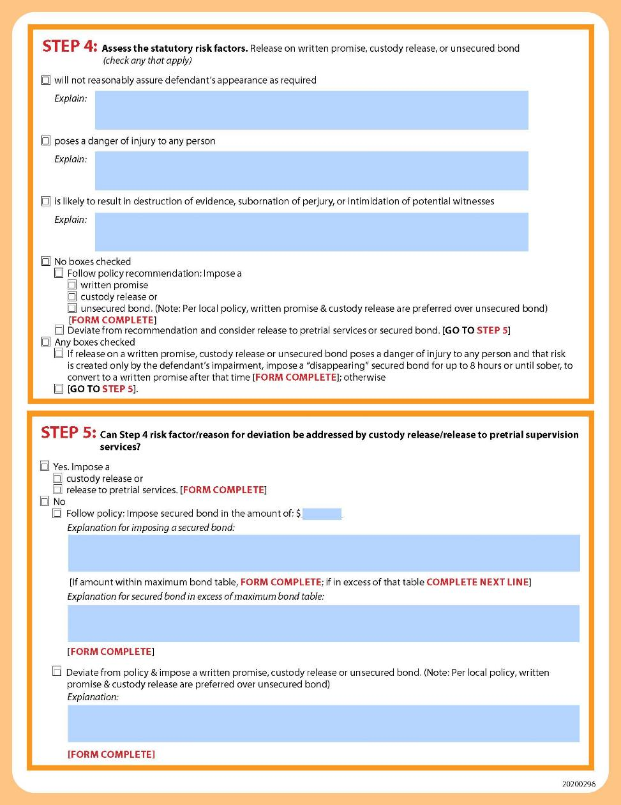

5. Mecklenburg County Reason Codes—For Use on AOC-CR-200
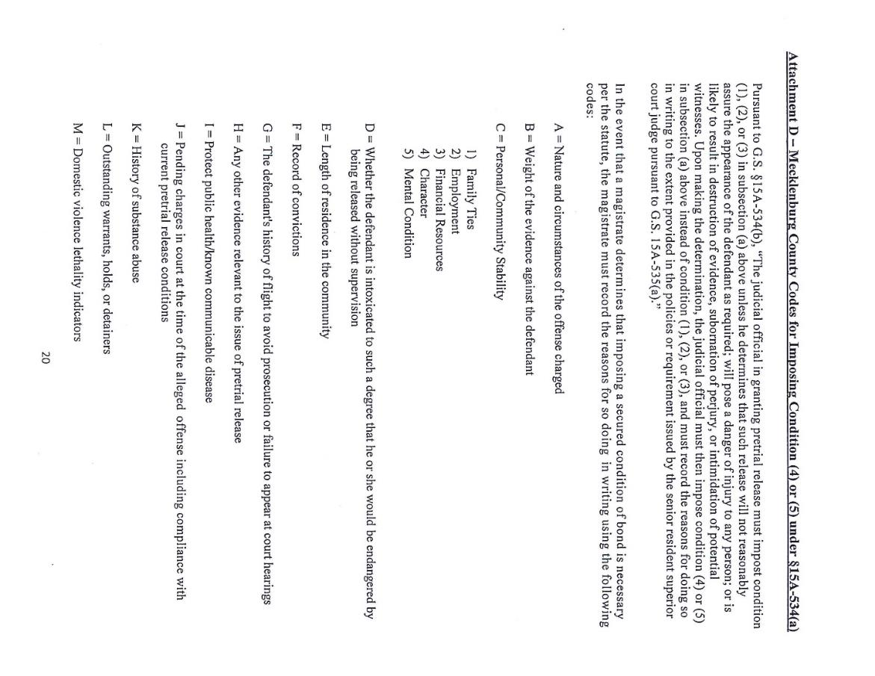

Appendix B: Sample Matrices—For Use with Empirical Risk Assessment Tools

Mecklenburg County Decision-Making Matrix
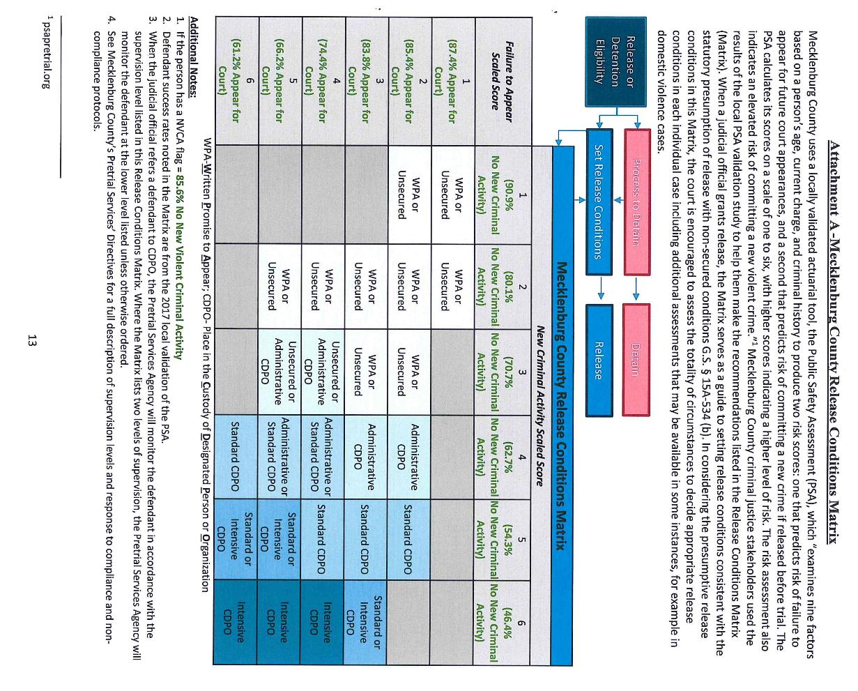

Buncombe County Decision-Making Matrix

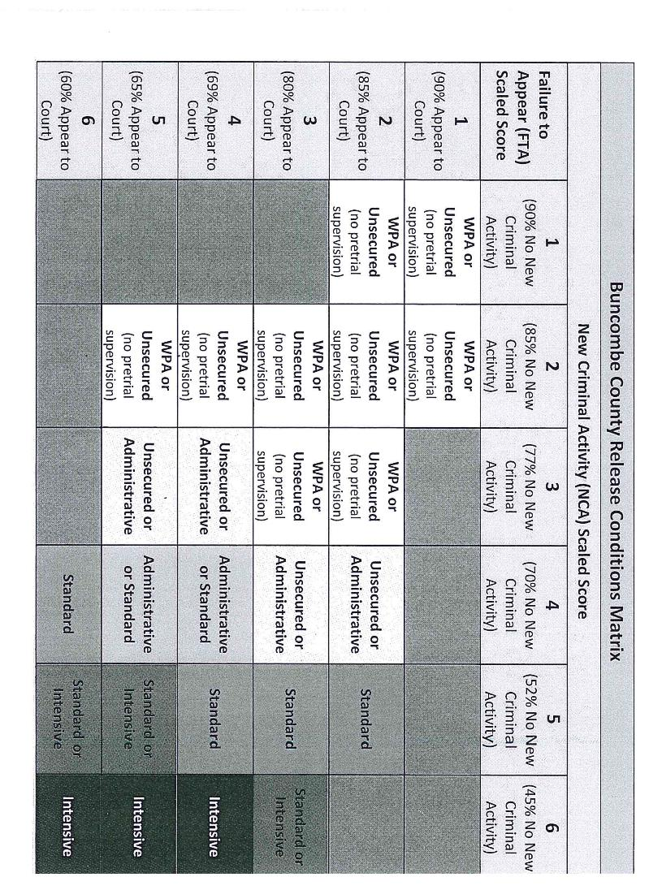

Orange County Decision-Making Matrix
VPRAI-R Pretrial Praxis

Risk Level | Supervision Level
Level 1 | No Supervision
Level 2 | No Supervision
Level 3 | Administrative
Level 4 | Level I
Level 5 | Level II
Level 6 | Detain
Risk Level | Supervision Level
Level 1 | No Supervision
Level 2 | Administrative
Level 3 | Administrative
Level 4 | Level I
Level 5 | Level II
Level 6 | Detain
Non-Violent Misdemeanor Driving While Impaired

Non-Violent Felony Violent Misdemeanor
Risk Level | Supervision Level
Level 1 | No Supervision
Level 2 | Administrative
Level 3 | Level I
Level 4 | Level II
Level 5 | Level III
Level 6 | Detain
Risk Level | Supervision Level
Level 1 | No Supervision
Level 2 | Administrative
Level 3 | Level I
Level 4 | Level II
Level 5 | Detain
Level 6 | Detain

Violent Felony or Firearm
Risk Level | Supervision Level
Level 1 | Level II
Level 2 | Level III
Level 3 | Detain
Level 4 | Detain
Level 5 | Detain
Level 6 | Detain

Appendix C: Sample Structured Decision-Making Tools—For Determining Conditions of Release

Judicial District 30B Tool
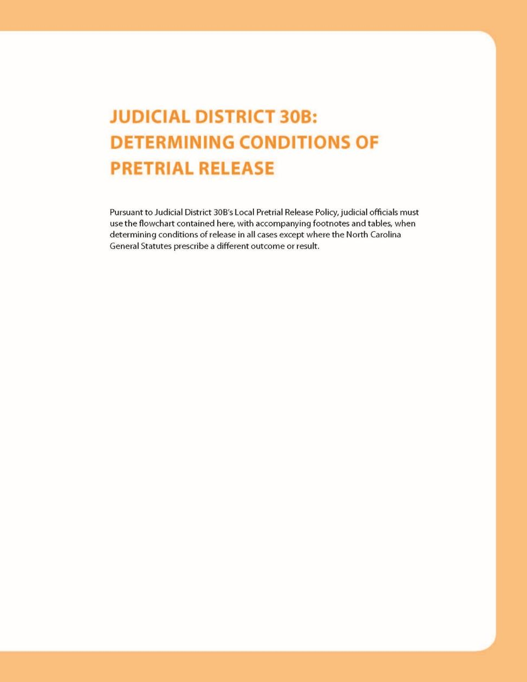
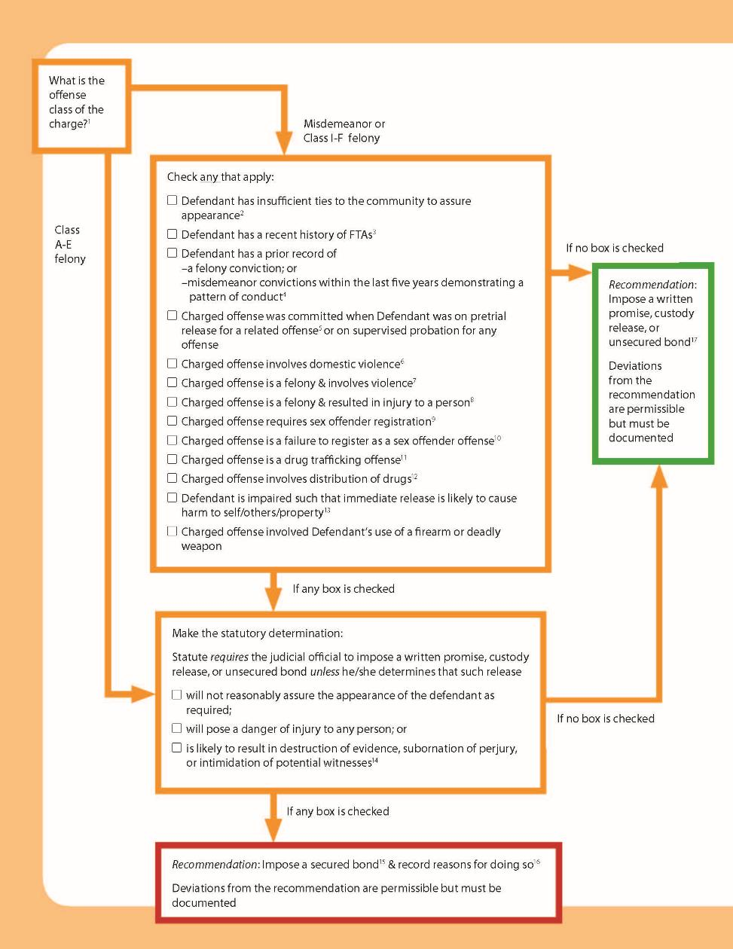

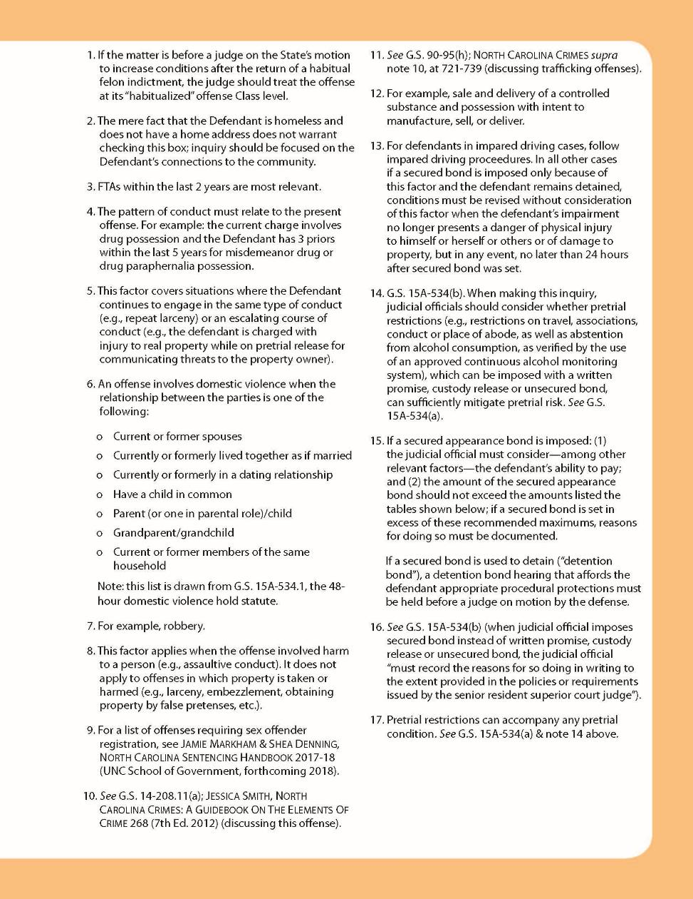

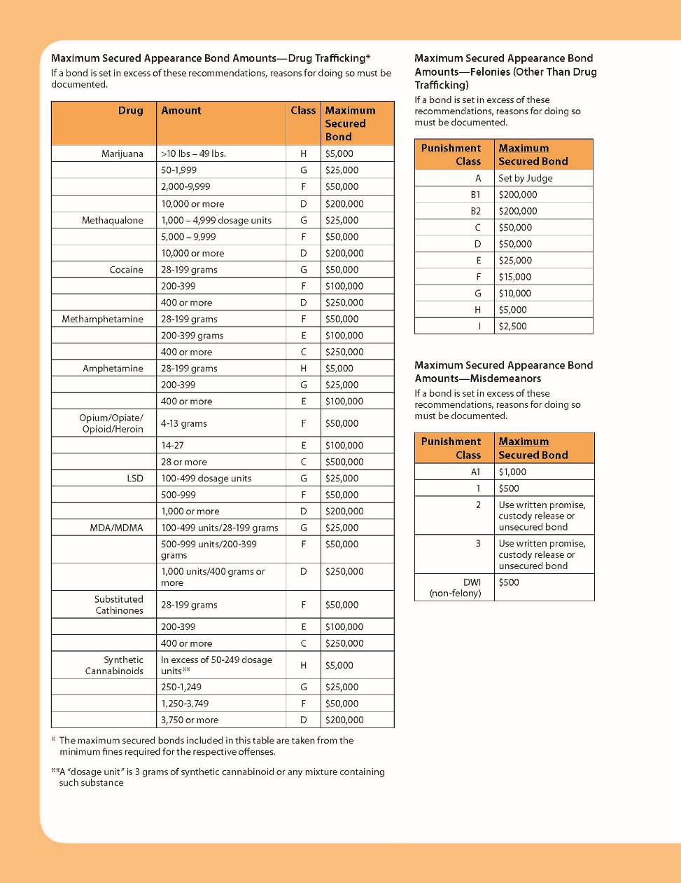

Judicial District 21 Tool
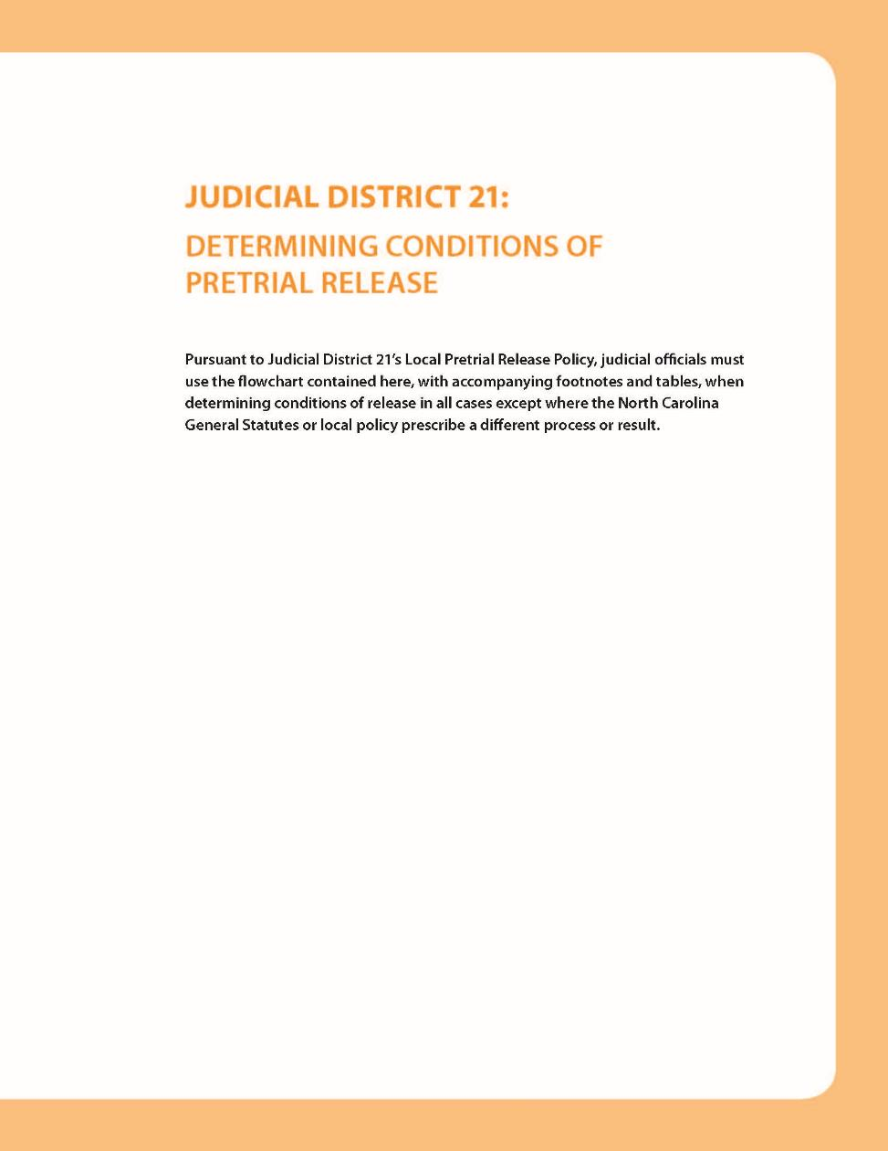

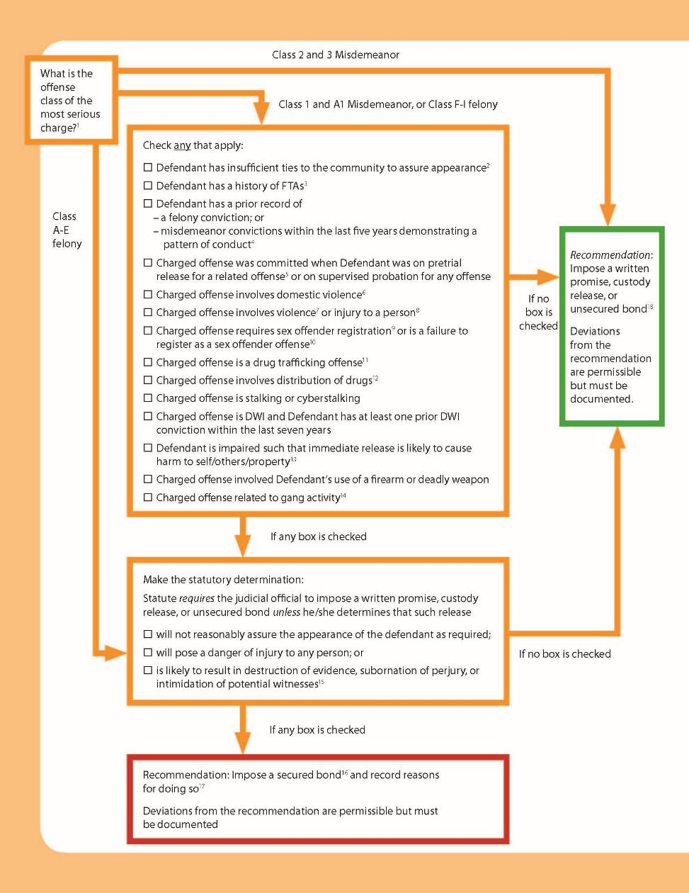

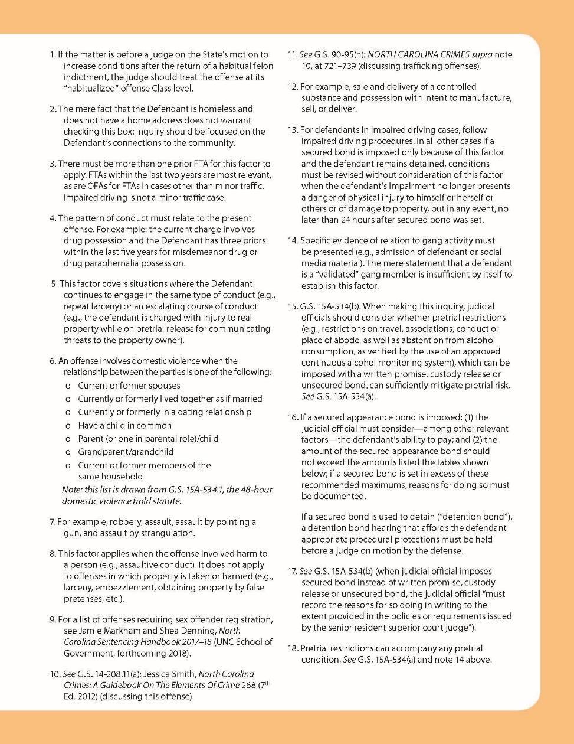

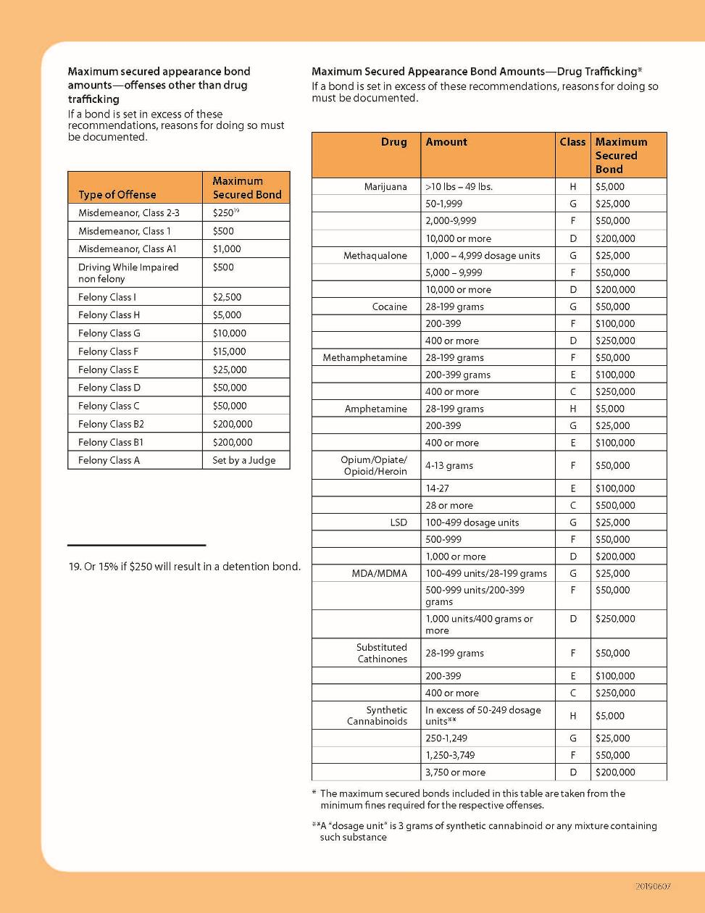

Judicial District 2 Tool
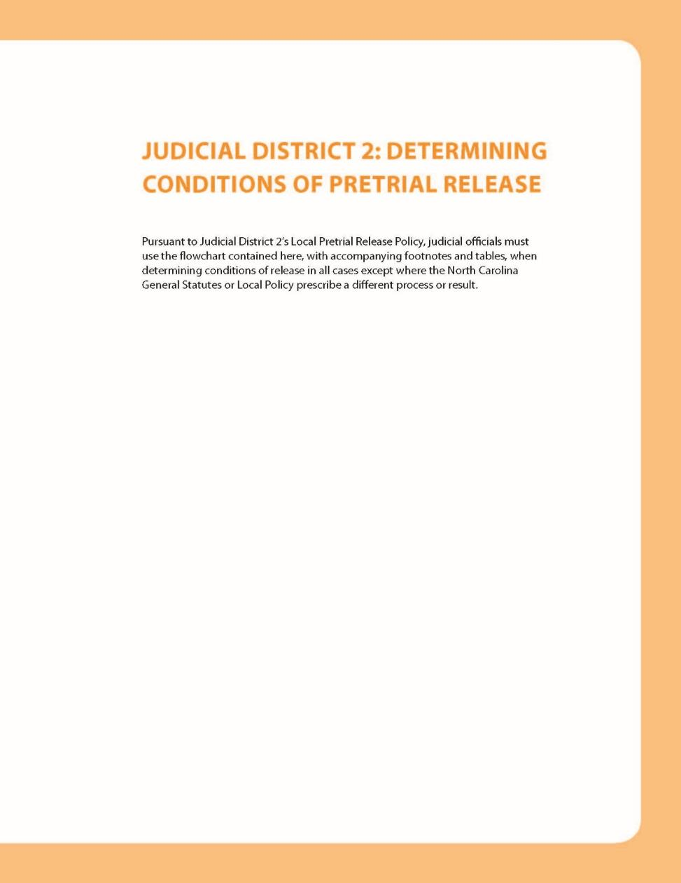

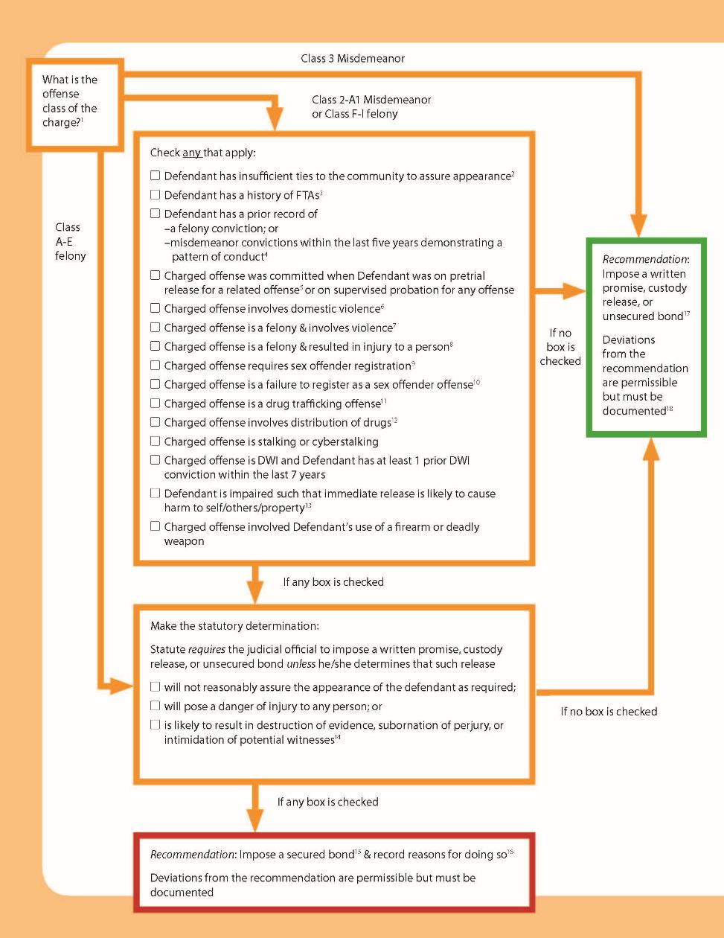

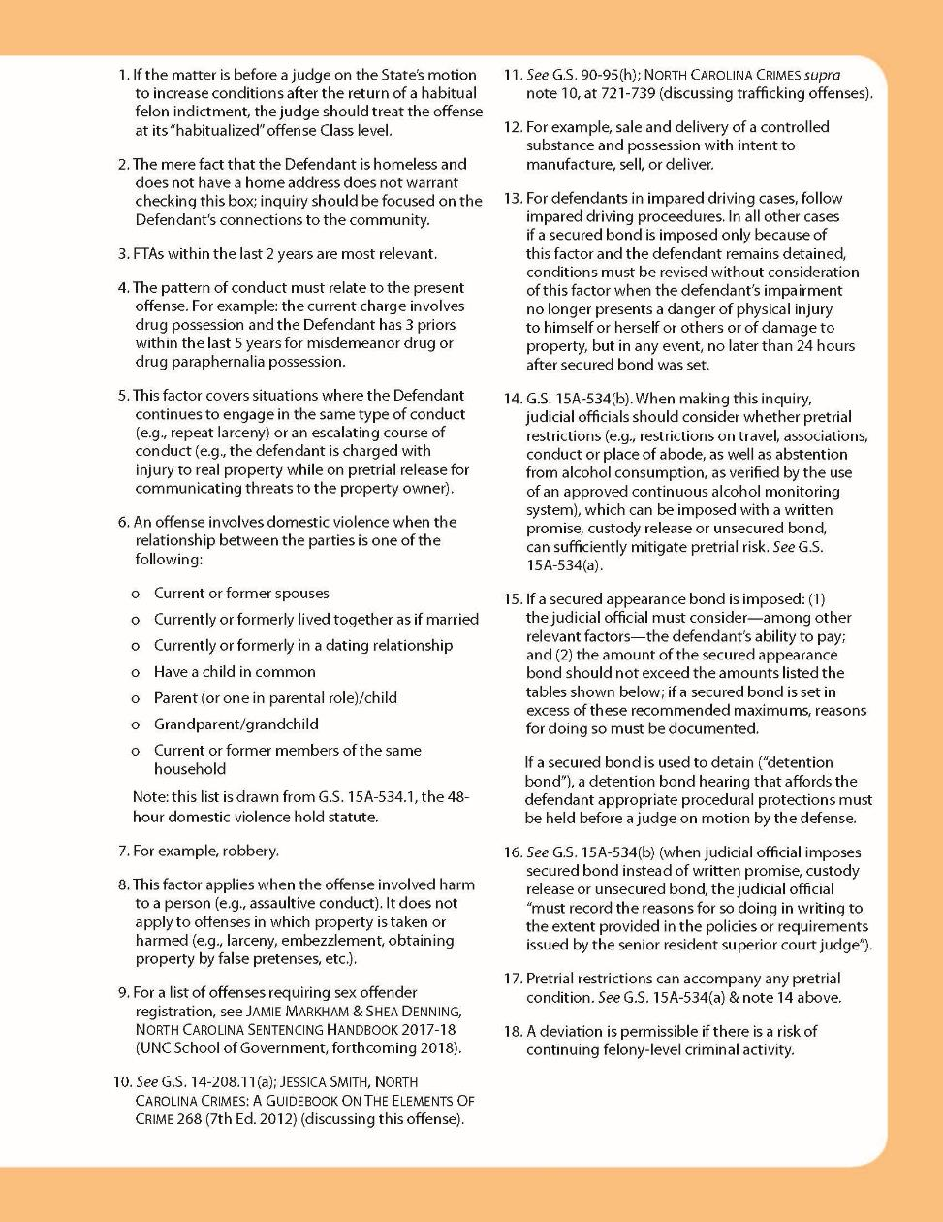
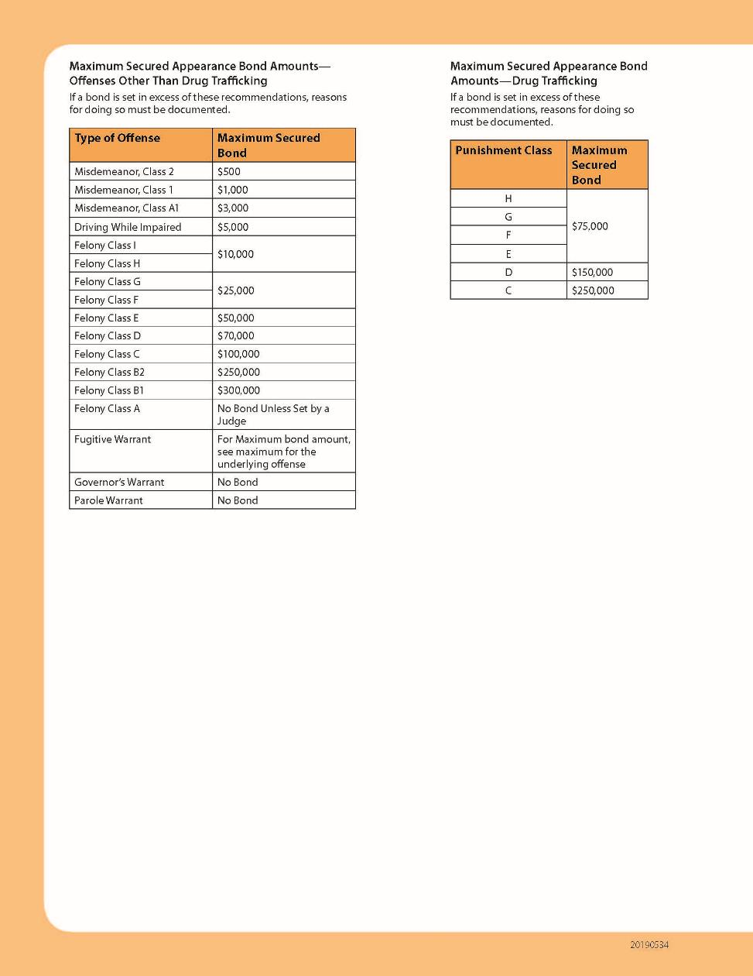

Alamance County Tool
        - Alamance Flowchart
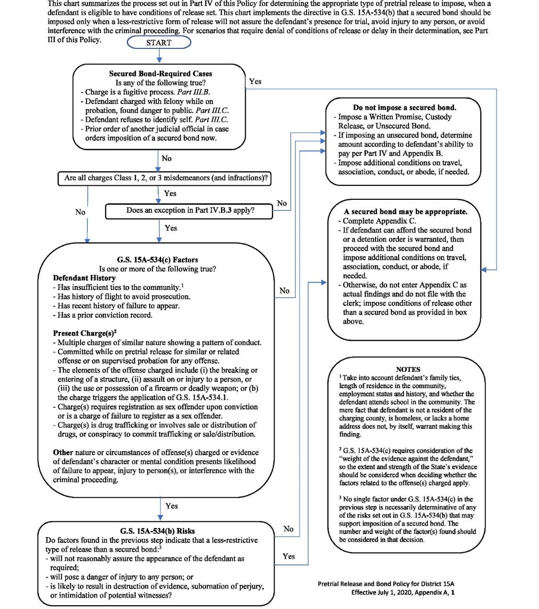
        - Step-By-Step Guide to the Alamance Flowchart
Note: References within this document to Appendices refer to Appendices in the Alamance Policy, not in this Model Bail Policy.

New Alamance County Pretrial Release Flowchart: A Step-By-Step Guide
Jessica Smith, UNC SOG, June 2020

Step 1: Secured Bond-Required Cases
Any of the following true?
- Charge is a fugitive process
Note: Under Part III.B.5 of the Policy (page 7), a defendant arrested on a fugitive process for an offense punishable by death or life in prison is not entitled to conditions of release. However, a defendant arrested on fugitive process for an offense not subject to death or life in prison is entitled to conditions, the condition must be a secured bond & this box is checked.
- Defendant charged with felony while on probation, found danger to public
Note: Under Part III.C.5 of the Policy (pages 13-14), when determining conditions for a defendant charged with a felony and currently on probation, the judicial official must determine if the defendant poses a danger to the public before setting conditions. If the defendant poses a danger to the public, the official must impose a secured bond & this box is checked. If the official finds that the defendant does not pose a danger to the public, conditions are set as usual.
- Defendant refuses to identify self
Note: Under Part III.C.7 of the Policy (pages 15-16), if at the initial appearance the defendant cannot be identified and continues to refuse to identify himself, that refusal must be deemed clear and convincing evidence that the defendant is unlikely to appear in court, a secured bond must be imposed & this box is checked.
- Another judicial official’s prior order requires imposition of a secured bond now
Note: Under Part IV.B.7.b of the Policy (page 19), if a secured bond has been ordered by a senior judicial official, that condition must be imposed & this box is checked.

If none of the above apply, go to Step 2
If any of the above apply, go to Step 7

Step 2: Are All Charges Class 1-3 Misdemeanors or Infractions?

If Yes, go to Step 3
If No, go to Step 4

Step 3: Do any of the following exceptions apply?
Note. Part IV.B.3. of the Policy (pages 17-18) provides that when the most serious charged offense is a Class 1-3 misdemeanor, the judicial official must impose a condition other than a secured bond unless one of the following exceptions applies.
- Elements of the charged offense include: breaking or entering a structure; assault on/injury to a person, or the use/possession of a firearm or deadly weapon
- G.S. 15A-534.1 (domestic violence) is triggered because of the offenses charged and the relationship between the defendant and the victim
- Clear and convincing evidence of one or more factors in G.S. 15A-534(c) (see Step 4) presents a substantial likelihood of one or more of the risks in G.S. 15A-534(b) (failure to appear, injury to persons, interference with the criminal proceeding)

If none of the exceptions apply, go to Step 6
If any of the exceptions apply, go to Step 4

Step 4: Consider the “G.S. 15A-534(c) Factors”
Is one or more of the following true:
- Defendant History
  - Has insufficient ties to the community
Note: Consider defendant’s family ties, length of residence in the community, employment status and history, and whether the defendant attends school in the community. The mere fact that defendant is not a resident of the charging county, is homeless, or lacks a home address does not, by itself, warrant making this finding.
  - Has history of flight to avoid prosecution
  - Has recent history of failure to appear
  - Has a prior conviction record
- Present charge(s)
Note: G.S. 15A-534(c) requires consideration of the “weight of the evidence against the defendant,” so the extent and strength of the State’s evidence should be considered when deciding whether the factors related to the offense(s) charged apply.
  - Multiple charges of similar nature showing a pattern of conduct
  - Committed while on pretrial release for similar or related offense or on supervised probation for any offense
  - Elements of the charged offense include: breaking or entering a structure; assault on/injury to a person; or the use/possession of a firearm or deadly weapon
  - G.S. 15A-534.1 (domestic violence 48-hour rule) applies
  - Charge(s) requires registration as sex offender upon conviction or is a charge of failure to register as a sex offender
  - Charge(s) is drug trafficking or involves sale or distribution of drugs, or conspiracy to commit trafficking or sale/distribution
- Nature or circumstances of offense(s) charged or evidence of defendant’s character or mental condition presents likelihood of failure to appear, injury to person(s), or interference with the criminal proceeding

If none of the above apply, go to Step 6
If any of the above apply, go to Step 5

Step 5: Assess G.S. 15A-534(b) Risks
Do any factors found in Step 4 indicate that a written promise, custody release or unsecured bond:
- will not reasonably assure the appearance of the defendant as required;
- will pose a danger of injury to any person; or
- is likely to result in destruction of evidence, subornation of perjury, or intimidation of potential witnesses
Notes
- No single factor under G.S. 15A-534(c) in Step 4 is necessarily determinative of any of the G.S. 15A-534(b) risks that may support imposition of a secured bond. The number and weight of the factor(s) found should be considered in that decision.
- For Class 3 misdemeanors charged against defendants with less than 4 prior convictions, a secured bond may not be imposed absent clear and convincing evidence that release poses danger of injury to any person. See Part IV.B.7.c (page 19). In these Class 3 misdemeanor cases, you may proceed to Step 7 only if the second box above is checked; otherwise proceed to Step 6.

If none of the above apply, go to Step 6
If any of the above apply, go to Step 7

Step 6: Do Not Impose a Secured Bond
- Impose a written promise, custody release, or unsecured bond.
Note: The Policy recommends a presumption in favor of non-monetary types of release (written promise and custody release) over an unsecured bond. See Part IV.B.2 (page 17).
- If imposing an unsecured bond, determine the amount according to the defendant’s ability to pay per Part IV and Appendix B.
- Impose additional conditions on travel, association, conduct, or abode, if needed.

Step 7: A Secured Bond May Be Appropriate
- Determine amount according to defendant’s ability to pay per Part IV and Appendix B.
- Make written findings of reasons for imposing secured bond and about defendant’s ability to pay on the form in Appendix C.
- Impose additional conditions on travel, association, conduct, or abode, if needed.

Orange County Tool
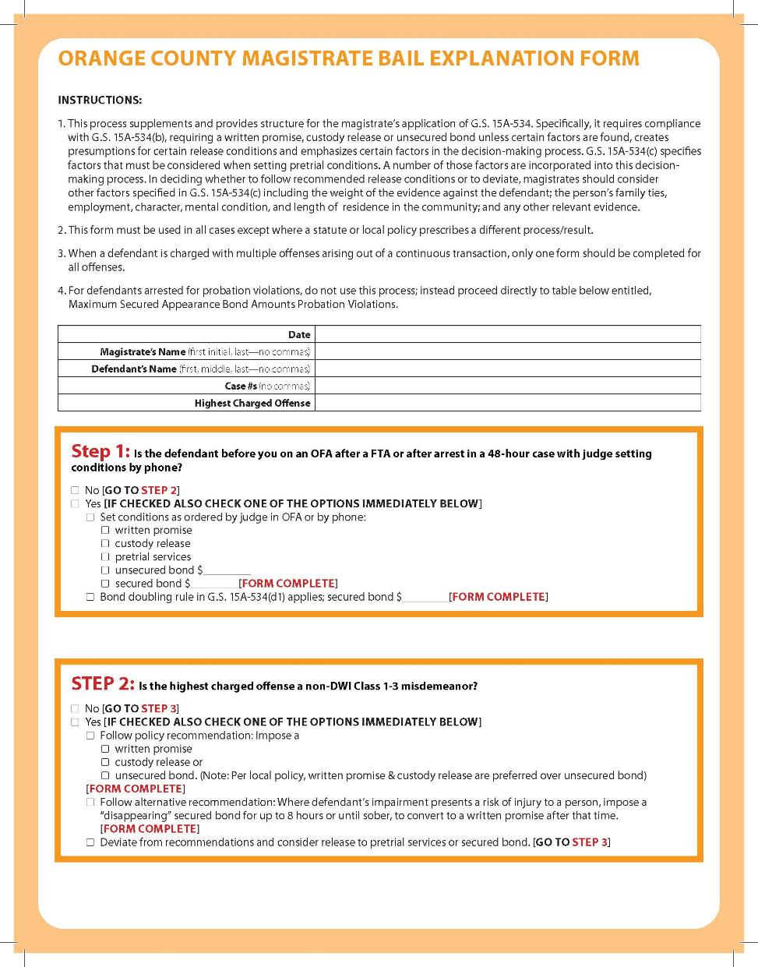
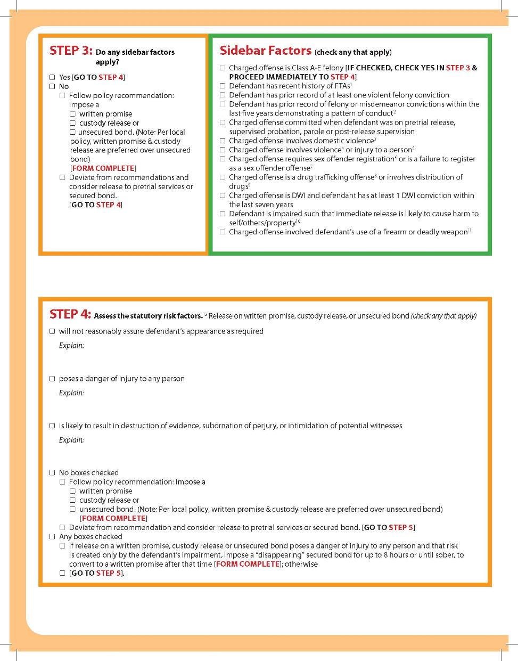

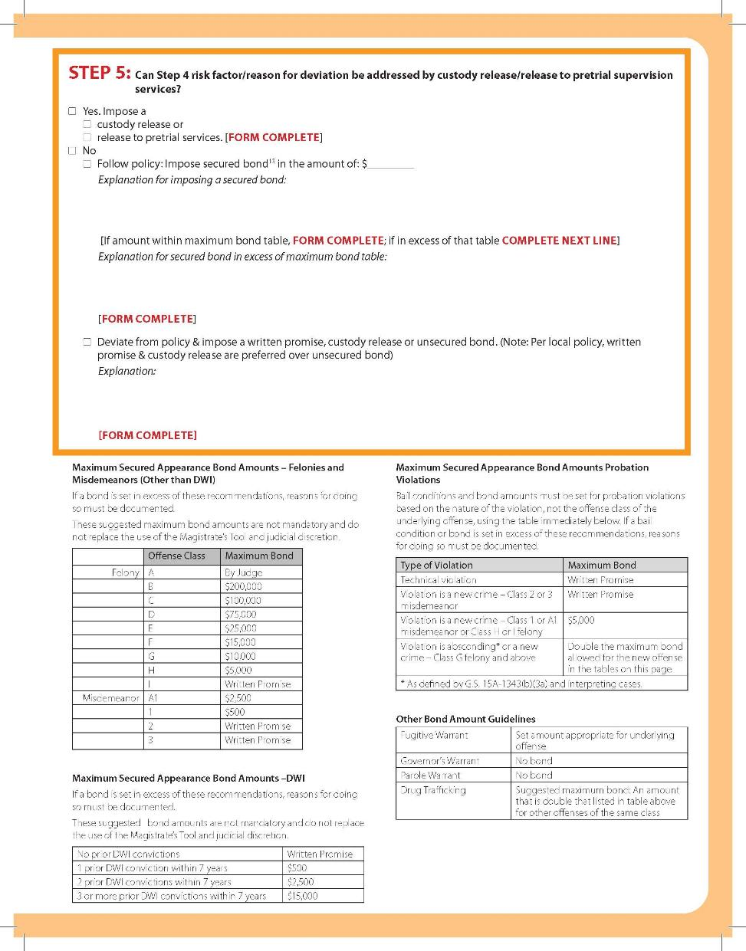

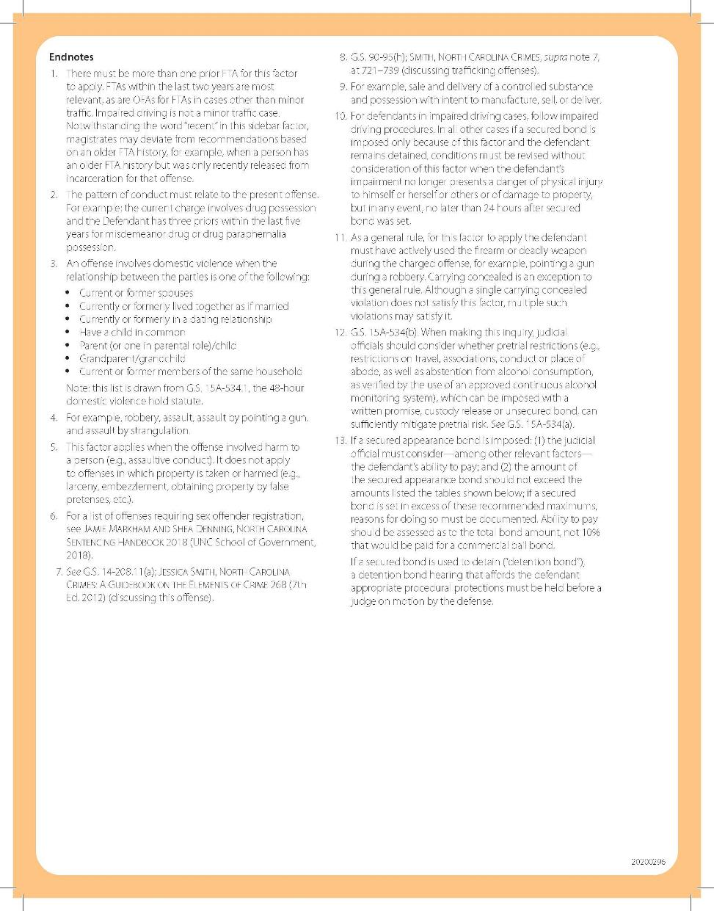

Appendix D: Sample Oral Notice–At Initial Appearance
Note: Adapt this language, as appropriate, based on other decisions made in your bail policy.
Initial Appearance for New Charge(s)
This is an initial appearance, but it is not your trial. I cannot try or dismiss the charges against you. You will be able to address the charges against you with the court soon, and if you want a lawyer to assist you in court and cannot afford one, the court will appoint one for you. Right now, I must determine whether you must be held in jail while your case is pending and any conditions for your release from jail during that time. If I have to set conditions for your release, I will be considering information about several factors, including your history with the courts, if any, and the nature of your current charges. If the conditions I impose include a monetary bond for your release, I must consider your financial situation and your ability to pay a bond. You have the right to provide me with information or evidence about those decisions, but you also have the right to remain silent. Anything you say might be used later in evidence against you, so you should not discuss the events that led to your arrest. When we are done, you will get a copy of the order I enter that includes any conditions for your release that I impose. You or your attorney can challenge my decision at a future hearing.
[Continue initial appearance as otherwise provided in G.S. 15A-511, including additional information to defendant set out in subsection (b) of that statute.]
Initial Appearance for Warrantless Arrest for Violation of Conditions of Release
This is an initial appearance, but it is not your trial. I cannot try or dismiss the charges against you. Right now, I must determine only whether there is cause to believe you have violated a condition of release in your case. If I find that, I will set new conditions for your release, and I will be considering information about several factors, including your history with the courts, if any, and the nature of your current charges. If the conditions I impose include a monetary bond for your release, I must consider your financial situation and your ability to pay a bond. You have the right to provide me with information or evidence about those decisions, but you also have the right to remain silent. Anything you say might be used later in evidence against you, so you should not discuss the events that led to your arrest. When we are done, you will get a copy of the order I enter that includes any conditions for your release that I impose. You or your attorney can challenge my decision at a future hearing.

Appendix E: Sample Notice–After Initial Appearance

For Defendants with Cases Pending in the District/County
Note: The content below is reproduced from the Alamance County Administrative Order regarding first appearances. Adapt this language, as appropriate, based on other decisions made in your bail policy.
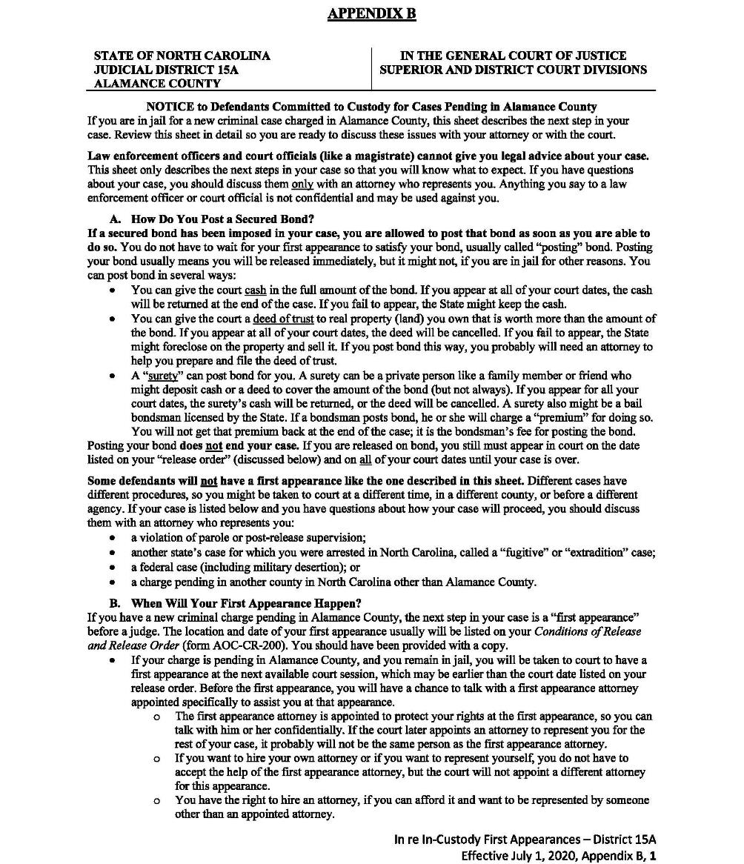
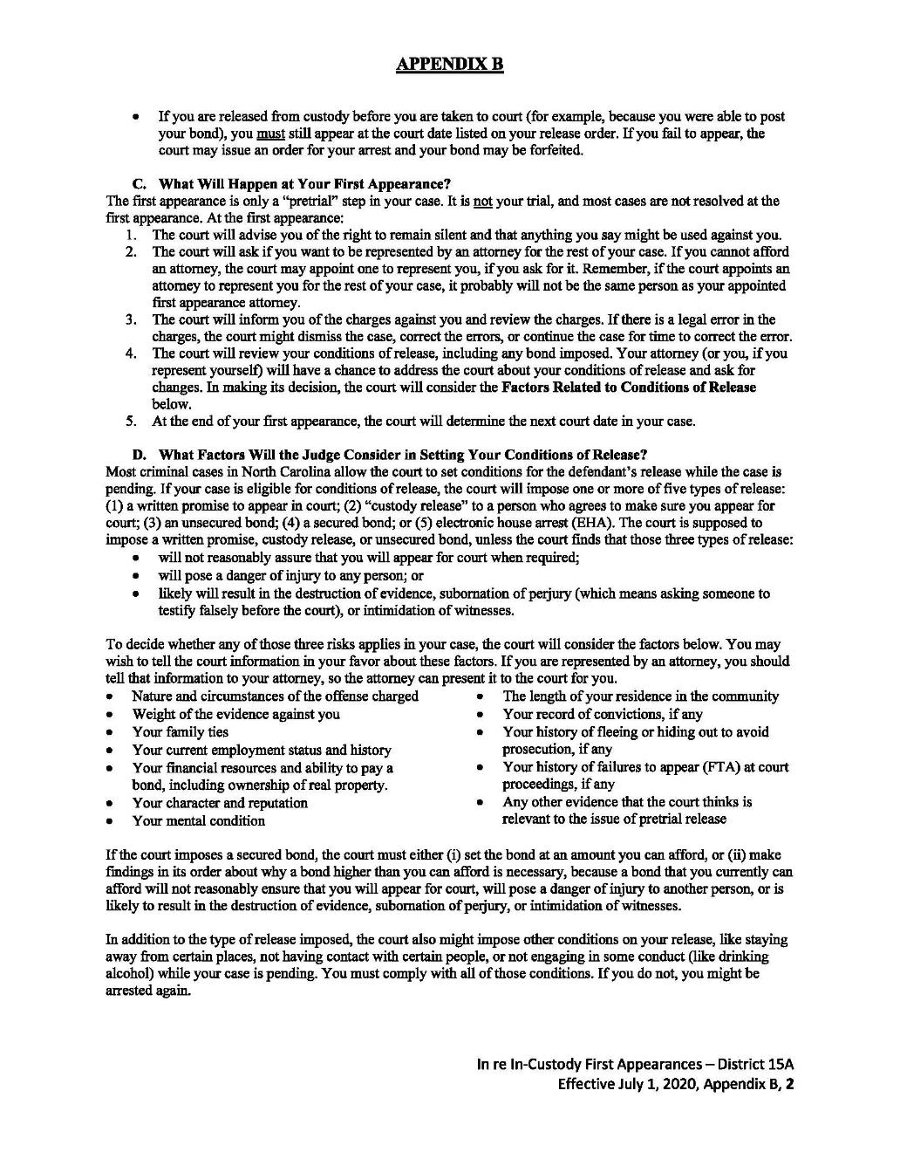

For Defendants with Cases Pending in Other Districts/Counties
Note: The content below is reproduced from the Alamance County Administrative Order regarding first appearances. Adapt this language, as appropriate, based on other decisions made in your bail policy.
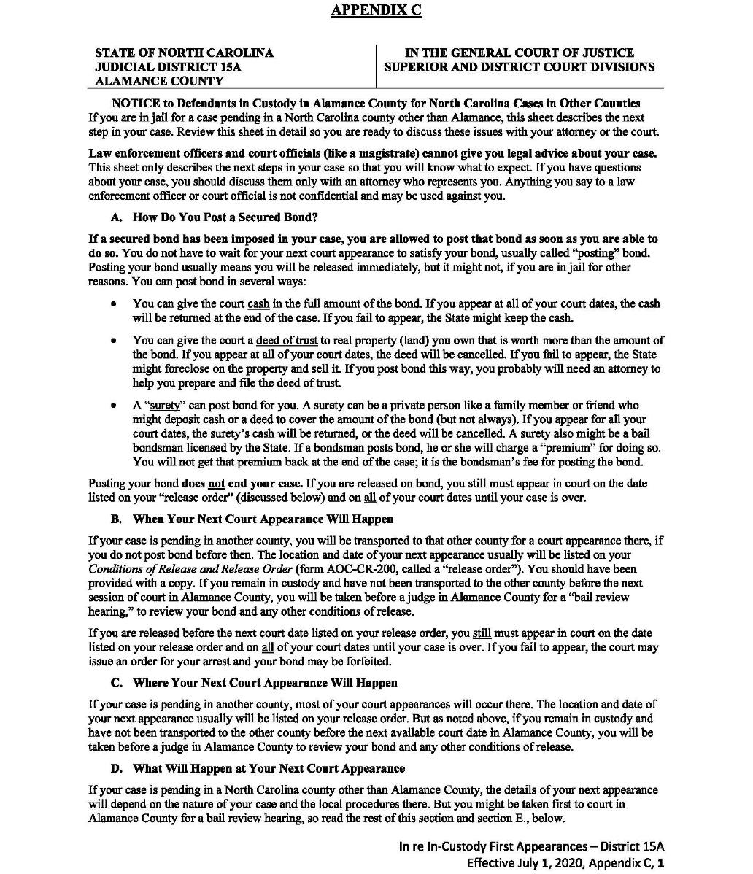
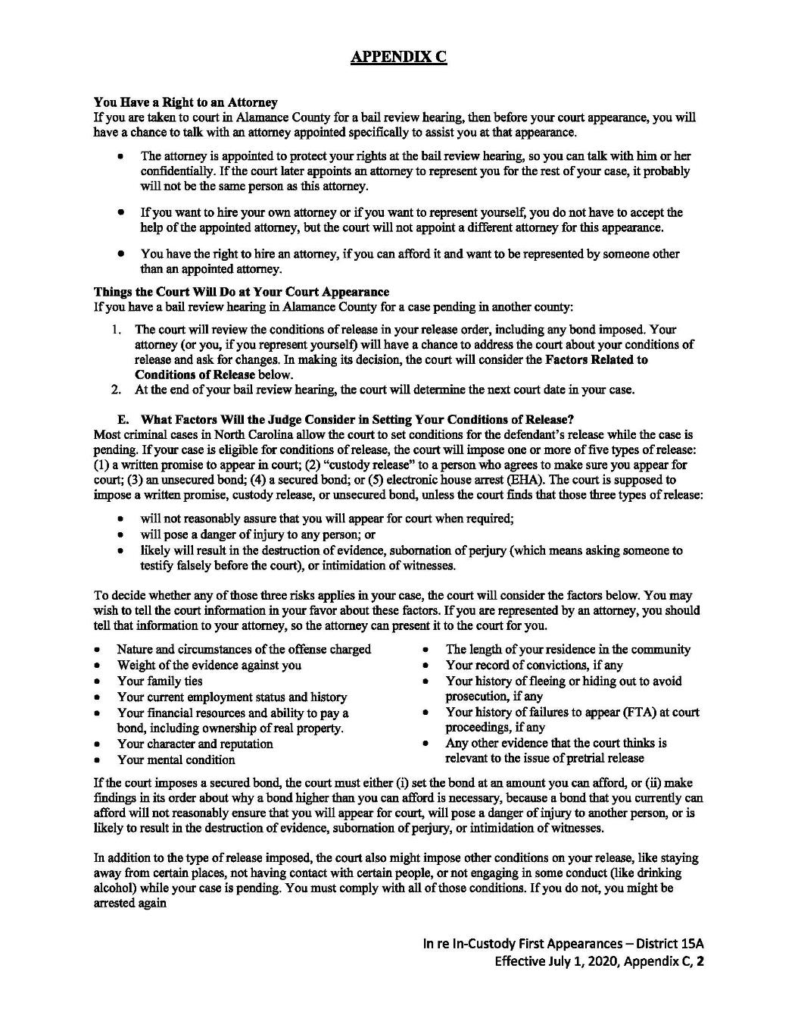

Appendix F: Sample First Appearance and Bail Review Advisement Summary
Note: The content below is taken from an Appendix to the new Alamance County Administrative Order regarding first appearances. Adapt this language, as appropriate, based on other decisions made in your bail policy.
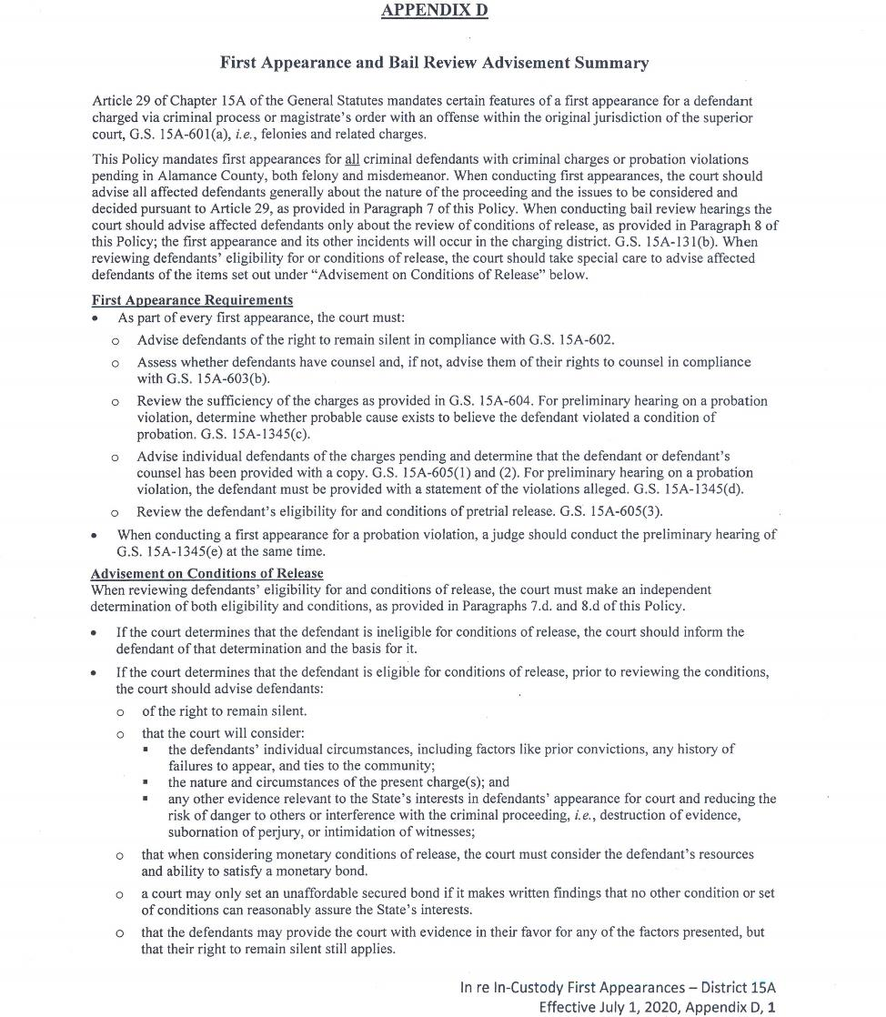

Appendix G: Sample Decision Making Tool–Responding to Non-Appearances

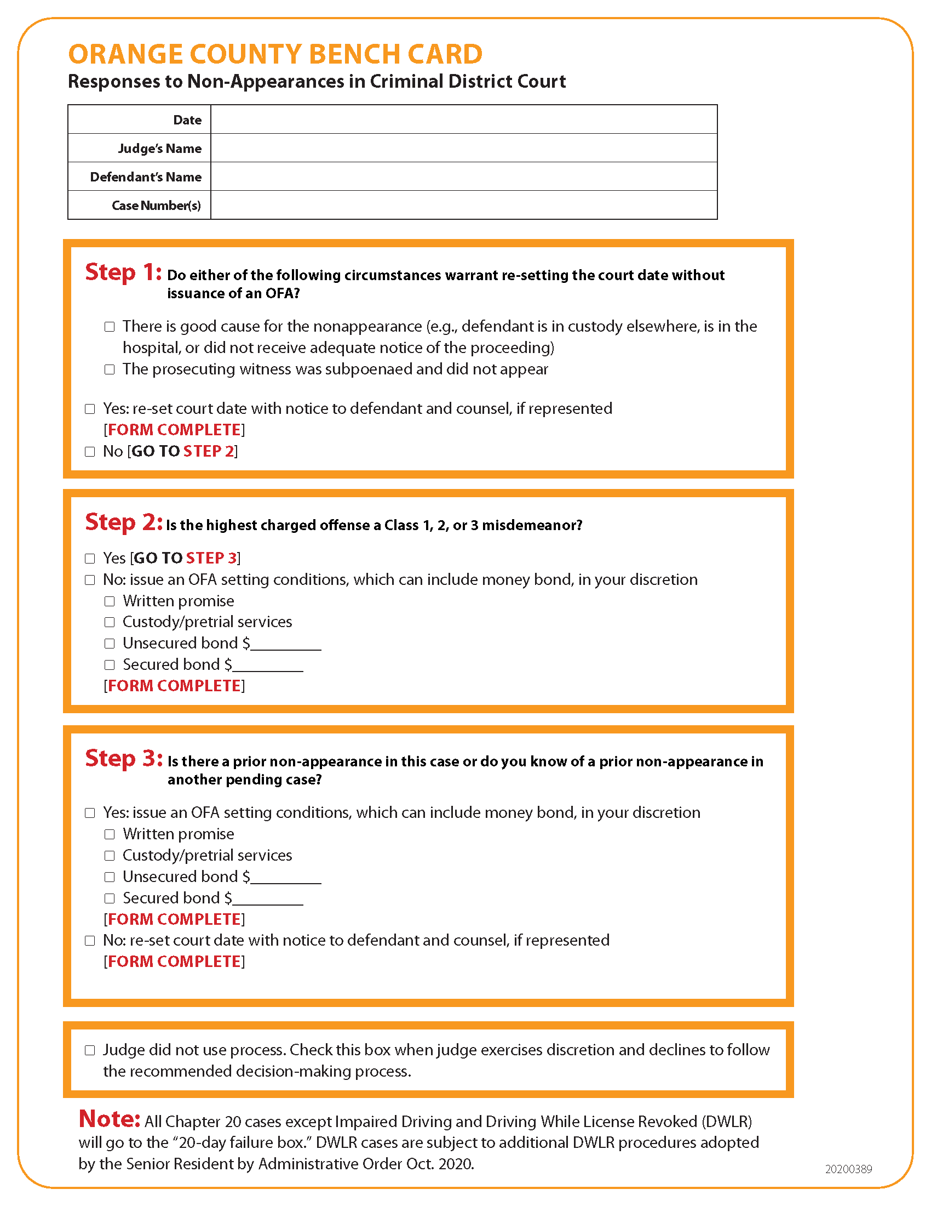

© 2021
School of Government
The University of North Carolina at Chapel Hill Use of this publication for commercial purposes or without acknowledgment of its source is prohibited. Reproducing, distributing, or otherwise making available to a nonpurchaser the entire publication, or a substantial portion of it, without express permission, is prohibited. For permissions questions or requests, email the School of Government at copyright_permissions@sog.unc. Other School reports can be accessed on the Publications page of our website: sog.unc.edu/publications.

